**1 MASON AVENUE, CHELTENHAM (“Oban”)**

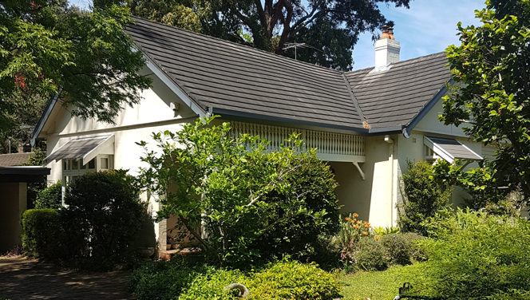

Lot B DP 175680

**Hornsby Shire Council details**

**Heritage Register: (NONE)**

Part of Cheltenham Park Estate Subdivision 1901

The 1901 Cheltenham Park Estate Subdivision created lots for sale along the Beecroft Road, Mason Avenue, Kent Road (later Cheltenham Road) and Boronia Avenue.

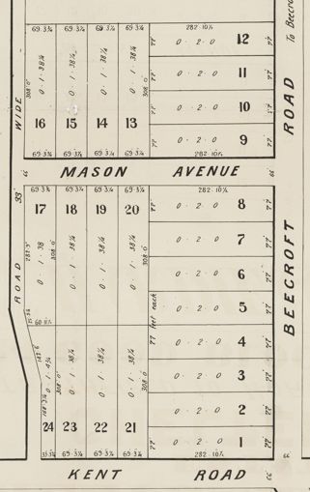

**Sands Directories: 1918-1932-3 Neil Livingston “Oban”**

**+ 1933 Electoral Roll Catherine Livingston No. 1**

Neil and Catherine Grace Livingston were living at this house in 1920.

*[Neil Livingston married Catherine Grace McPhail in 1907, Dapto]*

They had previously been living at “Rutherglen,” 158 Beecroft-road, Cheltenham (alternate address: 1 B Mason-avenue, Cheltenham). “Oban” was immediately behind “Rutherglen.”

**Neil & Kate Livingston 1914**

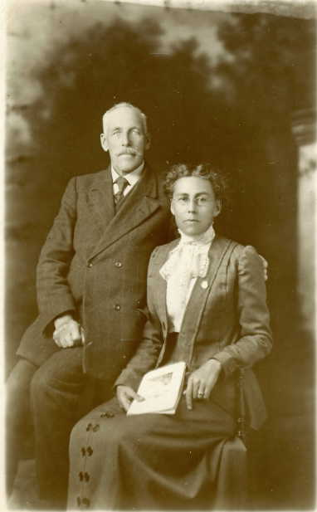

In 1930, at “Oban,” Neil Livingston died, aged 85 years, survived by his wife Catherine and children: Agnes, Flora, Peter, Mary, and Neil.

Catherine Grace was still living at 1 Mason-avenue in 1963.

**Bibliography: none**

**Resources available (varies):**

* Sands Directories 1858-1933 City of Sydney [Sands Postal Directory | City of Sydney Archives (nsw.gov.au)](https://archives.cityofsydney.nsw.gov.au/nodes/view/495003)
* Newspaper articles – TROVE - [Search - Trove (nla.gov.au)](https://trove.nla.gov.au/search/advanced/category/newspapers)
* Ancestry.com (subscription only) [Genealogy, Family Trees and Family History Records online - Ancestry.com](https://www.ancestry.com.au/) – Sands Directories, Electoral Rolls, Family photos (Public Member photos), Census lists, marriage details, + miscellaneous
* N.S.W. Births, Deaths & Marriages [Family history search | NSW Government](https://www.nsw.gov.au/family-and-relationships/family-history-search) (QLD & Victoria also obtainable online)
* House photos and information via Hornsby Shire Council website for Property Search and Heritage Register [Heritage | Hornsby Shire Council (nsw.gov.au)](https://www.hornsby.nsw.gov.au/property/build/heritage)
* House photos and associated information via Internet search on address via Real Estate websites (from 2005)
* “Beecroft and Cheltenham Heritage Walks” - Beecroft-Cheltenham History Group Inc. 2004 book (1st edition)
* Australian War Museum website [Home | Australian War Memorial (awm.gov.au)](https://www.awm.gov.au/)