**10-12 THE BOULEVARD, CHELTENHAM (“Kuraroo”)**

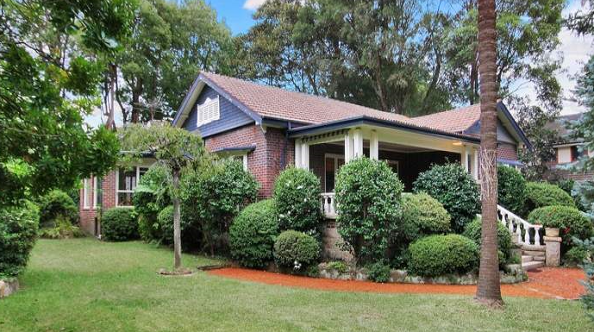

Lots 25 & 26 DP 5440

**Hornsby Shire Council details**

**Heritage Register: Item No. 282 (Garden only)**

Part of Mount Pleasant Estate – Cheltenham 1st Subdivision 1908

Sands Directory 1925-1932/3: J. Buckle “Kuraroo”

Electoral Roll 1933: John Buckle No.12

A rambling Californian bungalow style home with small leadlight front windows. The garden with palms and old spruce is heritage listed.

In early 1923 tenders were accepted for the erection of a large residence at Cheltenham.

The house was probably designed by his brother, Francis Buckle, architect, who lived at 30 The Crescent, Cheltenham, from 1924 to 1932/3.

John Wiseman Buckle was living at “Kuraroo” by 1925.

*[J. W. Buckle, born 1897, son of Mr. & Mrs. Frank Buckle (Francis & Dora) of Cremorne, married in 1921 Muriel Primrose (‘Primrose’), daughter of Mr. & Mrs. J. H. (John Harry Joseph) Lyon of The Promenade, Cheltenham*]

The Buckles resided at “Kuraroo,” 10-12 The Boulevard, Cheltenham until 1933, and then moved to Hornsby.

(1933 Electoral Roll: John Wiseman Buckle (merchant) and Muriel Primrose Buckle – 12 The Boulevard, Cheltenham)

They would eventually divorce - Muriel Primrose Buckle married James Watson in 1941 at Gosford; John Wiseman Buckle married Thycia Marie O’Sullivan in 1944 at Mosman.

During the 2nd World War John W. Buckle would serve in the Army, Citizen Military Forces.

“Kuraroo” was then occupied by John Buckle’s in-laws, John H. J. & Mary Lyon.

In 1935 Mary Lyon died at Cheltenham. John Lyon would continue to live at no. 10 The Boulevard until his death in 1956.

The property was last sold in 2010.**1**

**Bibliography:**

1 [10 The Boulevard, Cheltenham, NSW 2119 - Property Details (realestate.com.au)](https://www.realestate.com.au/sold/property-house-nsw-cheltenham-106430235)

**Resources available (varies):**

* Sands Directories 1858-1933 City of Sydney [Sands Postal Directory | City of Sydney Archives (nsw.gov.au)](https://archives.cityofsydney.nsw.gov.au/nodes/view/495003)
* Newspaper articles – TROVE - [Search - Trove (nla.gov.au)](https://trove.nla.gov.au/search/advanced/category/newspapers)
* Ancestry.com (subscription only) [Genealogy, Family Trees and Family History Records online - Ancestry.com](https://www.ancestry.com.au/) – Sands Directories, Electoral Rolls, Family photos (Public Member photos), Census lists, marriage details, + miscellaneous
* N.S.W. Births, Deaths & Marriages [Family history search | NSW Government](https://www.nsw.gov.au/family-and-relationships/family-history-search) (QLD & Victoria also obtainable online)
* House photos and information via Hornsby Shire Council website for Property Search and Heritage Register [Heritage | Hornsby Shire Council (nsw.gov.au)](https://www.hornsby.nsw.gov.au/property/build/heritage)
* House photos and associated information via Internet search on address via Real Estate websites (from 2005)
* “Beecroft and Cheltenham Heritage Walks” - Beecroft-Cheltenham History Group Inc. 2004 book (1st edition)
* Australian War Museum website [Home | Australian War Memorial (awm.gov.au)](https://www.awm.gov.au/)
* Beecroft and Cheltenham History Group website [Beecroft and Cheltenham History - Beecroft Cheltenham History Group (bchg.org.au)](https://bchg.org.au/)