**10 CHELTENHAM ROAD, CHELTENHAM (“Inverrughie”)**

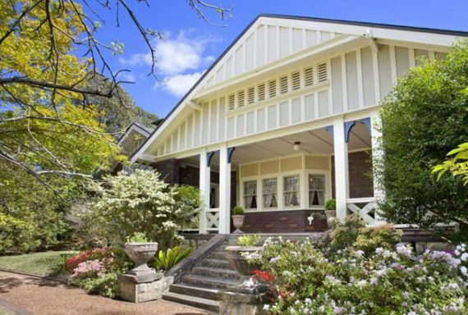

Lots 136 & 137 DP 12364

**Hornsby Shire Council details:**

**Heritage Register: No. 272**

Part of Mount Pleasant Estate – Cheltenham 3rd Subdivision 1924

Sands Directories 1927-1932/3 A. H. Whitney

Electoral Roll 1933: Athelstone Whitney No. 10

Large Inter-War Bungalow style single-storey brick house, which forms a pair with No. 8 adjoining.

*NOTE: Perhaps No. 8 and No. 10 were built as two residences at the same time to accommodate separately the various members of the Whitney family, with the postal address as No. 10 up to the time that it was sold, or leased, to the Joyce family about 1940, then two separate addresses were used.*

Built c.1925 for Athelstane Hubert Whitney, solicitor.

Athelstane H. Whitney was born 1885, the son of John Sydney (1839-1906) & Susannah Elizabeth Whitney (1847-1934). He remained unmarried, as did two of his sisters, ‘Lily” and Beatrice.

The 1926 Sands Directory has Athelstane’s address at 67 Castlereagh-street, City, and 68 Norton-street, Ashfield.

By 1927 he was living in Cheltenham.

In 1928 the Misses Whitney*, of Cheltenham, left for a world tour by the Otranto.

* Elizabeth Martha (‘Lily’) [1877-1953] & Beatrice Eleanor [1879-1973]

The 1930 Electoral Roll lists at Cheltenham, Athelstane Whitney (solicitor), his mother Susannah Elizabeth Whitney, and his two sisters, Elizabeth Martha (‘Lily’) & Beatrice Eleanor Whitney.

In 1933 they are all listed at 10 Cheltenham-road, Cheltenham.

In 1934 Athelstane’s mother, Susannah Elizabeth, died at her residence, Cheltenham.

In 1937 Athelstane and his two sisters are still listed as living at 10 Cheltenham-road, Cheltenham.

By 1943 they had moved to No. 8 Cheltenham-road and No. 10 was occupied by William Leslie Prior Joyce (company director) and Mary Frances Snowball Joyce (having previously lived in Epping). The Joyce family were still living there in 1963.

**Bibliography: none**

**Resources available (varies):**

* Sands Directories 1858-1933 City of Sydney [Sands Postal Directory | City of Sydney Archives (nsw.gov.au)](https://archives.cityofsydney.nsw.gov.au/nodes/view/495003)
* Newspaper articles – TROVE - [Search - Trove (nla.gov.au)](https://trove.nla.gov.au/search/advanced/category/newspapers)
* Ancestry.com (subscription only) [Genealogy, Family Trees and Family History Records online - Ancestry.com](https://www.ancestry.com.au/) – Sands Directories, Electoral Rolls, Family photos (Public Member photos), Census lists, marriage details, + miscellaneous
* N.S.W. Births, Deaths & Marriages [Family history search | NSW Government](https://www.nsw.gov.au/family-and-relationships/family-history-search) (QLD & Victoria also obtainable online)
* House photos and information via Hornsby Shire Council website for Property Search and Heritage Register [Heritage | Hornsby Shire Council (nsw.gov.au)](https://www.hornsby.nsw.gov.au/property/build/heritage)
* House photos and associated information via Internet search on address via Real Estate websites (from 2005)
* “Beecroft and Cheltenham Heritage Walks” - Beecroft-Cheltenham History Group Inc. 2004 book (1st edition)
* Australian War Museum website [Home | Australian War Memorial (awm.gov.au)](https://www.awm.gov.au/)