**11 CHORLEY AVENUE, CHELTENHAM**

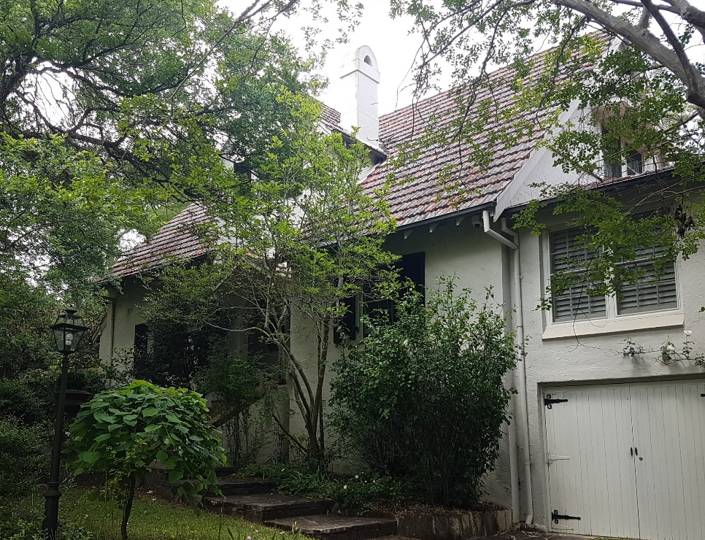

Lot 129 DP 12364

Sands Directories 1932/3 John Milling

Electoral Roll 1933: John Milling No. 11

In 1930 occupants were John Belleck Milling (merchant), Louisa Ann Belleck Milling, Henry John Milling (salesman) and Winifred Mary Beeleek Milling (nurse)

*[John Milling married Louisa A. Tubman in 1890, district of St. Leonard]*

They continued to live at this address up to 1937.

In 1938 Henry John Milling, salesman, late of Manly, was accidentally killed at Moree, N.S.W.

*[In 1944, Major John Milling, formerly of the NSW Lancers and the 7th Australian Light Horse, died at the age of 78, at his Balgowlah home. He was one of Sydney's oldest crockery importers. He came to Australia from Northern Ireland 60 years previously. He was a director of the firm of Lyon and Milling, and for his last seven years had been a director of the Cranston Trading Company.*

*Major Milling was survived by one daughter, Mrs. R. P. Sinclair, and one son, Oliver.]*

In 1939, at this address, occurred the death of Gertrude Sommerville Cock, aged 61 years, wife of John Cock, Inspector of Mines, Beechworth district.

Her daughter Thelma Clare Cock was married to William Ewart Hart, dentist, and former pioneer aviator.

*[William E. Hart married Thelma C. Cock in 1929, district of Sydney]*

In 1943 the property was occupied by William Ewart Hart (dentist) and Thelma Clare Hart (home duties).

That year William Ewart Hart died of natural causes in Sydney.

In 1949 Thelma Clare Hart was still in residency. Her death occurred in 1965 at Malvern, Stonnington City, Victoria.

That year the property was put up for auction, described as follows:

*Vacant Possession Residence*

*11 Chorley Avenue Cheltenham*

*IN EXCELLENT CONDITION and standing on a DELIGHTFUL CORNER ALLOTMENT on which trees have been retained in a natural state, this CHARMING ENGLISH STYLE 2-STOREY BRICK RESIDENCE will appeal to the buyer seeking something different, COMBINED WITH QUALITY OF CONSTRUCTION. Offered with IMMEDIATE VACANT POSSESSION this commodious home contains Ent. Hall, living-room dining room with sliding doors, and large open fireplace, verandah, sun deck, den, main bedroom, 3 other bedrooms, modern kitchen, sunny breakfast room, guests washroom under stairs, telephone-room, mauve tiled bathroom, storeroom, Large laundry underneath, and separate outside toilet. LAND 68ft x 174ft 9in, 175ft 6in.*1

**Bibliography:**

1 Sydney Morning Herald, 3rd September 1949

**Resources available (varies):**

* Sands Directories 1858-1933 City of Sydney [Sands Postal Directory | City of Sydney Archives (nsw.gov.au)](https://archives.cityofsydney.nsw.gov.au/nodes/view/495003)
* Newspaper articles – TROVE - [Search - Trove (nla.gov.au)](https://trove.nla.gov.au/search/advanced/category/newspapers)
* Ancestry.com (subscription only) [Genealogy, Family Trees and Family History Records online - Ancestry.com](https://www.ancestry.com.au/) – Sands Directories, Electoral Rolls, Family photos (Public Member photos), Census lists, marriage details, + miscellaneous
* N.S.W. Births, Deaths & Marriages [Family history search | NSW Government](https://www.nsw.gov.au/family-and-relationships/family-history-search) (QLD & Victoria also obtainable online)
* House photos and information via Hornsby Shire Council website for Property Search and Heritage Register [Heritage | Hornsby Shire Council (nsw.gov.au)](https://www.hornsby.nsw.gov.au/property/build/heritage)
* House photos and associated information via Internet search on address via Real Estate websites (from 2005)
* “Beecroft and Cheltenham Heritage Walks” - Beecroft-Cheltenham History Group Inc. 2004 book (1st edition)
* Australian War Museum website [Home | Australian War Memorial (awm.gov.au)](https://www.awm.gov.au/)