**11 THE BOULEVARD, CHELTENHAM (“Rosmon” (“Rosemont”), later “The Gables”)**

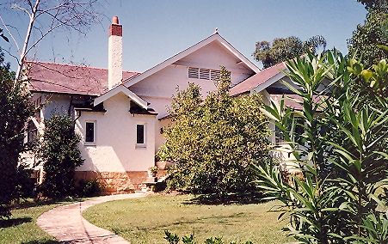

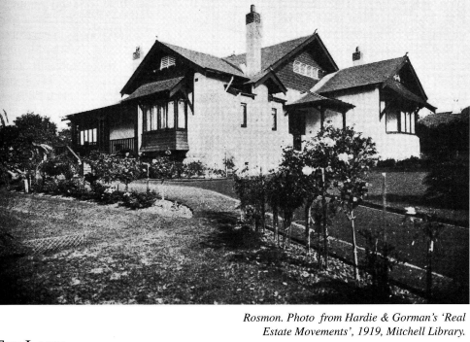

**Lot 2 DP 540033**

**Hornsby Shire Council details**

**Heritage Register: Item No. 283**

Part of Mount Pleasant Estate – Cheltenham 1st Subdivision 1908

*“Rosmon*, was built in 1914 for Ernest and Rosabelle Trigg. The name reflects Mrs Trigg’s name ‘Rose’ combined with ‘mount’ for the rise where the house is sited. Ernest was General Manager of the Meadowbank Manufacturing Company. Their only child died before they moved into this house and they only lived here for some 8 years. They were active Anglicans and attended St Andrews Cathedral where Ernest was a lay canon.

William Nixon was the architect and the house is designed in the arts and crafts style. It has many gables, ends covered in timber shingles, tall chimneys and wide eaves. A number of the windows are of diamond panes with a single ribbon and red and green roses in the upper portion. On the eastern side of the house was the tennis court reached by stone steps. There was a large garden.”

‘The land purchase in 1912 of the first Mount Pleasant subdivision was that of Lots 10 to 13 by R who paid Rosabelle Irene Trigg, wife of Ernest Samuel Trigg. Each lot was 70 feet by 200 feet, in total one and a quarter acres. The land was adjacent to Thomas Nossiter’s and had the same covenant as his. Lots 10 to 13 were on both Portion 500 and Portion 493, the latter being purchased at public auction by William Chorley in 1900 who paid £105 for the three and a half acres. He combined both portions in DP5440 for the subdivision. In 1916 Rosabelle Trigg sold part of Lot 10 to Thomas Nossiter. The Triggs sold the remainder of the property, with the house, in 1920, to Charles Potts, grain and produce merchant, of Hunters Hill, who subdivided the land and resold it in 1923 and 1924.’1

Ernest Trigg was living in Cheltenham in November 1911, according to an article on his presence at a wedding between George A. W. Pollock of London and Miss Clara M. Irons, daughter of the manager of the Clyde Engineering Co's. Works, Mr. T. Irons. Nieces of the bride, Joan and Nancy Nossiter, were in attendance.

*[The previous year Ernest and Rosabelle Trigg’s three-year-old daughter, Mary Irene, died at their home “Mornington,” Homebush-road, Strathfield.]*

The Electoral Roll of 1913 lists Ernest Samuel Trigg (manager), Rosabelle Irene Trigg living at Carlingford-road [now The Crescent], Cheltenham.

*[Ernest S. Trigg married Rosabelle I. Barnes in 1906, at Darlinghurst]*

The 1915 Sands Directory records Ernest Trigg as living at “Hillview,” Cheltenham-avenue, Cheltenham [52 The Crescent].

Sands Directories 1915-1920: Ernest S. Trigg “Rosmon”

Sands Directories 1921-1924: Charles J. Potts “Mornington”

Sands Directories 1926-1927: W. Kenrick “Mornington”

Sands Directories 1930-1932/3: Mrs. C. M. Pollock “The Gables”

Electoral Roll 1933: Clara Pollock No. 11

In January 1915 it was reported that Ernest Trigg ‘(manager of the Meadowbank Manufacturing Co.) is now occupying his new home at Cheltenham.’ In 1917 the house is referred to as “Rosinon” [sic].

The Mount Pleasant Estate – Cheltenham (2nd Subdivision) 1918 shows the house being occupied by Mr. Trigg.

The home is said to have been sold in 1920 to Charles Potts, a grain and produce merchant. Then in 1926 to W. Kenrick, and in 1928 to Mrs. C. M. Pollock.

By 1930, with Mrs. Clara Millicent Pollock as occupant, the house is renamed “The Gables.”

*[Clara Millicent Irons, daughter of Thomas Irons, married George Pollock in 1911, at Granville; George Pollock died in 1920; Thomas Irons would later live at 15 The Boulevard, Cheltenham]*

In 1933 occupants were Clara Millicent Pollock and Patrick Joseph Wiltoc Kelly (labourer)

In 1937 occupants were Clara Millicent Pollock (home duties), Richard Allan Pollock (student), Peter Trons Pollock (clerk) and Edith Florence Martin (home duties)

That year the house was put up for sale, described as follows:

“THE GABLES," No. 11 THE BOULEVARD,

within 3 minutes of station.

BUNGALOW HOME, of brick (rough cast), on stone, slate roof, having Spacious Verandah, Entrance Porch and Vestibule Hall, Lounge and Dining Rooms (both approached by sliding doors from Vestibule and opening to Verandah, so forming an attractive suite for entertainment), 4 Bedrooms (one having sleep-out), tiled Bathroom (Septic Tank System), Return Hall and ample built-in cupboards. Kitchen, Laundry. Maid's Suite of Bedroom and Bathroom. Storerooms, etc.

Detached of brick are Garage and Man's Room.

THE LAND (about 200 feet by 200 feet) Is delightfully laid out with Gravel Paths and Motor Drive, Lawns, Flower and Vegetable Gardens. Well-grown Ornamental Shrubs, etc. TURF TENNIS COURT.2

In 1943 occupants were Peter Trons Pollock (clerk), Michael Barrett (guesthouse keeper), Harriet Barrett, William Henry Shepherd (fruit merchant), Margaretta Shepherd.

**Bibliography:**

1 “Houses of Hornsby Shire, Volume II” by Helen Barker

2 Sydney Morning Herald, 19th July 1937

**Resources available (varies):**

* Sands Directories 1858-1933 City of Sydney [Sands Postal Directory | City of Sydney Archives (nsw.gov.au)](https://archives.cityofsydney.nsw.gov.au/nodes/view/495003)
* Newspaper articles – TROVE - [Search - Trove (nla.gov.au)](https://trove.nla.gov.au/search/advanced/category/newspapers)
* Ancestry.com (subscription only) [Genealogy, Family Trees and Family History Records online - Ancestry.com](https://www.ancestry.com.au/) – Sands Directories, Electoral Rolls, Family photos (Public Member photos), Census lists, marriage details, + miscellaneous
* N.S.W. Births, Deaths & Marriages [Family history search | NSW Government](https://www.nsw.gov.au/family-and-relationships/family-history-search) (QLD & Victoria also obtainable online)
* House photos and information via Hornsby Shire Council website for Property Search and Heritage Register [Heritage | Hornsby Shire Council (nsw.gov.au)](https://www.hornsby.nsw.gov.au/property/build/heritage)
* House photos and associated information via Internet search on address via Real Estate websites (from 2005)
* “Beecroft and Cheltenham Heritage Walks” - Beecroft-Cheltenham History Group Inc. 2004 book (1st edition)
* Australian War Museum website [Home | Australian War Memorial (awm.gov.au)](https://www.awm.gov.au/)
* Beecroft and Cheltenham History Group website [Beecroft and Cheltenham History - Beecroft Cheltenham History Group (bchg.org.au)](https://bchg.org.au/)