**12 CHELTENHAM ROAD, CHELTENHAM (“Ardbeg”)**

**Alternate Address(es):**

**3 Chorley Avenue CHELTENHAM NSW 2119**

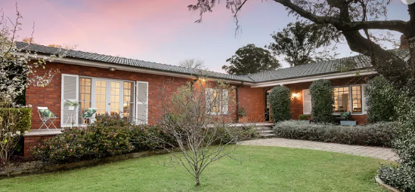

**[New home]**

12 Cheltenham Road Lot 135 DP 12364

3 Chorley Avenue Lot 135 DP 12364

**Hornsby Shire Council details**

**Heritage Register: (NONE)**

Part of Mount Pleasant Estate – Cheltenham 3rd Subdivision 1924

The original house would appear to have been demolished and replaced.

Sands Directory 1925: Alex. King Chorley-crescent

Sands Directories 1927-1930: Alex. King “Ardbeg” Chorley-crescent

In 1925 Alexander King was in residence until 1930.

For 1931-2 Mrs. Fanny Amy Garraway was living there.

In 1933 Alexander King and his wife Agnes Weir King was again in residence; also Stanley Bennet Peterson and Ethel Ida Peterson.

In 1934 the house was unsuccessfully put up for sale, described as follows:

*“Ardbeg,” No 12 Cheltenham-road*

*Modern Brick Bungalow Residence, with wide return Verandahs, floored with Terrazzo. Wide Impressive Plate-glass Entrance Doors. Vestibule Hall tastefully panelled in picked wood. Impressive and spacious Lounge room, large open fire place, Billiard or Ball room, with specially selected Jarrah floor, also with open fireplace, Smokeroom, Dining room, Morning room, 3 main Bedrooms, Maid’s Room, main Bathroom is spacious, all tiled.*

*Separate shower recess and lavatory. Also, maid’s bathroom. Kitchen with every modern culinary convenience. Jarrah floorings throughout.*

*LAND 136ft frontage to Cheltenham-road by a frontage to Chorley crescent of 256ft and a depth of 210ft.*

*TENNIS COURT, GARAGE.*

*Well laid out. Gravel Paths and Lawns.***1**

In 1935 Alexander King, engineer) died at 12 Cheltenham-road, survived by his widow, Agnes Weir King, and three sons (James, David & Ralston).

Alexander King was well- known in shipping circles, both in New South Wales and Queensland. He was born in Glasgow, and came to Australia in 1902. He became a member of the firm of McLeod & King, at Rockhampton, and, later on, was the Queensland Government marine engineer at Rockhampton.

In 1920 Mr. King came to Sydney and was a director of the Australian Provincial Insurance Association for some years. He also had shipping and pastoral interests in Sydney.

In 1937 “Ardbeg” was occupied by James McEwen King (architect) and Thelma Alice King.

**Bibliography:**

1 Sydney Morning Herald, 15th September 1934

**Resources available (varies):**

* Sands Directories 1858-1933 City of Sydney [Sands Postal Directory | City of Sydney Archives (nsw.gov.au)](https://archives.cityofsydney.nsw.gov.au/nodes/view/495003)
* Newspaper articles – TROVE - [Search - Trove (nla.gov.au)](https://trove.nla.gov.au/search/advanced/category/newspapers)
* Ancestry.com (subscription only) [Genealogy, Family Trees and Family History Records online - Ancestry.com](https://www.ancestry.com.au/) – Sands Directories, Electoral Rolls, Family photos (Public Member photos), Census lists, marriage details, + miscellaneous
* N.S.W. Births, Deaths & Marriages [Family history search | NSW Government](https://www.nsw.gov.au/family-and-relationships/family-history-search) (QLD & Victoria also obtainable online)
* House photos and information via Hornsby Shire Council website for Property Search and Heritage Register [Heritage | Hornsby Shire Council (nsw.gov.au)](https://www.hornsby.nsw.gov.au/property/build/heritage)
* House photos and associated information via Internet search on address via Real Estate websites (from 2005)
* “Beecroft and Cheltenham Heritage Walks” - Beecroft-Cheltenham History Group Inc. 2004 book (1st edition)
* Australian War Museum website [Home | Australian War Memorial (awm.gov.au)](https://www.awm.gov.au/)