**12 MASON AVENUE, CHELTENHAM (“Boonga”)**

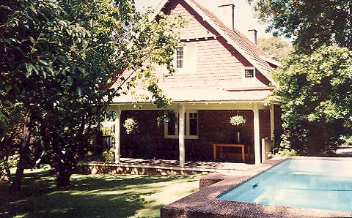

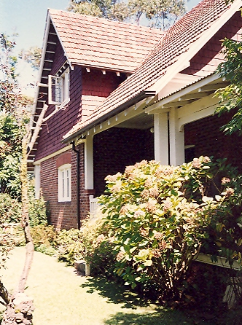

Lot 1 DP 537455

**Hornsby Shire Council details:**

**Heritage Register: No.278**

The name of the house “Boonga” was believed to mean ‘our home.’ However, Boonga is a taboo term used in New Zealand to refer to a person of Polynesian origin. The origin of the word is uncertain, but it may be of native Australian origin.

*“Boonga,”* of Federation and Arts and Crafts style, is now on a battle axe block but is the 1903 home of Joseph Seale. This home was built for his bride and it shows influences of John Horbury Hunt, with its steeply pitched roof and timber shingles on the gable ends. The leadlight glass in the front door was a wedding present. Originally on two acres, it has been subdivided into seven houses.

Part of Cheltenham Park Estate Subdivision 1901

The 1901 Cheltenham Park Estate Subdivision created lots for sale along the Beecroft Road, Mason Avenue, Kent Road (later Cheltenham Road) and Boronia Avenue.

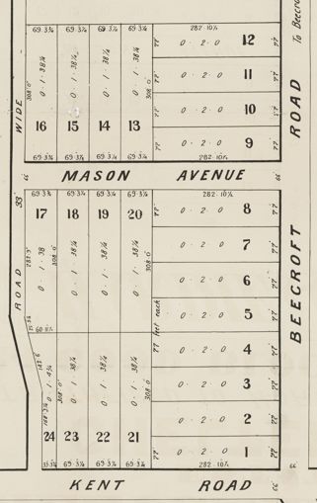

**Sands Directories 1915-1932: Joseph R. Seale, “Boonga”**

**Electoral Roll 1933: Joseph Seale No.6???**

In 1903 Joseph Richard Seale, architect, 3rd son of John Seale of “Mindaribba,” 14-18 Malton-road, Beecroft, married Mary Hilda Noad of East Maitland.

*[In 1901 Thomas Skellett engaged Cheltenham architect Joseph Seale to design the two-storey brick house “Chetwynd” at 138 Copeland-road, Beecroft.]*

By January 1905 they had moved into their new residence and in February a son, Alan M. Seale, was born there.

By April 1905 Robert Brodrick was building next to Mr. Seale’s place.

Joseph and Mary Seale had four children; Alan M., in 1905 (died 1906); Geoffrey Maitland (Geoff), in 1907, Herbert P. (Bill), in 1909, and a daughter, Isabel Mary, in 1914.

In 1933 the occupants were Joseph Richard Seale (architect), Mary Hilda Seale and Geoffrey Maitland Seale. The address given is 6 [?] Mason-avenue.

In 1936 Geoffrey Maitland Seale married Doris Helen Young, of Cheltenham.

In 1949 Joseph Richard Seale died, aged 76 years, at his residence, 6 [?] Mason-avenue, Cheltenham. The confusion with the house number may be due to later renumbering of properties.

His wife, Mary Hilda Seale, would die in 1964, in the district of Balmain.

**Bibliography: none**

**Resources available (varies):**

* Sands Directories 1858-1933 City of Sydney [Sands Postal Directory | City of Sydney Archives (nsw.gov.au)](https://archives.cityofsydney.nsw.gov.au/nodes/view/495003)
* Newspaper articles – TROVE - [Search - Trove (nla.gov.au)](https://trove.nla.gov.au/search/advanced/category/newspapers)
* Ancestry.com (subscription only) [Genealogy, Family Trees and Family History Records online - Ancestry.com](https://www.ancestry.com.au/) – Sands Directories, Electoral Rolls, Family photos (Public Member photos), Census lists, marriage details, + miscellaneous
* N.S.W. Births, Deaths & Marriages [Family history search | NSW Government](https://www.nsw.gov.au/family-and-relationships/family-history-search) (QLD & Victoria also obtainable online)
* House photos and information via Hornsby Shire Council website for Property Search and Heritage Register [Heritage | Hornsby Shire Council (nsw.gov.au)](https://www.hornsby.nsw.gov.au/property/build/heritage)
* House photos and associated information via Internet search on address via Real Estate websites (from 2005)
* “Beecroft and Cheltenham Heritage Walks” - Beecroft-Cheltenham History Group Inc. 2004 book (1st edition)
* Australian War Museum website [Home | Australian War Memorial (awm.gov.au)](https://www.awm.gov.au/)
* Beecroft and Cheltenham History Group website [Beecroft and Cheltenham History - Beecroft Cheltenham History Group (bchg.org.au)](https://bchg.org.au/)