**14 THE BOULEVARD, CHELTENHAM (“Tatworth”)**

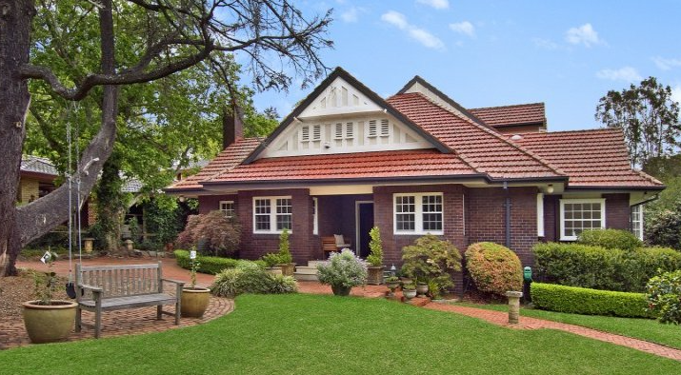

Lot B DP 302976

**Hornsby Shire Council details**

**Heritage Register: Item No. 284 (House and Garden)**

Part of Mount Pleasant Estate – Cheltenham 1st Subdivision 1908

The Heritage Register dates the house as circa 1940 and the garden circa 1930-40’s which conflicts with the below information.

“Tatworth” was built for John Harry Joseph Lyon in about 1912.

In 1913 the occupants were John Harry Lyon (accountant), MaryLyon and Mabel Lyon.

*[John H. J. Lyon married Mary Hancock in 1892, district of Ashfield]*

In March 1913 tenders were called for gravelling of paths and formation of lawns at the residence.

Sands Directories 1915-1932/3: John Lyon “Tatworth”

Electoral Roll 1933: John Lyon No.10

In 1915 Mabel Lyon (daughter of Mrs. Lyon and the late William Hancock, of Exeter, England) married Cuthbert W. Robson, of Mosman.

The Mount Pleasant Estate – Cheltenham (2nd Subdivision) 1918 shows the house being occupied by Mr. Lyon.

In 1921 “Tatworth” was put up for sale, described as follows:

“Most substantially constructed of best RED O.K. BRICKS on massive stone foundation, full slate roof, TILED VERANDAH PORCH IN FRONT, WIDE VERANDAH ON EASTERN SIDE 50ft. long, and SLEEP-OUT VERANDAH ON NORTHERN SIDE, and containing ENTRANCE HALL, EXTENSION HALL, LOUNGE and DINING ROOMS, BREAKFAST-ROOM, 4 BEDROOMS, BILLIARD-ROOM, LARGE BATHROOM (tiled floor and wall), HEATER and BASIN, LINEN PRESS, CHINA CUPBOARD, STOREROOM, LARGE KITCHEN and LAUNDRY, GAS, CITY WATER, and TELEPHONE services.

LAND about 147ft. x 200ft., laid out in well-kept lawns and gardens. Tool-room and fuel-house.

TENNIS COURT.

BRICK GARAGE, IRON ROOF AND CEMENT FLOOR.”**1**

The property was not sold and the Lyon family continued to be the occupants.

In late 1921 Muriel Primrose (Primrose) Lyon, daughter of John H. Lyon, married John W. Buckle, son of Mr. & Mrs. Frank Buckle, of Cremorne.

From about 1925 to 1933 they resided at “Kuraroo,” 10-12 The Boulevard, Cheltenham. They then moved to Hornsby. They would eventually divorce - Muriel Primrose Buckle married James Watson in 1941 at Gosford; John Wiseman Buckle married Thycia Marie O’Sullivan in 1944 at Mosman.

By 1933 John H. J. Lyon had moved next door at “Kuraroo,” 10-12 The Boulevard, Cheltenham, where his daughter and son-in-law had previously lived.

In that year, John’s father, William John Debenham Lyon (merchant) was living at 34 Copeland-street, Beecroft, along with his wife Margaret Mary Lyon, John Wallace Lyon (bookkeeper) and Nancy Lauder Lyon. William J. D. Lyon, of Beecroft, died in 1946.

*[William J. D. Lyon married Margaret M. Wallace in 1908, Ryde]*

By 1937 Ebenezer Parsons House (manager), Emily Morland House and Elizabeth Jane Winkworth (home duties) occupied 14 The Boulevard, Cheltenham

In 1940 the occupant was John Norman Lawson, and in 1945 the Felton family.

By 1953 the house occupants were William and Marion McDonald. That year Marion McDonald was accidentally killed after overstepping the edge of an upper-tier wharf and falling to the wharf below.

“Tatworth” was last sold in 2014.2

**Bibliography:**

1 Daily Telegraph, 5th March 1921

2 [14 Cheltenham Road, Cheltenham, NSW 2119 - Property Details (realestate.com.au)](https://www.realestate.com.au/sold/property-house-nsw-cheltenham-137540998)

**Resources available (varies):**

* Sands Directories 1858-1933 City of Sydney [Sands Postal Directory | City of Sydney Archives (nsw.gov.au)](https://archives.cityofsydney.nsw.gov.au/nodes/view/495003)
* Newspaper articles – TROVE - [Search - Trove (nla.gov.au)](https://trove.nla.gov.au/search/advanced/category/newspapers)
* Ancestry.com (subscription only) [Genealogy, Family Trees and Family History Records online - Ancestry.com](https://www.ancestry.com.au/) – Sands Directories, Electoral Rolls, Family photos (Public Member photos), Census lists, marriage details, + miscellaneous
* N.S.W. Births, Deaths & Marriages [Family history search | NSW Government](https://www.nsw.gov.au/family-and-relationships/family-history-search) (QLD & Victoria also obtainable online)
* House photos and information via Hornsby Shire Council website for Property Search and Heritage Register [Heritage | Hornsby Shire Council (nsw.gov.au)](https://www.hornsby.nsw.gov.au/property/build/heritage)
* House photos and associated information via Internet search on address via Real Estate websites (from 2005)
* “Beecroft and Cheltenham Heritage Walks” - Beecroft-Cheltenham History Group Inc. 2004 book (1st edition)
* Australian War Museum website [Home | Australian War Memorial (awm.gov.au)](https://www.awm.gov.au/)
* Beecroft and Cheltenham History Group website [Beecroft and Cheltenham History - Beecroft Cheltenham History Group (bchg.org.au)](https://bchg.org.au/)