**15 CHELTENHAM ROAD, CHELTENHAM (“Highclere”)**

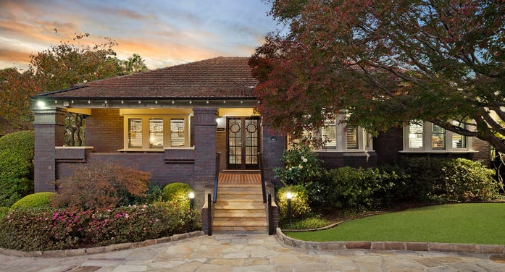

Lot 11 DP 600205

Sands Directories 1930-1932/3 C. McKenzie “Highclere”

Electoral Roll 1933: Charles McKenzie No. 45[s/be 15}

**Hornsby Shire Council details**

**Heritage Register: (NONE)**

*Highclere* was built in about 1927 for Charles McKenzie who had a timber firm.

*[Charles McKenzie married Annie C. Sharpe in 1927, district of Burwood]*

As with its neighbour, No. 19, it has the dark Thornleigh brick. It has a tile verandah and sandstone drive. It has its original fence and tecoma hedge.

A son, John Hepburn, was born March 1929 to Charles & Annie McKenzie who were then living in Cheltenham.

In 1933 occupants were Charles McKenzie (timber merchant) and Annie Christobel McKenzie

In 1952 their son, John Hepburn McKenzie, married Dorothy, elder daughter of Rev. and Mrs. R. A. Gibbons of Beecroft.

In 1977 Charles and Annie were still living at 15 Cheltenham-road.

The house was last sold in 2022.1

**Bibliography:**

1 [15 Cheltenham Road, Cheltenham, NSW 2119 - Property Details (realestate.com.au)](https://www.realestate.com.au/sold/property-house-nsw-cheltenham-139430979)

**Resources available (varies):**

* Sands Directories 1858-1933 City of Sydney [Sands Postal Directory | City of Sydney Archives (nsw.gov.au)](https://archives.cityofsydney.nsw.gov.au/nodes/view/495003)
* Newspaper articles – TROVE - [Search - Trove (nla.gov.au)](https://trove.nla.gov.au/search/advanced/category/newspapers)
* Ancestry.com (subscription only) [Genealogy, Family Trees and Family History Records online - Ancestry.com](https://www.ancestry.com.au/) – Sands Directories, Electoral Rolls, Family photos (Public Member photos), Census lists, marriage details, + miscellaneous
* N.S.W. Births, Deaths & Marriages [Family history search | NSW Government](https://www.nsw.gov.au/family-and-relationships/family-history-search) (QLD & Victoria also obtainable online)
* House photos and information via Hornsby Shire Council website for Property Search and Heritage Register [Heritage | Hornsby Shire Council (nsw.gov.au)](https://www.hornsby.nsw.gov.au/property/build/heritage)
* House photos and associated information via Internet search on address via Real Estate websites (from 2005)
* “Beecroft and Cheltenham Heritage Walks” - Beecroft-Cheltenham History Group Inc. 2004 book (1st edition)
* Australian War Museum website [Home | Australian War Memorial (awm.gov.au)](https://www.awm.gov.au/)