15 CHORLEY AVENUE, CHELTENHAM (“Noreuil”)

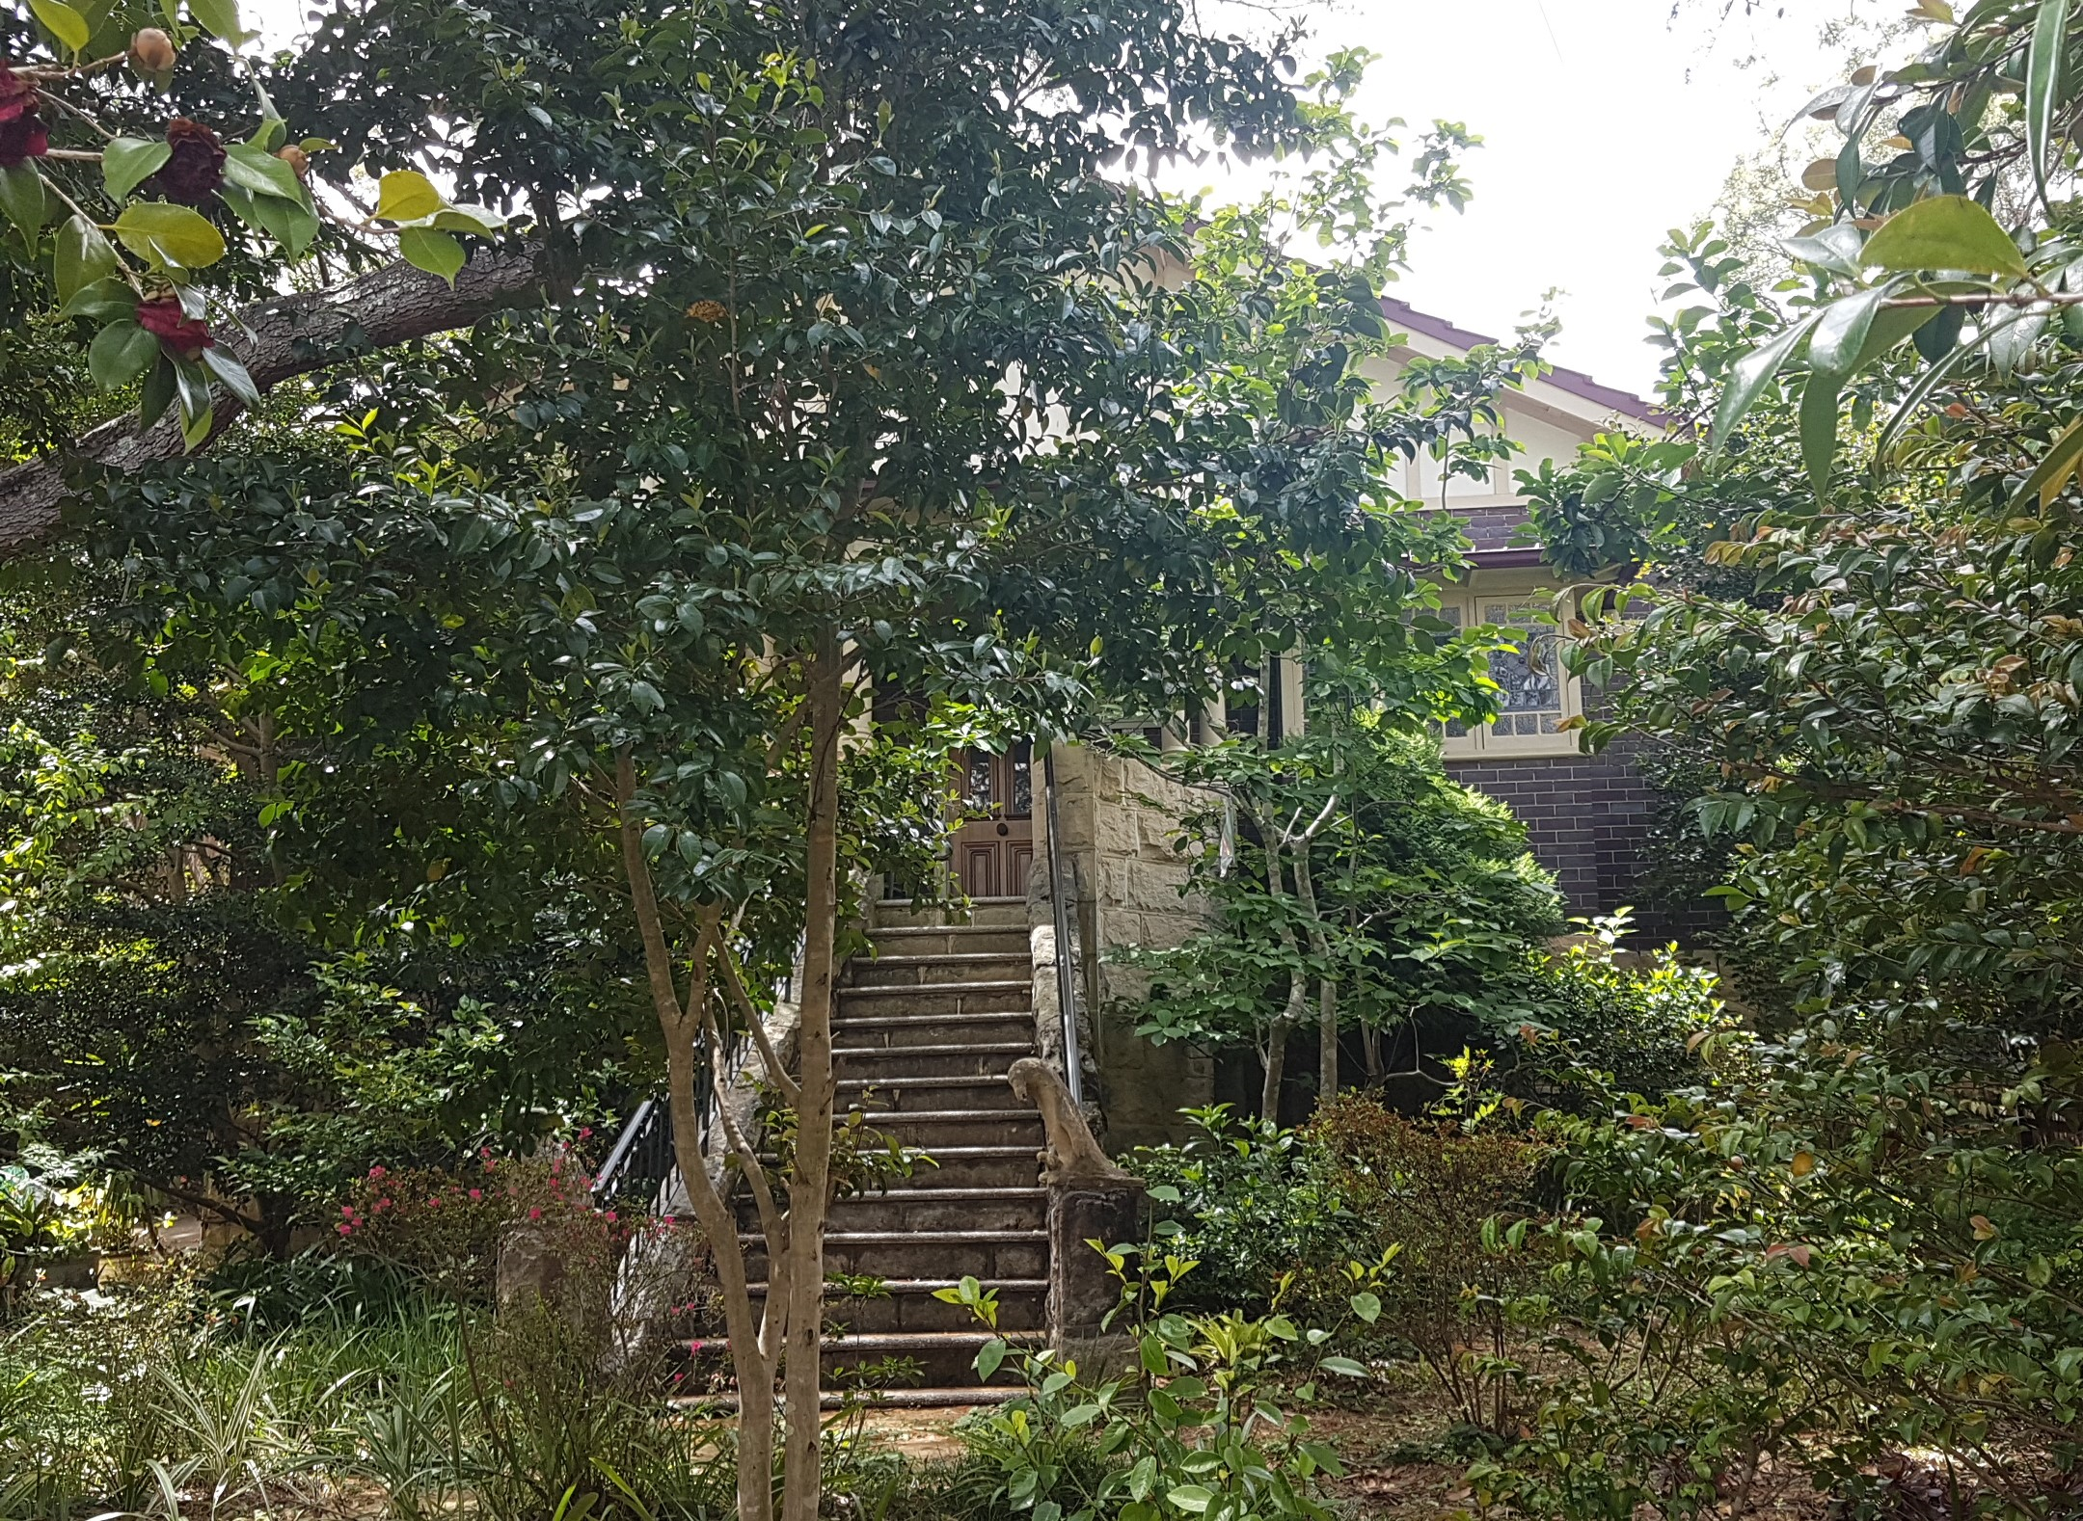
Lot 128 DP 12364

Sands Directories 1930-32/3 C. E. Rahn “Noreuil”
Electoral Roll 1933: Cecil Rahn No. 15

Noreuil is a commune in the Pas-de-Calais department in the Hauts-de-France region of France. In 1917 it was the location of fighting during World War 1. Noreuil is close to Bullecourt, the southern end of the battlefront for the Battle of Arras.
Cecil Rahn had been served as a private in WW1 and wounded in June 1917 so this is most likely where his injuries occurred.]

In 1929 Cecil Rahn was living at 15 Chorley -avenue,
[Cecil Ernest Rahn, born abt. 1897, married Eva M. Littlejohn 17th Dec 1927, Petersham, N.S.W.]
A son, Alan George, was born that year and in 1931 their son, Neil John, was born.

In 1933 occupants were Cecil Ernest Rahn (labourer) and Eva May Rahn.

In 1937 occupants were Cecil Ernest Rahn (labourer), Eva May Rahn and Frances Catherine Littlejohn (home duties).
That year, at this address, occurred the death of Frances Catherine Littlejohn, widow of the late John Littlejohn, and loving mother of Mary, Jessie, John, Alfred, Walter, and Eva, aged 80 years.

In 1963 Cecil Ernest Rahn (labourer) and Eva May Rahn continued to live at this address.
Eva May Rahn died in 1981 and Cecil Ernest Rahn died in 1988.

Bibliography: none

Resources available (varies):
- Sands Directories 1858-1933 City of Sydney Sands Postal Directory | City of Sydney Archives (nsw.gov.au)
- Newspaper articles – TROVE - Search - Trove (nla.gov.au)
- Ancestry.com (subscription only) Genealogy, Family Trees and Family History Records online - Ancestry.com – Sands Directories, Electoral Rolls, Family photos (Public Member photos), Census lists, marriage details, + miscellaneous
- N.S.W. Births, Deaths & Marriages Family history search | NSW Government (QLD & Victoria also obtainable online)
- House photos and information via Hornsby Shire Council website for Property Search and Heritage Register Heritage | Hornsby Shire Council (nsw.gov.au)
- House photos and associated information via Internet search on address via Real Estate websites (from 2005)
- “Beecroft and Cheltenham Heritage Walks” - Beecroft-Cheltenham History Group Inc. 2004 book (1st edition)
- Australian War Museum website Home | Australian War Memorial (awm.gov.au)

