**15 THE BOULEVARD, CHELTENHAM (“Boambee”)**

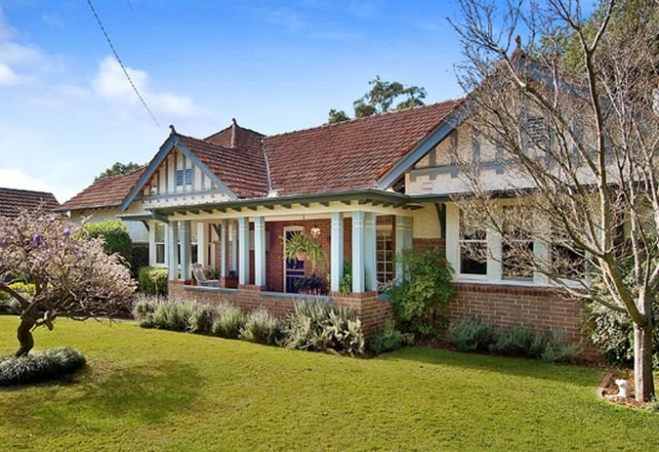

15 The Boulevard Lot 1 DP 807998

197 Beecroft Road Lot 1 DP 807998

**Hornsby Shire Council details**

**Heritage Register: Item No. 285**

Part of Mount Pleasant Estate – Cheltenham 1st Subdivision 1908

“*Boambee* was built for Clarence Hardie Gorman of Hardie & Gorman real estate agents. In about 1919 the home was sold to Mr. & Mrs. Thomas Irons, the parents of Mrs. (Nell) Nossiter of *Jenanbe*. The house was eventually purchased by Major T. G. Millner whose commitment to rugby led to the oval in Eastwood being named in his honour.”

In June 1912, ‘at a meeting of the Hornsby Shire Council, a letter was read from C. H. Gorman, asking permission to plant shade trees on the Beecroft-road and the Boulevard, facing his property at Cheltenham. He proposed to plant callistemons, and wishes to know what distance the trees should be planted. He also asked the council to make up the footpath along his boundary facing Beecroft-road. The request was granted, trees to be planted 30ft. apart, in guards 3ft. square. The engineer was instructed to have the footpath fixed up as soon as men were available for the purpose.’

The 1913 Electoral Roll lists Clarence Hardie Gorman (auctioneer), Ada Jessie Gorman as living at Beecroft-road, Cheltenham

That year C. H. Gorman was Chairman of Directors of The Cheltenham Recreation Club, Ltd, a company incorporated with a capital of £2000 divided into 4000 shares of 10/ each, a block of land having been handed over by W. H. Harris for this purpose.

In October 1914 there was an advertisement for a laundress wanted at “BOAMBEE,” Beecroft Road, Cheltenham.

In 1915 the “Boambee” address is in The Boulevard. That year Mrs. Gorman advertised for a general hand wanted for a small family.

Sands Directories 1915-1917: C. H. Gorman “Boambee”

Sands Directory 1918: Thomas Irons

Sands Directory 1919: Mrs. Minnie Irons

Sands Directory 1920: David Bertram

Sands Directories 1921-1932/3: T. G. Milner “Boambee”

Electoral Roll 1933: Thomas Milner No. 15

In 1916 ‘Mr. C. H. Gorman again wrote to Hornsby Council drawing attention to the necessity for doing something to the water-table at the intersection of Beecroft-road and the Boulevarde at Cheltenham. The crossing at the intersection of the streets named is a quagmire, and it would appear necessary to put in pipes. He also called attention to some bad spots in Cheltenham-crescent.’

In 1917 the home was occupied by Thomas Irons & family.

*[In 1911, at Granville, a wedding took place of George Pollock to Miss Clara M. Irons, the daughter of the manager of the Clyde Engineering Co's. Works, Thomas Irons. Also present were the Nossiters and the Triggs, also later to become residents in The Boulevard, Cheltenham. The Nossiters were related to the Irons.]*

In November 1917 news was received that Captain Thomas Roy Irons, son of Mr. and Mrs. T. Irons, "Boambee," Cheltenham, was married in London to the Hon. Winifred Smith, daughter of Lord and Lady Colwyn, Colwyn Bay, Wales.

‘Captain Irons is in the Royal Flying Corps, and went over to England from America two years ago. He obtained a commission in the 3rd York and Lancaster Regiment, and was later transferred, at his own request, to the Flying Corps. He was promoted to Flight commander while in France.’

The Mount Pleasant Estate – Cheltenham (2nd Subdivision) 1918 shows the house being occupied by Mr. Irons.

By 1923 Major (later Lieut.-Col.) Thomas George Millner, J.P., was occupying “Boambee.”

**Thomas George Millner**

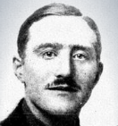

T. G. Millner (1887-1986) received his first commission In the Australian Army Service Corps in 1910, and was attached to the 8th West Sydney Company, and went to the front with the 2nd Army Service Corps under General Bridges. He was reported wounded in June 1915, in the Dardanelles. He enlisted for WWII in July 1942, service no. NX100031, his last rank being Lieutenant Colonel.

The 1930 Electoral Roll lists Thomas George Millner (mgr. dir.) and Mary Millner (nee Pattinson) at “Boambee,” The Boulevarde, Cheltenham. Their only child was James Sinclair Millner. A live-in domestic servant would occasionally be employed.

**15 The Boulevard 1941**

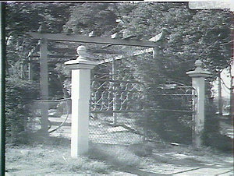

In 1972 Thomas George and Mary Millner were still living at 15 The Boulevard, Cheltenham.

The house was last sold in 2013.1

**Bibliography:**

1 [15 The Boulevard, Cheltenham, NSW 2119 - Property Details (realestate.com.au)](https://www.realestate.com.au/sold/property-house-nsw-cheltenham-114699291)

**Resources available (varies):**

* Sands Directories 1858-1933 City of Sydney [Sands Postal Directory | City of Sydney Archives (nsw.gov.au)](https://archives.cityofsydney.nsw.gov.au/nodes/view/495003)
* Newspaper articles – TROVE - [Search - Trove (nla.gov.au)](https://trove.nla.gov.au/search/advanced/category/newspapers)
* Ancestry.com (subscription only) [Genealogy, Family Trees and Family History Records online - Ancestry.com](https://www.ancestry.com.au/) – Sands Directories, Electoral Rolls, Family photos (Public Member photos), Census lists, marriage details, + miscellaneous
* N.S.W. Births, Deaths & Marriages [Family history search | NSW Government](https://www.nsw.gov.au/family-and-relationships/family-history-search) (QLD & Victoria also obtainable online)
* House photos and information via Hornsby Shire Council website for Property Search and Heritage Register [Heritage | Hornsby Shire Council (nsw.gov.au)](https://www.hornsby.nsw.gov.au/property/build/heritage)
* House photos and associated information via Internet search on address via Real Estate websites (from 2005)
* “Beecroft and Cheltenham Heritage Walks” - Beecroft-Cheltenham History Group Inc. 2004 book (1st edition)
* Australian War Museum website [Home | Australian War Memorial (awm.gov.au)](https://www.awm.gov.au/)
* Beecroft and Cheltenham History Group website [Beecroft and Cheltenham History - Beecroft Cheltenham History Group (bchg.org.au)](https://bchg.org.au/)