**150 BEECROFT ROAD, CHELTENHAM (“Lauriston”, prev. “Fremblik”)**

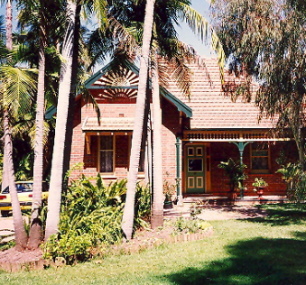

Lot 2 DP 373724

**Hornsby Shire Council details**

**Heritage Register: Item No. 260**

An impressive Federation period house built for Christen Nielsen Lykke (1851-1946) who arrived in 1877 at Sydney aboard the ship “Trevelyan,” a carpenter, aged 26, born Denmark. He married Ada J. Wilkinson in 1881 and later that year rented a workshop for cabinet-making. In 1891 he purchased the land on which “Fremblik” was built – Register Book Vol.1015 Fol. 179, Field of Mars, 4 acres 1 rood. By 1893 he was listed as cabinet-maker at Darlington, Sydney, where he lived for some years.

*[“Fremblik” is a Danish word meaning “Presentation”]*

The 1901 Cheltenham Park Estate Subdivision created lots for sale along the Beecroft Road, Mason Avenue, Kent Road (later Cheltenham Road) and Boronia Avenue.

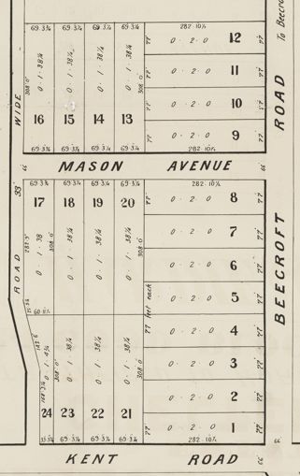

**“Fremblik” was described in May 1902, as follows:**

‘Mr. C. Lykke's recently erected [home] at Fremblik, at the junction of Murray-road and the main Beecroft-road, deserves more than passing mention. It is a large eight-roomed house, built of faced bricks of Croydon make, with tiled roof, and gabled, somewhat after the Elizabethan style. The verandahs and gables are finished with ornamental work, which contrasts well with the red brick of the body of the building, and viewed from the road the house presents a neat and picturesque appearance. The interior, too, is quite in keeping with the outward semblance, and evidence a more than ordinary appreciation of the beautiful as well as the useful. There are stained glass windows, of artistic design, a Corinthian arch in the hall, and handsome centre pieces to the ceilings in the chief rooms, and there is much good taste displayed in the way in which the interior is painted and finished. The northerly aspect provides that every room except the kitchen shall receive its due share of sunshine, and the situation of the bathroom, at the end of the back verandah, obviates the dangers arising from the damp incidental to a room used for such purpose. The land embraces an area of four and a half acres, part being under orchard, and vegetable garden, and the remainder bush. When the flower gardens are laid out, and the planting of ornamental trees and hedge plants completed, this will be one of the prettiest properties in the district; and Mr. Lykke and his family are very decent folk, genial and homely, and in every way worthy of the recherche home which they have built for themselves.’1

In late 1904 Mr. Lykke sold “Fremblik” to Mr. Perry (of the Australian Drug Company), who moved in at the commencement of the New Year.

*[Michael Joseph Thomas Perry (1872-1939) married Frances Elizabeth Maughn Newton in 1892 at Five Dock]*

The Land for Sale 1906 – Beecroft and Cheltenham Subdivision shows the residence of Mr. Perry.

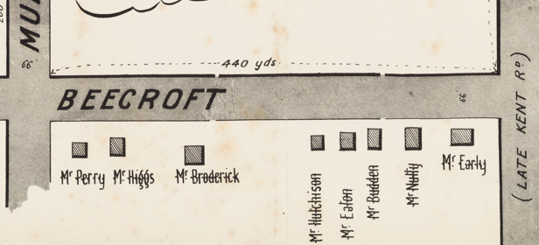

*(Mason Avenue is not shown although it did exist in 1901)*

The Mount Pleasant Estate – Cheltenham (1st Subdivision) 1908 shows the house being occupied by Mr. Perry.

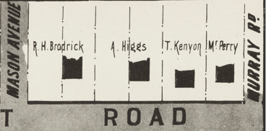

In 1913 Mr. Perry is described as a manufacturer. He also owned several cottages in the area, which he rented out.

In 1916 their son, Corporal Vernon Michael Stanley Perry, A.I.F., was wounded and by early 1918 had returned to Australia.

Sands Directories 1915-1919 Thomas Perry “Fremblik”; 1919-1932/3 Whitfield King “Lauriston”

1933 Electoral Roll: Raymond King No. 150

By early 1919 Whitfield King & family occupied the house, which was renamed “Lauriston,” perhaps named after Lauriston Castle in Edinburgh.

*[Whitfield King (1880-1949), married Lucy Manildra Miller 1905 Molong, N.S.W.]*

In 1933 he is described as a wool expert. His son Frederick was then described as a wool valuer.

In 1934 Mrs. King’s mother, Charlotte Miller, died at the residence, aged 84 years. She was formerly from the Manildra district.

In 1949 Whitfield (“Whit”) King died at “Lauriston.” His occupation is described as Wool Department Manager and Chief Valuer of Winchcombe, Carson Ltd., and was associated with the firm for 54 years. He was said to be consistently cheerful and pleasant to his associates, as well as being a veritable “tiger” for work. Having a valuable knowledge of sheep breeding, he had property in the Manildra-Parkes district, carrying approximately 2.000 sheep.

His wife, Lucy Manildra King, continued to live at “Lauriston” up to 1954 but later moved to Lindfield and died in 1973 within the district of St. Leonards.

**Whitfield, Lucy, Fred & Ray King Whitfield & Lucy King**

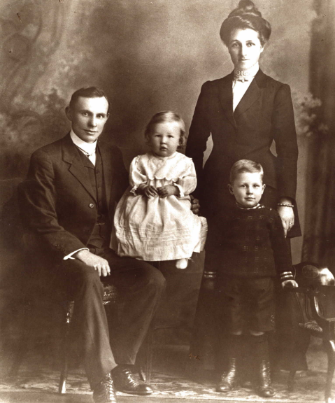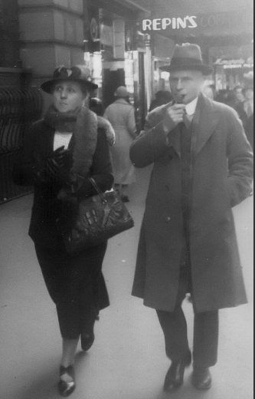

**Bibliography:**

1 Cumberland Argus 24 May 1902

**Resources available (varies):**

* Sands Directories 1858-1933 City of Sydney [Sands Postal Directory | City of Sydney Archives (nsw.gov.au)](https://archives.cityofsydney.nsw.gov.au/nodes/view/495003)
* Newspaper articles – TROVE - [Search - Trove (nla.gov.au)](https://trove.nla.gov.au/search/advanced/category/newspapers)
* Ancestry.com (subscription only) [Genealogy, Family Trees and Family History Records online - Ancestry.com](https://www.ancestry.com.au/) – Sands Directories, Electoral Rolls, Family photos (Public Member photos), Census lists, marriage details, + miscellaneous
* N.S.W. Births, Deaths & Marriages [Family history search | NSW Government](https://www.nsw.gov.au/family-and-relationships/family-history-search) (QLD & Victoria also obtainable online)
* House photos and information via Hornsby Shire Council website for Property Search and Heritage Register [Heritage | Hornsby Shire Council (nsw.gov.au)](https://www.hornsby.nsw.gov.au/property/build/heritage)
* House photos and associated information via Internet search on address via Real Estate websites (from 2005)
* “Beecroft and Cheltenham Heritage Walks” - Beecroft-Cheltenham History Group Inc. 2004 book (1st edition)
* Australian War Museum website [Home | Australian War Memorial (awm.gov.au)](https://www.awm.gov.au/)
* Beecroft and Cheltenham History Group website [Beecroft and Cheltenham History - Beecroft Cheltenham History Group (bchg.org.au)](https://bchg.org.au/)