**152 BEECROFT ROAD, CHELTENHAM (“Quambi”, later “Chislehurst”)**

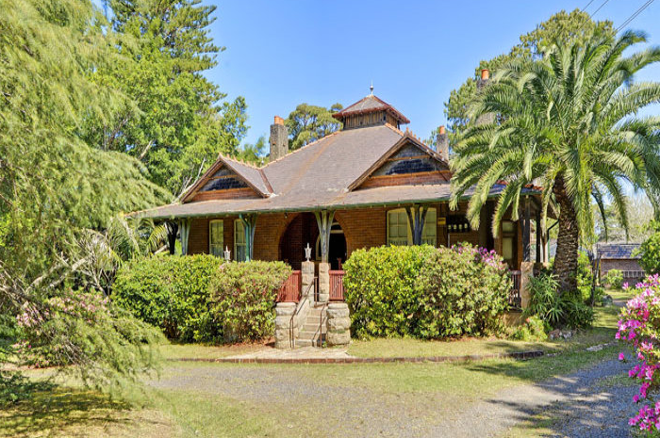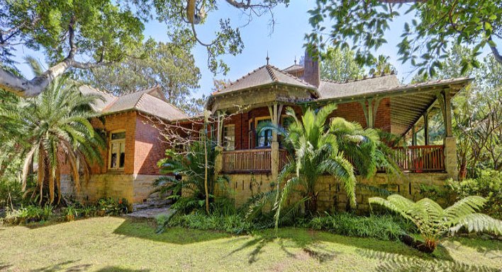

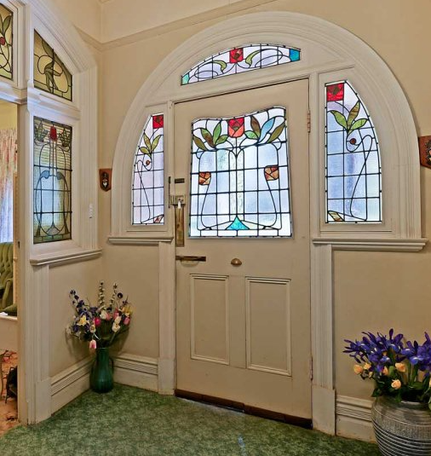

Lot 102 DP 600100

**Hornsby Shire Council details**

**Heritage Register: Item No. 261**

The name 'Quambi' means 'place of shelter', presumably an aboriginal word.

The 1901 Cheltenham Park Estate Subdivision created lots for sale along the Beecroft Road, Mason Avenue, Kent Road (later Cheltenham Road) and Boronia Avenue.

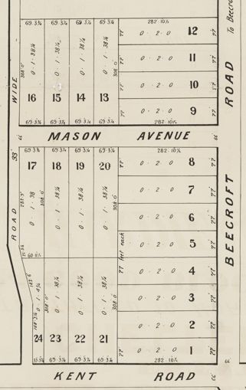

A large Federation Bungalow of fine quality design with distinctive features,

built between 1902-10.

The Land for Sale 1906 – Beecroft and Cheltenham Subdivision does not show the residence of Mr. Kenyon.

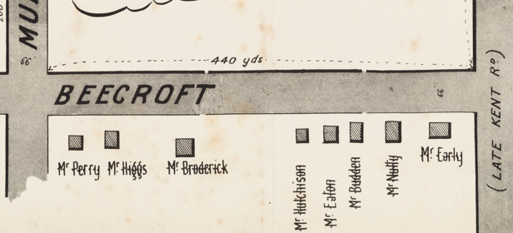

*(Mason Avenue is not shown although it did exist in 1901)*

The first known occupant was Thomas Sherington Kenyon in 1907.

*[Thomas [1863-1935] married Minnie Lavinia Smith in 1895, at Darlinghurst]*

The 1907-1909 Hornsby Council Rate Books mention him as owning a property on the Carlingford-road, Beecroft – 66ft x 200 ft. Also, another property on the Murray Road, Beecroft – 2 roods (1/2 acre).

The Mount Pleasant Estate – Cheltenham (1st Subdivision) 1908 shows the house being occupied by Mr. Kenyon.

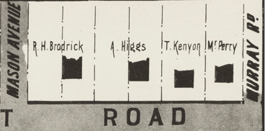

In 1909 Thomas Kenyon was a member of the Beecroft Progress Association.

In December 1910 Mrs. Kenyon, of “Quambi,” was advertising for a girl for housework and in August 1911 for a general servant.

In 1913 his occupation was a law-stationer, living in Beecroft-road, Cheltenham. His residence was referred to as “pretty,”

Sands Directories 1915-1920 Thomas Kenyon “Quambi”; 1921-1924 Dr. Jenner “Chislehurst: 1925-7 Shirlow Stewart “Chislehurst”; 1930-1932/3 G. Oliver “Chislehurst”

1933 Electoral Roll: Alice Oliver

In 1917 Minnie’s brother, Captain Louis Lionel Smith, of Melbourne, was killed in action in France.

The Mount Pleasant Estate – Cheltenham (1st Subdivision) 1908 shows the house being occupied by Mr. T. Kenyon.

In December 1919 the home was put up for sale. The property is described as a Beautiful Modern Brick Cottage, comprising 5 bedrooms, dining-room, and living-rooms, and all offices, verandahs on 3 sides, large sleeping-out loggia, large billiard-room, 18ft. high, tennis court, large swimming bath, also lawns. Fruit trees in full bearing. Motor garage, stables, and man and feed room. Own sewerage. Land, 154ft. x 300ft, with rose garden off the tennis court.1

The next owner was Dr. Wesley John Jenner (Lic. R. Coll. Phys. Edin., 1899; Lic. R. Coll. Surg. Edin., 1899; Lic. Fac. Phys. Surg. Glasg., 1899; F.R.C.S. Edin., 1916).

*[Wesley John Jenner married Annie Amelia Black, in 1900, district of Kiama]*

His wife, Annie, would involve herself with the Methodist Church, and believed in the importance of women's work, both in the Church and the home.

The house was renamed “**Chislehurst**,” probably after the Chislehurst Caves in Kent; his father, John Daniel Jenner, was born at Plumstead Common, Kent, in 1841.

Born at Bathurst in 1870, Dr. Wesley John Jenner was educated at Maitland High School, matriculated at Sydney University, and became a dispenser for Dr. Treloar, at the Bank Corner, Newcastle. When 24 he went to England, became a doctor at Edinburgh University, and later studied at Brussels University, where he obtained his Belgian M.D.

Returning to Australia, Dr. Jenner practised at Leichhardt for 15 or 20 years before practising for five years in London. When his father became ill in 1921, he came back to Australia and set up practice at Cheltenham.

Dr. Jenner put up the home for auction in April 1923. It was described as ‘a high-class, well-built cottage residence, in area 1 acre 28 perches, having 146 feet 8 inches frontage to BEECROFT-ROAD, by varying and considerable depth lines, WITH RIGHT-OF-WAY ENTRANCE to BORONIA-STREET, at rear. It contains hall, 5 fine main rooms, breakfast-room, maid's room, kitchen, bathroom (with tiled floor), laundry, and offices. Attached is substantial Building of brick on stone, containing excellent LARGE BILLIARD-ROOM and smaller apartment. Detached at rear is Building of weatherboards, tiled roof, containing 2 rooms, GARAGE (2 apartments) and loft. At rear in grounds are large SWIMMING BATH (about 25ft x 10ft), of brick and cement.’2

The reason for the sale was that Dr. Jenner, with Mrs. Jenner and their daughters, would be leaving for England, largely in the interests of their daughters' education, although the death of his father in October 1922 may have played a part in his decision.

In August 1923 all the household furniture was put up for auction.3

By early 1924 Dr. Jenner was practising in London.

Dr. W. J. Jenner died in 1948 at his residence at Plumstead, Kent, England, where he had built a home and surgery on land where his father's original home stood, and practised there until 10 years ago prior, when he retired.

“Chislehurst” was then occupied by Dr. Shirlow S. Stewart, medical practitioner, for several years.

By 1930 Dr. Charles Henry Oliver was residing at “Chislehurst”, no. 152 Beecroft-road. After studying at the Royal College of Surgeons, Dublin, he came to Australia in 1915. He practised in Weston and Blayney before coming to Cheltenham. In July 1932 Dr. Oliver died suddenly at his residence, aged 50 years.

His wife, Alice Mabel Oliver continued to live at “Chislehurst,” along with the presence of a gardener, Ernest Arthur Chambers.

In February 1935 the house was put up for auction.4

In April 1936 it again went to auction.5

In 1937 the house was occupied by Rupert Clarence Symons (builder), and a gardener, James Robert Goodin.

By 1943 it was occupied by William Barrington Rothwell and family.

In October 1954 the house was again put up for sale. It is described thus: ‘The RESIDENCE comprises 8 ROOMS, Including MAGNIFICENT BALLROOM with dome celling and stage. All rooms have fireplace. Large verandah space front and side, bathroom. 2 toilets, shower-room, well-appointed kitchen, driveway, and garage buildings at rear. Tennis court and small concrete swimming pool (both out of use).

Land: Comprises an area of about 1 ¼ acres and is attractively laid out in lawns and gardens. Frontage of about 146ft 8in x irreg. depths, with 10ft R O.W. to Boronia Avenue at rear.’6

The house was again put up for sale in 2013.7

**Bibliography:**

1 Daily Telegraph, 6th Dec 1919

2 Sydney Morning Herald, 4th April 1923

3 Sydney Morning Herald, 18th Aug 1923

4 Daily Telegraph, 13th Feb 1935

5 Sydney Morning Herald, 1st April 1936

6 Sydney Morning Herald, 6 Oct 1954

7 [152 Beecroft Road, Cheltenham, NSW 2119 - realestate.com.au](https://www.realestate.com.au/property/152-beecroft-rd-cheltenham-nsw-2119/)

**Resources available (varies):**

* Sands Directories 1858-1933 City of Sydney [Sands Postal Directory | City of Sydney Archives (nsw.gov.au)](https://archives.cityofsydney.nsw.gov.au/nodes/view/495003)
* Newspaper articles – TROVE - [Search - Trove (nla.gov.au)](https://trove.nla.gov.au/search/advanced/category/newspapers)
* Ancestry.com (subscription only) [Genealogy, Family Trees and Family History Records online - Ancestry.com](https://www.ancestry.com.au/) – Sands Directories, Electoral Rolls, Family photos (Public Member photos), Census lists, marriage details, + miscellaneous
* N.S.W. Births, Deaths & Marriages [Family history search | NSW Government](https://www.nsw.gov.au/family-and-relationships/family-history-search) (QLD & Victoria also obtainable online)
* House photos and information via Hornsby Shire Council website for Property Search and Heritage Register [Heritage | Hornsby Shire Council (nsw.gov.au)](https://www.hornsby.nsw.gov.au/property/build/heritage)
* House photos and associated information via Internet search on address via Real Estate websites (from 2005)
* “Beecroft and Cheltenham Heritage Walks” - Beecroft-Cheltenham History Group Inc. 2004 book (1st edition)
* Australian War Museum website [Home | Australian War Memorial (awm.gov.au)](https://www.awm.gov.au/)
* Beecroft and Cheltenham History Group website [Beecroft and Cheltenham History - Beecroft Cheltenham History Group (bchg.org.au)](https://bchg.org.au/)