**154 BEECROFT ROAD, CHELTENHAM (“Mulwaree”, prev. “Maroo”)**

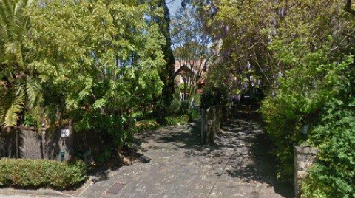

Lot B DP 39634

**Hornsby Shire Council details**

**Heritage Register: (NONE)**

*“Mulwaree”* was built in 1902 for Alfred Higgs by the architect Joseph Seale. It has an interesting mix of roofing materials: Marseilles tiles on the main roof, slate on the verandah roof and timber shingles on the gable ends. The double garage with billiard room is an addition.1

“Mulwaree” is an aboriginal word for ‘long water.’ It is also the name of one of the aboriginal tribes that lived near the town of Goulburn.

“Maroo,” also referred to as “Norroo,” “Noroo,” and “Marroo,” cannot be determined.

Part of Cheltenham Park Estate Subdivision 1901

The 1901 Cheltenham Park Estate Subdivision created lots for sale along the Beecroft Road, Mason Avenue, Kent Road (later Cheltenham Road) and Boronia Avenue.

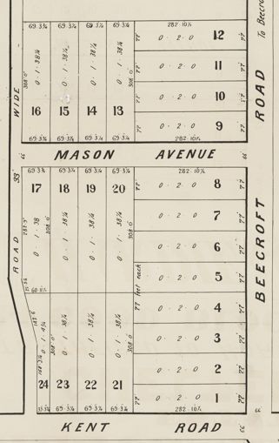

The Land for Sale 1906 – Beecroft and Cheltenham Subdivision shows the residence of Mr. Higgs.

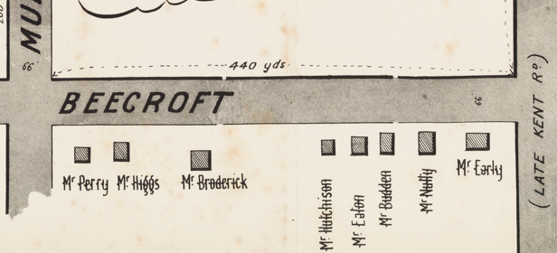

*(Mason Avenue is not shown although it did exist in 1901)*

The Mount Pleasant Estate – Cheltenham (1st Subdivision) 1908 shows the house being occupied by A. Hicks.

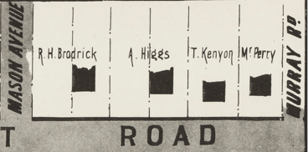

In 1913 the residence was still occupied by Alfred Higgs (clerk), his wife Alice Mary Higgs, and sister-in-law, Emmeline Apperley. The home was then called “Maroo.” Later that year Alfred’s wife, Alice Mary, died. She was a prominent worker at St. John’s Church, Beecroft.

*[Alfred Higgs (c1873-1942) married Alice Mary Apperly 14th Jan 1903 Hurstville]*

Alfred did not remarry. His sister-in-law, Emmeline, continued to live in the house until her death there in 1940.

Sands Directories 1932/3: Alfred Higgs “Maroo”

Electoral Roll 1933: Alfred Higgs No. 154

In 1942 Alfred Higgs also died there. In 1943 the house was occupied by Alfred’s daughter, Margaret, and his son, Arthur. By 1949 the house had been sold and both Margaret and Arthur were living at 2 The Boulevard, Cheltenham.

**Bibliography:**

1 BCHS Walks book reference (2004)

**Resources available (varies):**

* Sands Directories 1858-1933 City of Sydney [Sands Postal Directory | City of Sydney Archives (nsw.gov.au)](https://archives.cityofsydney.nsw.gov.au/nodes/view/495003)
* Newspaper articles – TROVE - [Search - Trove (nla.gov.au)](https://trove.nla.gov.au/search/advanced/category/newspapers)
* Ancestry.com (subscription only) [Genealogy, Family Trees and Family History Records online - Ancestry.com](https://www.ancestry.com.au/) – Sands Directories, Electoral Rolls, Family photos (Public Member photos), Census lists, marriage details, + miscellaneous
* N.S.W. Births, Deaths & Marriages [Family history search | NSW Government](https://www.nsw.gov.au/family-and-relationships/family-history-search) (QLD & Victoria also obtainable online)
* House photos and information via Hornsby Shire Council website for Property Search and Heritage Register [Heritage | Hornsby Shire Council (nsw.gov.au)](https://www.hornsby.nsw.gov.au/property/build/heritage)
* House photos and associated information via Internet search on address via Real Estate websites (from 2005)
* “Beecroft and Cheltenham Heritage Walks” - Beecroft-Cheltenham History Group Inc. 2004 book (1st edition)
* Australian War Museum website [Home | Australian War Memorial (awm.gov.au)](https://www.awm.gov.au/)
* Beecroft and Cheltenham History Group website [Beecroft and Cheltenham History - Beecroft Cheltenham History Group (bchg.org.au)](https://bchg.org.au/)