**156 BEECROFT ROAD, CHELTENHAM**

New House on site.

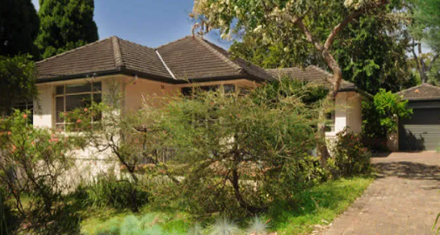

Lot A DP 396364

**REFER 6 MASON AVENUE -** Access to this property was originally through 156 Beecroft-road.

**Hornsby Shire Council details**

**Heritage Register: (NONE)**

Part of Cheltenham Park Estate Subdivision 1901.