**157 BEECROFT ROAD, CHELTENHAM (“Mossbrae”, prev. “The Cottage” & “Cotopaxi”)**

**Alternate Address(es):11A Murray Road BEECROFT NSW 2119**

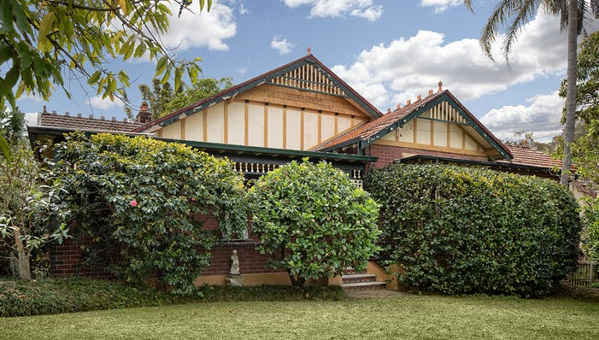

157 Beecroft Road Lot 1 DP 311458

Lot 2 DP 7132

Pt Lot 3 DP 7132

11a Murray Road Lot 1 DP 311458

Lot 2 DP 7132

Pt Lot 3 DP 7132

**Hornsby Shire Council details**

**Heritage Registry: Item No. 262**

A large Federation bungalow located on a corner block.

In 1913 it was the home of William Henry Sargent (merchant), Mary Ann Sargent (dom. duties), Edith May Sargent – “The Cottage,” Cheltenham

*[William H. Sargent (c.1833-1917) married Mary Ann Parsons in 1870, Sydney]*

In 1914 Mrs. Sargent died at “The Cottage” in 1914, aged 72 years, of heart trouble of 2 years, and was survived by her husband, one married daughter & a single daughter (Edith). Mary Ann Sargent had been connected with the local Presbyterian Church for a number of years.

Sands Directories 1915-16 Wm. H. Sargent “The Cottage”; 1918 J. Chamberlain; 1924-32/33 Walter Rothwell “Cotopaxi” No. 157

Electoral Roll 1933: Walter Rothwell

William moved from Cheltenham after the death of his wife and died in 1917 at Waverley, aged 94 years.

In 1917 “The Cottage” was occupied by Albert E. Dudney.

By 1925 it was the home of Walter & Christina Rothwell.

*[Walter Rothwell married Christina Elma (or Ellina) Shipham in 1911, Burwood]*

It was now named “Cotopaxi,” probably after an active volcano in Ecuador, South America.

In 1920 they had been living at Boronia-avenue, Cheltenham, the house also called “Cotopaxi.”

In 1928 they advertised for a General Help.

By 1932 the address of the Rothwells is recorded as 157 Beecroft-road, Cheltenham. Walter was then working as a commercial traveller. Between 1936 and 1940 Walter was selling from his home orchids and flowering plants.

In 1937 Walter was unemployed but later returned to his usual occupation of commercial traveller.

Walter and Christina continued to live at his address until 1958.

Walter died 1960 in the district of Taree. Christina died in 1976.

The house was last sold in 2022, now named “Mossbrae.”1

**Bibliography:**

**1** [157 Beecroft Road, Cheltenham, NSW 2119 - Property Details (realestate.com.au)](https://www.realestate.com.au/sold/property-house-nsw-cheltenham-137482698)

**Resources available (varies):**

* Sands Directories 1858-1933 City of Sydney [Sands Postal Directory | City of Sydney Archives (nsw.gov.au)](https://archives.cityofsydney.nsw.gov.au/nodes/view/495003)
* Newspaper articles – TROVE - [Search - Trove (nla.gov.au)](https://trove.nla.gov.au/search/advanced/category/newspapers)
* Ancestry.com (subscription only) [Genealogy, Family Trees and Family History Records online - Ancestry.com](https://www.ancestry.com.au/) – Sands Directories, Electoral Rolls, Family photos (Public Member photos), Census lists, marriage details, + miscellaneous
* N.S.W. Births, Deaths & Marriages [Family history search | NSW Government](https://www.nsw.gov.au/family-and-relationships/family-history-search) (QLD & Victoria also obtainable online)
* House photos and information via Hornsby Shire Council website for Property Search and Heritage Register [Heritage | Hornsby Shire Council (nsw.gov.au)](https://www.hornsby.nsw.gov.au/property/build/heritage)
* House photos and associated information via Internet search on address via Real Estate websites (from 2005)
* “Beecroft and Cheltenham Heritage Walks” - Beecroft-Cheltenham History Group Inc. 2004 book (1st edition)
* Australian War Museum website [Home | Australian War Memorial (awm.gov.au)](https://www.awm.gov.au/)
* Beecroft and Cheltenham History Group website [Beecroft and Cheltenham History - Beecroft Cheltenham History Group (bchg.org.au)](https://bchg.org.au/)