**158 BEECROFT ROAD, CHELTENHAM (“Rutherglen”)**

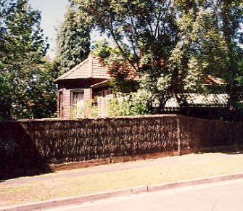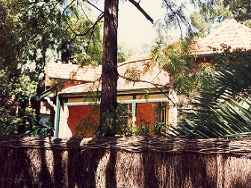

158 Beecroft Road Lot 4 DP 530116

1B Mason Avenue Lot 4 DP 530116

**Hornsby Shire Council details**

**Heritage Register**: Item No. 263

“Rutherglen,” a fine quality Federation period house on the corner of Beecroft-road and Mason-avenue, Cheltenham, the original owner and probable builder being Neil Livingston, builder, born 1845 at Rutherglen, Lanarkshire, Scotland.

Part of Cheltenham Park Estate Subdivision 1901

The 1901 Cheltenham Park Estate Subdivision created lots for sale along the Beecroft Road, Mason Avenue, Kent Road (later Cheltenham Road) and Boronia Avenue.

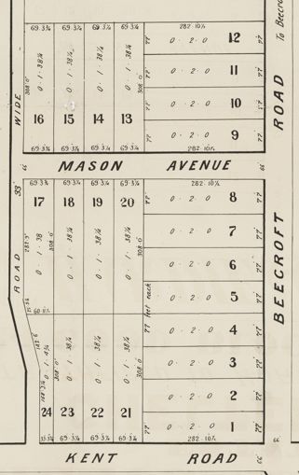

In March 1907 he commenced the creation of two villa residences at Cheltenham, most likely one of which was “Rutherglen.”

Neil married Catherine Grace McPhail at Dapto in early 1907. Both were heavily involved with the Presbyterian Church over many years.

He had previously been married to Agnes, who died in March 1904 at Leichhardt, aged 60 years, leaving 5 children. There were no children to this marriage.

The Land for Sale 1906 – Beecroft and Cheltenham Subdivision does not show the residence of Mr. Livingston.

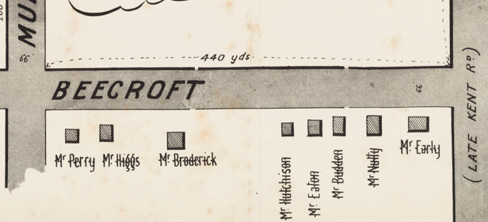

*(Mason Avenue is not shown although it did exist in 1901)*

The Mount Pleasant Estate – Cheltenham (1st Subdivision) 1908 shows the house being occupied by Mr. Livingston.

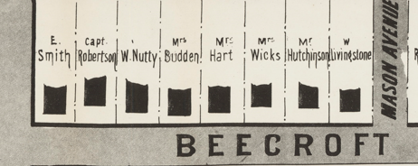

**Neil & Kate Livingston 1914**

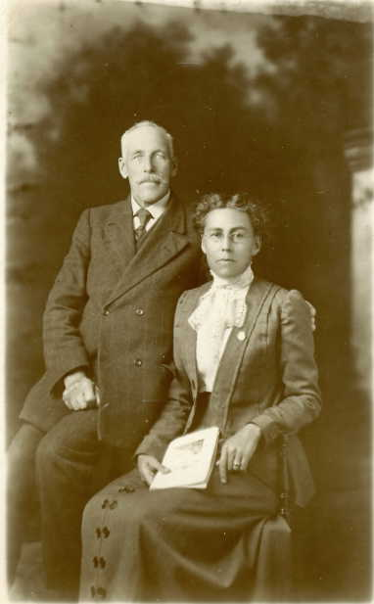

The Mount Pleasant Estate – Cheltenham (2nd Subdivision) 1918 shows the house being occupied by Mr. Livingston.

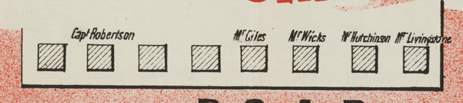

In 1920 he moved to “Oban,” 1 Mason-avenue, immediately behind “Rutherglen,” which was purchased by John Dickson Copes.

Sands Directories 1915-17 Neil Livingston “Rutherglen”; 1918-1931 John Copes “Rutherglen”; 1932/3 Mrs. F. Copes

1933 Electoral Roll: Flora Copes No. 158

Mr. Copes died in 1927. His wife Flora Dale Copes continued to live in the house until the early 1930’s and by 1935 had moved to Croydon and Arthur Thomas Hannam, company director, moved into “Rutherglen.”

In 1939 the deceased estate of John Dickson Copes was finalised by the Permanent Trustees Co. of N.S.W. Ltd and “Rutherglen” was auctioned. The house is described thus:

*"Rutherglen," No. 158 Beecroft Road, at corner of Mason Avenue, comprising a Detached Double-fronted Cottage, built of brick, tuck-pointed front, tiled roof, having tiled verandah to part front, wide sleep-out verandah on one side, verandah at rear, and containing hall, 5 rooms, bathroom, pantry. kitchen, laundry. Detached weatherboard and iron Garage. Electric light, gas, water connected. Land 77ft frontage to Beecroft Road, 141 feet 5 Inches to Mason Avenue. Torrens Title.1*

By 1943 Bernard Theodore Ruting (clerk) and family were living in “Rutherglen.”

**Bibliography:**

1 Sydney Morning Herald, 8th July 1939

**Resources available (varies):**

* Sands Directories 1858-1933 City of Sydney [Sands Postal Directory | City of Sydney Archives (nsw.gov.au)](https://archives.cityofsydney.nsw.gov.au/nodes/view/495003)
* Newspaper articles – TROVE - [Search - Trove (nla.gov.au)](https://trove.nla.gov.au/search/advanced/category/newspapers)
* Ancestry.com (subscription only) [Genealogy, Family Trees and Family History Records online - Ancestry.com](https://www.ancestry.com.au/) – Sands Directories, Electoral Rolls, Family photos (Public Member photos), Census lists, marriage details, + miscellaneous
* N.S.W. Births, Deaths & Marriages [Family history search | NSW Government](https://www.nsw.gov.au/family-and-relationships/family-history-search) (QLD & Victoria also obtainable online)
* House photos and information via Hornsby Shire Council website for Property Search and Heritage Register [Heritage | Hornsby Shire Council (nsw.gov.au)](https://www.hornsby.nsw.gov.au/property/build/heritage)
* House photos and associated information via Internet search on address via Real Estate websites (from 2005)
* “Beecroft and Cheltenham Heritage Walks” - Beecroft-Cheltenham History Group Inc. 2004 book (1st edition)
* Australian War Museum website [Home | Australian War Memorial (awm.gov.au)](https://www.awm.gov.au/)
* Beecroft and Cheltenham History Group website [Beecroft and Cheltenham History - Beecroft Cheltenham History Group (bchg.org.au)](https://bchg.org.au/)