**16-18 CHELTENHAM ROAD, CHELTENHAM (“Mornington”)**

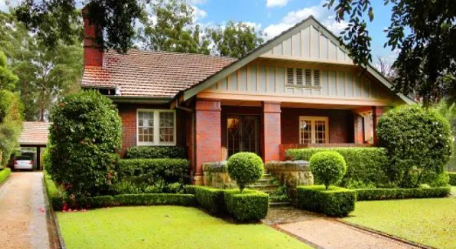

16 Cheltenham Road Lot 2 DP 1289727

18 Cheltenham Road Lot 1 DP 1289727

**Hornsby Shire Council details**

**Heritage Register: (NONE)**

Part of Mount Pleasant Estate – Cheltenham 3rd Subdivision 1924

Sands Directories 1925-1932/33 Charles Potts “Trelawney”

Electoral Roll 1933: Charles Potts No. 20

In 1920 Merton Alan Potts, son of Mr. & Mrs. Charles John Potts, of “Mornington,” The Boulevard, Cheltenham, was married to Dorothy Clarke, of Woolwich.

*[Charles J. Potts married Madeline C. M. Clarke in 1888, district of Murrumburrah]*

In 1928 Keith Potts, youngest son of Mr. & Mrs. C. J. Potts, of “Mornington” was married to Meryl Bertram, only daughter of Mr. & Mrs. David Bertram, of “Maida Vale,” The Boulevard, Cheltenham.

In 1933 occupants of “Mornington” were Charles John Potts (produce merchant), Madeline Connie Matilda Potts, Mona Lily Potts, Edwin Lloyd Potts (clerk) and Keith Gibson Potts (salesman) – 20 Cheltenham-road, Cheltenham.

The family were still at 20 Cheltenham-road in 1936, but had moved to Ryde East by 1937.

[NOTE: The house “By-Way,” 20 Cheltenham-road, Cheltenham was not built until 1938. It could be assumed that Mr. Potts owned the land on lot No. 20, adjoining lots nos. 16-18 where “Mornington” is situated so the house number is fluid. He most likely sold the no. 20 land after his departure from Cheltenham.]

In 1941 Charles John Potts, aged 83 years, died suddenly at his home at Blackheath. He was survived by Mrs. Potts and five sons. He was well-known as proprietor of C. J. Potts and Coy., Sussex-street, Sydney.

**Bibliography:**

1

**Resources available (varies):**

* Sands Directories 1858-1933 City of Sydney [Sands Postal Directory | City of Sydney Archives (nsw.gov.au)](https://archives.cityofsydney.nsw.gov.au/nodes/view/495003)
* Newspaper articles – TROVE - [Search - Trove (nla.gov.au)](https://trove.nla.gov.au/search/advanced/category/newspapers)
* Ancestry.com (subscription only) [Genealogy, Family Trees and Family History Records online - Ancestry.com](https://www.ancestry.com.au/) – Sands Directories, Electoral Rolls, Family photos (Public Member photos), Census lists, marriage details, + miscellaneous
* N.S.W. Births, Deaths & Marriages [Family history search | NSW Government](https://www.nsw.gov.au/family-and-relationships/family-history-search) (QLD & Victoria also obtainable online)
* House photos and information via Hornsby Shire Council website for Property Search and Heritage Register [Heritage | Hornsby Shire Council (nsw.gov.au)](https://www.hornsby.nsw.gov.au/property/build/heritage)
* House photos and associated information via Internet search on address via Real Estate websites (from 2005)
* “Beecroft and Cheltenham Heritage Walks” - Beecroft-Cheltenham History Group Inc. 2004 book (1st edition)
* Australian War Museum website [Home | Australian War Memorial (awm.gov.au)](https://www.awm.gov.au/)