**160 BEECROFT ROAD, CHELTENHAM (“Madeley”, prev. “Charlton”)**

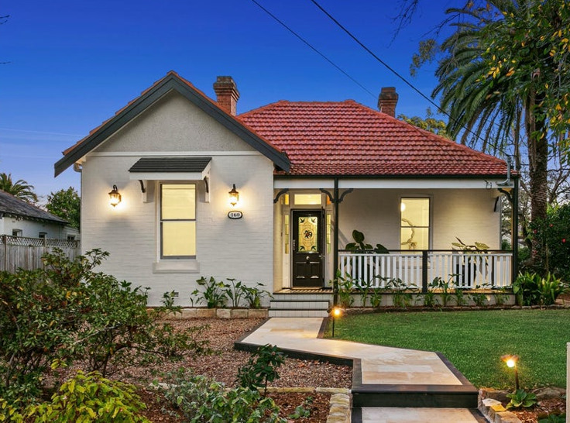

Lot 2 DP 203368

**Hornsby Shire Council details:**

**Heritage Register: (NONE)**

Part of Cheltenham Park Estate Subdivision 1901

The 1901 Cheltenham Park Estate Subdivision created lots for sale along the Beecroft Road, Mason Avenue, Kent Road (later Cheltenham Road) and Boronia Avenue.

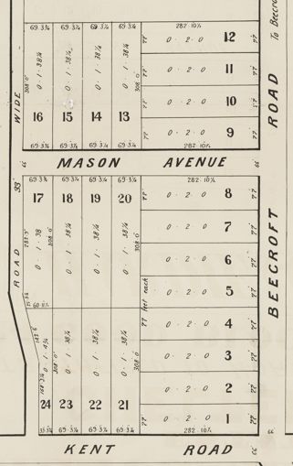

The Land for Sale 1906–Beecroft and Cheltenham Subdivision shows the residence of Mr. Hutchison.

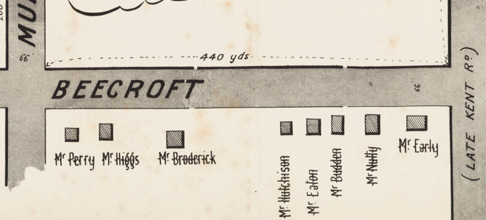

*(Mason Avenue is not shown although it did exist in 1901)*

The Mount Pleasant Estate – Cheltenham (1st Subdivision) 1908 shows the house being occupied by Mr. Hutchinson (Hutchison?).

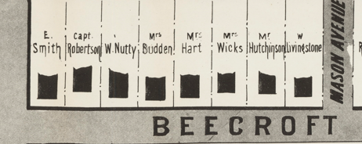

*[The 1901 Census for the district of Beecroft lists a John Hutchison with a household of 2 males and 2 females.]*

By 1913 Alexander Gazer Campbell (accountant) & his wife Catherine Elizabeth Campbell were living in the property.

In that year a Marjorie Hutchison (saleswoman) was living at The Boulevard, Cheltenham. By 1915 she had left the district.

By 1915 the house was referred to by the name “Charlton.”

1915-1923 Alex Campbell “Charlton”; 1924-7 Mrs. O. E. Campbell “Charlton”; 1930-1932/3 B. C. Hughes “Madeley”

1933 Electoral Roll: Basil Hughes No. 160

**Alexander Gaiser Campbell (1864-1918) & Catherine Elizabeth Campbell**

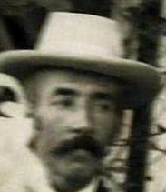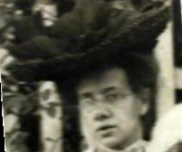

Alexander Campbell died at Sydney Hospital in June 1918.

The Mount Pleasant Estate – Cheltenham (2nd Subdivision) 1918 shows the house being occupied by Mr. Hutchinson.

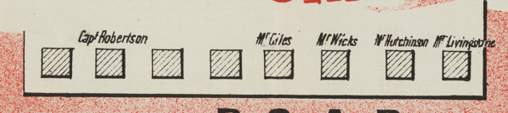

In October 1923 the house was put up for auction, and described as follows:

*"CHARLTON," BEECROFT-ROAD,*

*between Cheltenham-road and Mason-avenue, close to Station.*

*Det. D.F. COTTAGE, of brick on stone, tiled roof, front, side, and rear verandahs, hall, drawing, dining, and breakfast room, 3 bedrooms, kitchen, gas and fuel stoves, bathroom (bath and basin), pantry, laundry, and all conveniences, fowl runs, bush-house, cow shed, and a number of fruit-bearing trees. LAND, about 77ft by 288ft. TITLE TORRENS.1*

The sale was apparently unsuccessful as Mrs. Campbell & a daughter continued to live at the residence until it was again put up for sale in 1926, described as follows:

*FOR POSITIVE SALE - OWNER LEAVING THE DISTRICT.*

*(1) CHELTENHAM, on the Highlands.*

*"CHARLTON." a double-fronted Cottage, fronting BEECROFT-ROAD {nearly opposite the Promenade}, built of brick, tuckpointed front, hating verandah front, wide sleeping-out verandah at rear, and containing hall, 6 rooms, bathroom, pantry, kitchen, laundry, land 77 x 288 feet. TORRENS TITLE. SMALL ORCHARD at rear, occupied by Mrs. Campbell.2*

“Charlton” passed into the hands of Basil Brooke Childe Hughes (retired headmaster) and was renamed “Madeley,” either a place-name or family-name.

*[B. B. C. Hughes (1865-1947) married Annie Norman at Corowa, 1889]*

**Basil Brooke Childe Hughes, wife Annie & child**

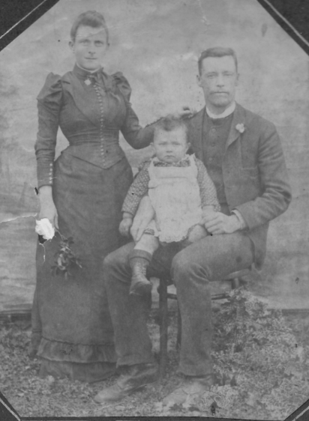

In 1933 their daughter, Elizabeth Ruth Childe Hughes, aged 29 years, died at her parents’ residence.

The Brooke family continued to live at “Madeley.”

In 1947 Basil B. C. Hughes died, aged 80 years, at his Cheltenham residence, leaving 4 surviving children and his widow. He was, for many years, in charge of the Berrigan public school. He was said to have been an excellent teacher, and a gentleman highly esteemed and respected both by pupils and the general public.

The house was last sold in 2022.3

**Bibliography:**

1 Sydney Morning Herald, 31st October 1923

2 Sydney Morning Herald, 15th March 1926

3 [160 Beecroft Road, Cheltenham NSW 2119 | Domain](https://www.domain.com.au/160-beecroft-road-cheltenham-nsw-2119-2018644101)

**Resources available (varies):**

* Sands Directories 1858-1933 City of Sydney [Sands Postal Directory | City of Sydney Archives (nsw.gov.au)](https://archives.cityofsydney.nsw.gov.au/nodes/view/495003)
* Newspaper articles – TROVE - [Search - Trove (nla.gov.au)](https://trove.nla.gov.au/search/advanced/category/newspapers)
* Ancestry.com (subscription only) [Genealogy, Family Trees and Family History Records online - Ancestry.com](https://www.ancestry.com.au/) – Sands Directories, Electoral Rolls, Family photos (Public Member photos), Census lists, marriage details, + miscellaneous
* N.S.W. Births, Deaths & Marriages [Family history search | NSW Government](https://www.nsw.gov.au/family-and-relationships/family-history-search) (QLD & Victoria also obtainable online)
* House photos and information via Hornsby Shire Council website for Property Search and Heritage Register [Heritage | Hornsby Shire Council (nsw.gov.au)](https://www.hornsby.nsw.gov.au/property/build/heritage)
* House photos and associated information via Internet search on address via Real Estate websites (from 2005)
* “Beecroft and Cheltenham Heritage Walks” - Beecroft-Cheltenham History Group Inc. 2004 book (1st edition)
* Australian War Museum website [Home | Australian War Memorial (awm.gov.au)](https://www.awm.gov.au/)