**162 BEECROFT ROAD, CHELTENHAM (“Crichel”, prev. “Carinya”)**

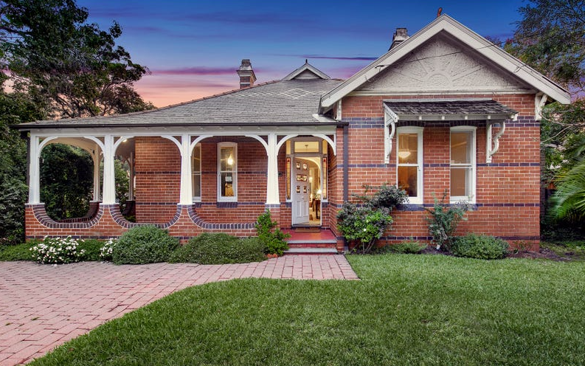

Lot 61 DP 590250

**Hornsby Shire Council details:**

**Heritage Register: (NONE)**

Part of Cheltenham Park Estate Subdivision 1901

The 1901 Cheltenham Park Estate Subdivision created lots for sale along the Beecroft Road, Mason Avenue, Kent Road (later Cheltenham Road) and Boronia Avenue.

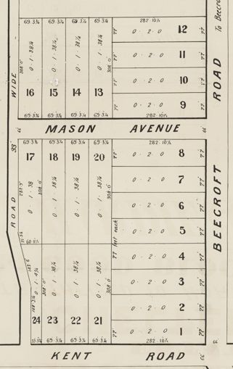

The Land for Sale 1906–Beecroft and Cheltenham Subdivision shows the residence of Mr. Eaton. This is between Mr. Hutchinson No.160 and Mr. Budden No. 166 so Mr. Eaton’s house could be No. 162 or No. 164).

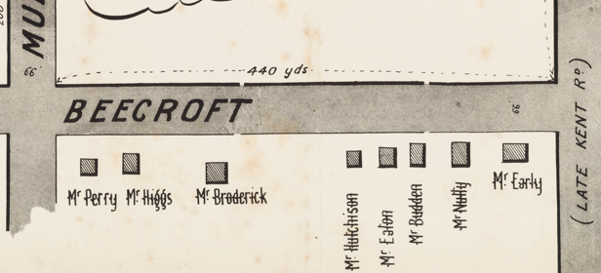

*(Mason Avenue is not shown although it did exist in 1901)*

The Mount Pleasant Estate – Cheltenham (1st Subdivision) 1908 shows the house being occupied by Mrs. Wicks.

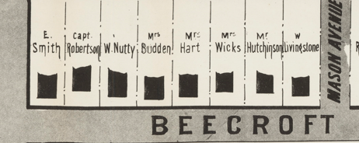

The 1913 Electoral Roll lists Henry Wicks (engineer), Mary Wicks, Mary Wicks junior, Percy Herbert Wicks (council clerk) at this property.

The 1915 Sands Directory refers to this property as “Carinya,” an aboriginal word meaning ‘happy home.’

Sands Directory 1915-18 Henry Wicks “Caringa”; 1919-1932/3 William R. Cave “Caringa”

Electoral Roll 1933: Helen Millner No. 162

The Mount Pleasant Estate – Cheltenham (2nd Subdivision) 1918 shows the house being occupied by Mr. Wicks.

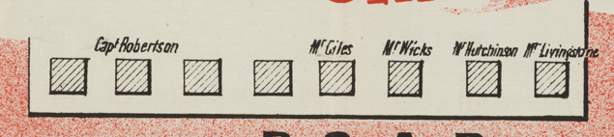

By the end of 1918 the Wicks family had moved to Lewisham and the house was occupied by William Reginald Cave.

It was put up for auction in 1927, as the owner was to leave the State, and described as follows:

*A MODERN Detached, Double-fronted Brick COTTAGE, SPLENDIDLY BUILT AND IN EXCELLENT CONDITION. Having tiled verandah in front, and containing hall and cross hall, 6 good rooms, kitchen, pantry, bathroom and linen press. Large open verandah at rear. ELECTRIC LIGHT.*

*THE LAND has 70ft frontage to the south side of Murray-road x 165, rear line 77. Brick ornamental fence in front. TORRENS.1*

However, the house was not sold and the Cave family remained.

The 1932 Electoral Roll lists as occupants: William Reginald Cave (manager), Elizabeth Ethel Cave, Gordon Rigby Cave (carpenter) – “Carinya,” Beecroft-road, Beecroft

“Carinya’ was again put up for sale in June 1932, stating again that the owner was leaving the State, described as follows:

*CHELTENHAM. - Modern Dwelling, 7 rooms, all conveniences, large garage, and other outbuildings. Land 77ft x 2B2ft. All brick, slate roof, tile ridging. Ironite verandah floors front and back. Electric light. House and grounds in thorough order. Nice garden and orchard. 162 Beecroft-road, Cheltenham. 36 minutes train Cheltenham to Wynyard square. Five minutes from station. Beautiful position and surroundings. Price £2000. Phone Epping 468. Owner leaving State.2*

This time the house was sold to William Wickham Millner, civil servant, who had served in WW1; he married Helen Sutherland Craig in 1926 at Chatswood.

They were still living there until Helen’s death in 1967 with William remaining there until the early 1970’s. William’s death occurred in 1975.

The house was last sold in 2019,3 by this time named “Crichel,” perhaps after Crichel House in Dorset, England but never mentioned in newspapers.

**Bibliography:**

1 Sydney Morning Herald, 18th May 1927

2 Sydney Morning Herald, 18th June 1932

3 [162 Beecroft Road, Cheltenham, NSW 2119 - realestate.com.au](https://www.realestate.com.au/property/162-beecroft-rd-cheltenham-nsw-2119/)

**Resources available (varies):**

* Sands Directories 1858-1933 City of Sydney [Sands Postal Directory | City of Sydney Archives (nsw.gov.au)](https://archives.cityofsydney.nsw.gov.au/nodes/view/495003)
* Newspaper articles – TROVE - [Search - Trove (nla.gov.au)](https://trove.nla.gov.au/search/advanced/category/newspapers)
* Ancestry.com (subscription only) [Genealogy, Family Trees and Family History Records online - Ancestry.com](https://www.ancestry.com.au/) – Sands Directories, Electoral Rolls, Family photos (Public Member photos), Census lists, marriage details, + miscellaneous
* N.S.W. Births, Deaths & Marriages [Family history search | NSW Government](https://www.nsw.gov.au/family-and-relationships/family-history-search) (QLD & Victoria also obtainable online)
* House photos and information via Hornsby Shire Council website for Property Search and Heritage Register [Heritage | Hornsby Shire Council (nsw.gov.au)](https://www.hornsby.nsw.gov.au/property/build/heritage)
* House photos and associated information via Internet search on address via Real Estate websites (from 2005)
* “Beecroft and Cheltenham Heritage Walks” - Beecroft-Cheltenham History Group Inc. 2004 book (1st edition)
* Australian War Museum website [Home | Australian War Memorial (awm.gov.au)](https://www.awm.gov.au/)