**164 BEECROFT ROAD, CHELTENHAM (“Sherbourne” later “Yantara”)**

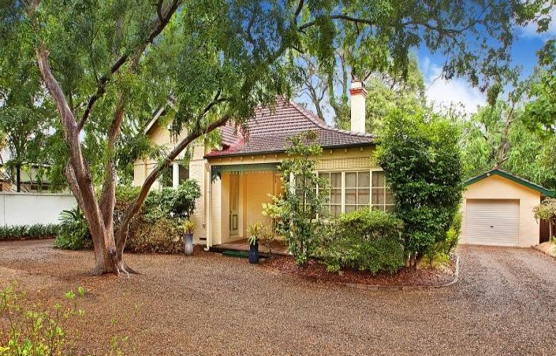

Lot 1 DP 519758

**Hornsby Shire Council details**

**Heritage Register: (NONE)**

The origin of the name “Sherbourne” cannot be determined.

“Yantara” is a division of N.S.W. and is believed to be derived from a local aboriginal word.]

Part of Cheltenham Park Estate Subdivision 1901

The 1901 Cheltenham Park Estate Subdivision created lots for sale along the Beecroft Road, Mason Avenue, Kent Road (later Cheltenham Road) and Boronia Avenue.

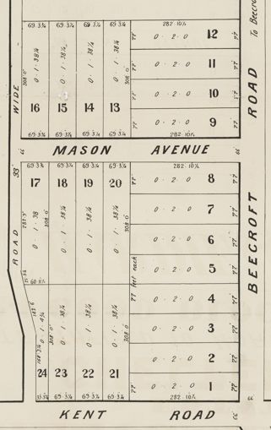

The Land for Sale 1906–Beecroft and Cheltenham Subdivision shows the residence of Mr. Eaton. This is between Mr. Hutchinson No.160 and Mr. Budden No. 166 so Mr. Eaton’s house could be No. 162 or No. 164).

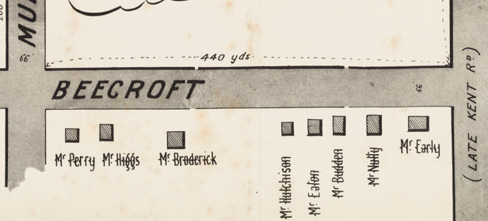

*(Mason Avenue is not shown although it did exist in 1901)*

The Mount Pleasant Estate – Cheltenham (1st Subdivision) 1908 shows the house being occupied by Mrs. Hart.

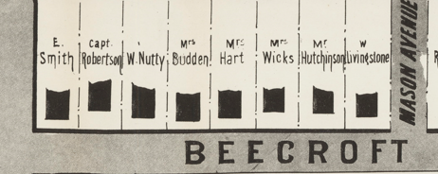

In 1909 Mrs. Hart left Cheltenham to take up her residence at Kiama, with Mr Dando to occupy the vacated premises.

In 1913 Alfred Herbert Giles, manager, and his wife Mary Elizabeth were owners and occupiers of the property, first recorded as “Sherbourne” in 1915.

The Mount Pleasant Estate – Cheltenham (2nd Subdivision) 1918 shows the house being occupied by Mr. Giles.

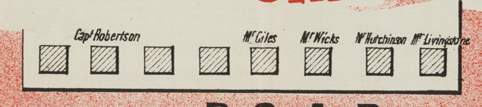

Sands Directory 1915-1919 Alfred Giles “Sherbourne”; 1921-1932/3 George Blumer “Yantara”

Electoral Roll 1933: George Blumer

In May 1919 it was reported that Mr. Giles had decided to move to Wollstonecraft. The property was auctioned, described as follows:

*The well-designed and faithfully constructed Modern Cottage of Brick with Tiled roof, and is in fine order, meriting attention of buyers.*

*Contains: Large dining-room, drawing-room, three good bedrooms, large sleeping-out verandahs front and at rear, kitchen, with gas stove and ample dom. offices, with all conveniences. City water, gas, telephone.*

*Fine area of land, 77ft. to Beecroft main road, great depth of 284ft. Title Torrens. Well laid out in lawn, flower, and veg. gardens. Assortment of best fruit trees, fowl yard anil sheds. Almost opposite the road down to Station. A chance par excellence for parties seeking health and happiness away from the more crowded suburbs.1*

Also, that month all the surplus furniture, fittings and sundries of Mr. Giles were also put up for sale.2

The next owner was George Alfred Blumer, Inspector of Schools, and his wife Mary Conradine. The house was then renamed “Yantara.”

*[George Alfred Blumer married Mary Conradine Fries in 1883, New Zealand]*

In 1928 George Blumer commenced long service leave, prior to retirement in 1929.

He had entered the Education Department's service in 1878, as a temporary assistant teacher at Fort-street. He subsequently taught in every class of school, from the small bush-school at Wattle Flat (1886) to the schools at Mudgee (1895) and St. Peters (1904). As a school inspector, Mr. Blumer has had charge of the Broken Hill, Grafton, Muswellbrook, Bathurst, Wollongong, and Canterbury districts successively. In 1923 he was elected president of the Inspectors' Institute, and since then has acted as its secretary and treasurer. He graduated B. A. in 1894, and M.A. in 1897.

His brothers Luke and Charles, also gave long service, in educational work.

George & Mary lived at 164 Beecroft-road, Cheltenham, until their deaths.

In 1943 George’s wife Mary died, aged 77 years.

In 1947 George Alfred Blumer died, aged 85 years.

**Bibliography:**

1 Daily Telegraph, 21st May 1919

2 Sydney Morning Herald, 24th May 1919

**Resources available (varies):**

* Sands Directories 1858-1933 City of Sydney [Sands Postal Directory | City of Sydney Archives (nsw.gov.au)](https://archives.cityofsydney.nsw.gov.au/nodes/view/495003)
* Newspaper articles – TROVE - [Search - Trove (nla.gov.au)](https://trove.nla.gov.au/search/advanced/category/newspapers)
* Ancestry.com (subscription only) [Genealogy, Family Trees and Family History Records online - Ancestry.com](https://www.ancestry.com.au/) – Sands Directories, Electoral Rolls, Family photos (Public Member photos), Census lists, marriage details, + miscellaneous
* N.S.W. Births, Deaths & Marriages [Family history search | NSW Government](https://www.nsw.gov.au/family-and-relationships/family-history-search) (QLD & Victoria also obtainable online)
* House photos and information via Hornsby Shire Council website for Property Search and Heritage Register [Heritage | Hornsby Shire Council (nsw.gov.au)](https://www.hornsby.nsw.gov.au/property/build/heritage)
* House photos and associated information via Internet search on address via Real Estate websites (from 2005)
* “Beecroft and Cheltenham Heritage Walks” - Beecroft-Cheltenham History Group Inc. 2004 book (1st edition)
* Australian War Museum website [Home | Australian War Memorial (awm.gov.au)](https://www.awm.gov.au/)