**166 BEECROFT ROAD, CHELTENHAM (“Hillcrest”)**

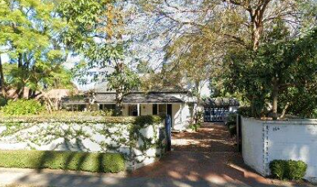

Lot 1 DP 507594

**Hornsby Shire Council details**

**Heritage Register: (NONE)**

Part of Cheltenham Park Estate Subdivision 1901

The 1901 Cheltenham Park Estate Subdivision created lots for sale along the Beecroft Road, Mason Avenue, Kent Road (later Cheltenham Road) and Boronia Avenue.

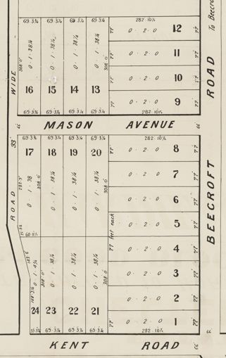

The first-known owner and occupant was Sophia Budden.

First noted in 1906 as an elector of “C” Riding, Hornsby Shire.

The Land for Sale 1906–Beecroft and Cheltenham Subdivision shows the residence of Mr. Budden.

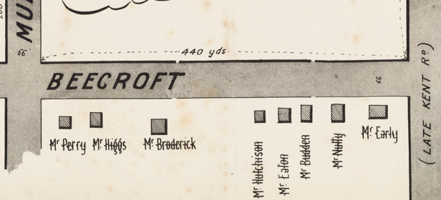

*(Mason Avenue is not shown although it did exist in 1901)*

The Mount Pleasant Estate – Cheltenham (1st Subdivision) 1908 shows the house being occupied by Mrs. Budden.

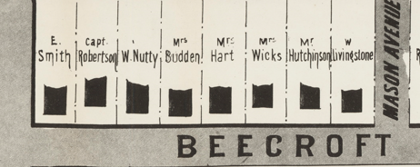

By 1915 Horace Evers, was living at “Hillcrest.”

*[Horace C. Evers married Evelyn Maud Foster in 1901 at Mosman]*

Sands Directory 1915-1932/3 H. Evers “Hillcrest”

Electoral Roll 1933: Horace Evers No. ?

**Horace Charles Evers (1878-1941)**

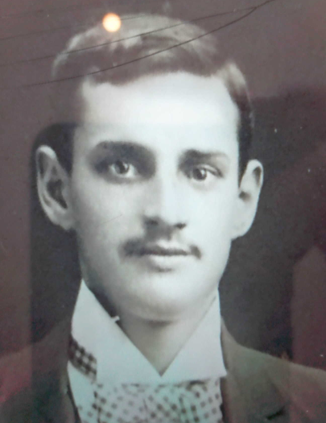

In 1928 and again in 1930 Horace is described as a commercial traveller representing Patterson, Laing, and Bruce, Ltd. As a side-line he would breed quality Buff Orpington chickens for sale.

The 1933 Electoral Roll lists Horace Charles Evers (com. traveller), Evelyn Maud Evers, Eric Roy Evers (labourer) – 166 Beecroft-road, Cheltenham

In July 1941 Horace Charles Evers died at his Cheltenham residence, aged 63 years, late employee of Paterson, Laing, and Bruce, Ltd.

The 1943 Electoral Roll lists Evelyn Maud Evers, Eric Roy Evers (labourer), Eliza Foster [sister of Evelyn] – 166 Beecroft-road, Cheltenham. The death occurred of Eliza Foster of this address in 1947.

Evelyn Evers continued to live at “Hillcrest” up to 1958 and died in 1962, Marrickville district.

In 1977 Dr. Michael John Price occupied the property.

**Resources available (varies):**

* Sands Directories 1858-1933 City of Sydney [Sands Postal Directory | City of Sydney Archives (nsw.gov.au)](https://archives.cityofsydney.nsw.gov.au/nodes/view/495003)
* Newspaper articles – TROVE - [Search - Trove (nla.gov.au)](https://trove.nla.gov.au/search/advanced/category/newspapers)
* Ancestry.com (subscription only) [Genealogy, Family Trees and Family History Records online - Ancestry.com](https://www.ancestry.com.au/) – Sands Directories, Electoral Rolls, Family photos (Public Member photos), Census lists, marriage details, + miscellaneous
* N.S.W. Births, Deaths & Marriages [Family history search | NSW Government](https://www.nsw.gov.au/family-and-relationships/family-history-search) (QLD & Victoria also obtainable online)
* House photos and information via Hornsby Shire Council website for Property Search and Heritage Register [Heritage | Hornsby Shire Council (nsw.gov.au)](https://www.hornsby.nsw.gov.au/property/build/heritage)
* House photos and associated information via Internet search on address via Real Estate websites (from 2005)
* “Beecroft and Cheltenham Heritage Walks” - Beecroft-Cheltenham History Group Inc. 2004 book (1st edition)
* Australian War Museum website [Home | Australian War Memorial (awm.gov.au)](https://www.awm.gov.au/)