**168 BEECROFT ROAD, CHELTENHAM (“Montford” or “Montfort”)**

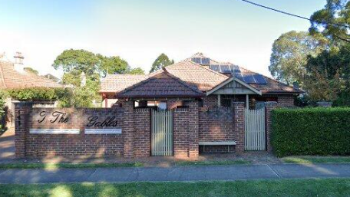

Lot CP SP 71348

Lots 1 to 6 SP 71348

**Hornsby Shire Council details**

**Heritage Register: (NONE)**

Part of Cheltenham Park Estate Subdivision 1901

The 1901 Cheltenham Park Estate Subdivision created lots for sale along the Beecroft Road, Mason Avenue, Kent Road (later Cheltenham Road) and Boronia Avenue.

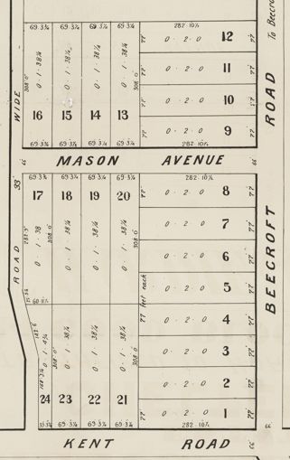

The Land for Sale 1906–Beecroft and Cheltenham Subdivision shows the residence of Mr. Nutty.

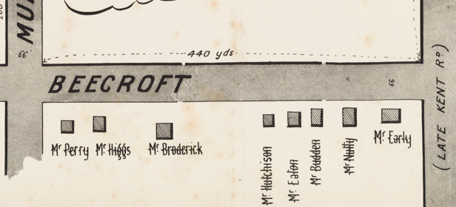

*(Mason Avenue is not shown although it did exist in 1901)*

The Mount Pleasant Estate – Cheltenham (1st Subdivision) 1908 shows the house being occupied by Mr. W. Nutty.

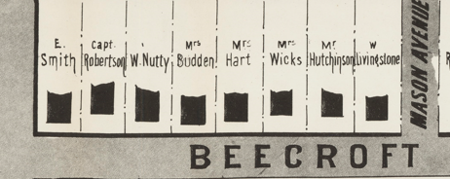

William Nutty died in 1913 at the home of his sister-in-law, 22 The Avenue, Strathfield. His wife, Jennie Nutty, continued to live at the Cheltenham home until 1920, then returned to live with her sister in Strathfield, where she died in 1924.

Sands Directory 1915 Richard Humphries; 1916 William Vincent; 1917, 1919-1920 Mrs. J. Nutty; 1921-1923 William Moss (Moses); 1924 A. Robinson; 1925 G. Harris “Montfort”; 1926-1932/3 C. Blumer “Montfort”

Electoral Roll 1933: Charles Blumer No. ?

From 1920 William Moses occupied the Cheltenham property “Montford,” where he died in 1923, aged 78 years. He was for many years in business in Windsor as a grocer and ironmonger together with a bakery, and carried on business as the Hawkesbury Stores at the corner of George and Bridge streets, still known as Moses' corner. He was associated with the early history of Windsor, and while in business here was closely identified with the rise and progress of the Hawkesbury district. He was a Justice of the Peace, and took a prominent interest in nearly all the public institutions of the town.

The property, now referred to as “Montfort,” was auctioned in February 1923, described as follows:

*DETACHED BRICK COTTAGE, iron roof, tiled front and return verandah, hall, dining-room, 4 bedrooms, breakfast-room, bathroom, kitchen, and pantry, fernery.*

*Land 77 feet to Beecroft-road by 282ft 10in. portion of which is laid out in tennis court. Lawns and gardens, 40 fruit trees, fowl houses and runs.1*

In late 1923 to 1925 “Montfort” was the home of Gordon Harris and family.

It then came into the possession of Charles Blumer, headmaster, and brother of George Blumer who lived at 164 Beecroft-road, Cheltenham.

Charles Blumer, headmaster of Petersham Intermediate High School since 1924, retired in 1930 after 49 years of service. He was previously headmaster of the Goulburn High School for 11 years. Mr. Blumer was the youngest of three brothers, each of whom gave nearly 50 years' educational service; his brothers being ex-Senior Inspector Luke Blumer, of Hunter's Hill, and Inspector George Blumer, M.A., of Cheltenham.

‘Himself a brilliant scholar, the veteran master enjoyed the dual distinction of being one of the most popular high school principals in New South Wales and also one of the most efficient senior officers in the Education Department. There are few secondary school teachers who were not familiar with the tall, gaunt, sharp-featured figure, whose very presence suggested the typical schoolmaster.’2

The 1933 Electoral Roll lists Charles Blumer (teacher), Esther Elizabeth Blumer - Beecroft-road, Cheltenham

*[Charles Blumer married Esther E. Howland in 1888, at Sydney]*

In 1940 Esther Elizabeth Blumer died at the Cheltenham home, aged 75 years.

In 1943 the house was occupied by William Edwin Lego, musician, and his wife Fanny Elizabeth, who had married in 1925.

Charles Blumer died in 1954 at his son’s residence, St Giles Rectory, Greenwich, aged 88 years. He was survived by four sons, Eric, Rex, Cecil and Paul, and one brother, John, of Penshurst.

**Bibliography:**

1 Sydney Morning Herald, 3rd February 1923

2 Goulburn Evening Penny Post, 29th October 1930

**Resources available (varies):**

* Sands Directories 1858-1933 City of Sydney [Sands Postal Directory | City of Sydney Archives (nsw.gov.au)](https://archives.cityofsydney.nsw.gov.au/nodes/view/495003)
* Newspaper articles – TROVE - [Search - Trove (nla.gov.au)](https://trove.nla.gov.au/search/advanced/category/newspapers)
* Ancestry.com (subscription only) [Genealogy, Family Trees and Family History Records online - Ancestry.com](https://www.ancestry.com.au/) – Sands Directories, Electoral Rolls, Family photos (Public Member photos), Census lists, marriage details, + miscellaneous
* N.S.W. Births, Deaths & Marriages [Family history search | NSW Government](https://www.nsw.gov.au/family-and-relationships/family-history-search) (QLD & Victoria also obtainable online)
* House photos and information via Hornsby Shire Council website for Property Search and Heritage Register [Heritage | Hornsby Shire Council (nsw.gov.au)](https://www.hornsby.nsw.gov.au/property/build/heritage)
* House photos and associated information via Internet search on address via Real Estate websites (from 2005)
* “Beecroft and Cheltenham Heritage Walks” - Beecroft-Cheltenham History Group Inc. 2004 book (1st edition)
* Australian War Museum website [Home | Australian War Memorial (awm.gov.au)](https://www.awm.gov.au/)