**17 CHORLEY AVENUE, CHELTENHAM (“Nerrigundah”?)**

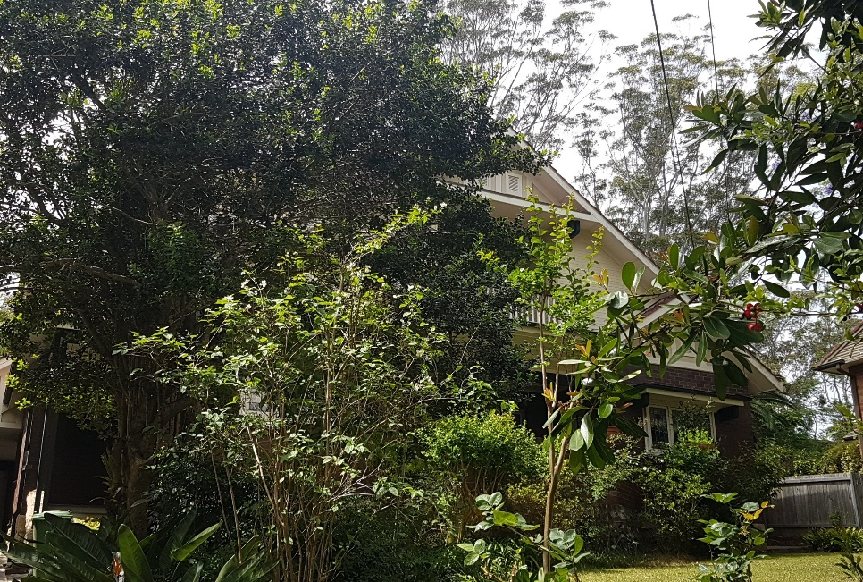

Lot 127 DP 12364

Sands Directories 1930-1932/3 C. E. Anderson “Merringunyah”

Electoral Roll 1933: Katherine Anderson “Narigunyah”

The house is most likely either named after Nerrigundah, a N.S.W. village, or is an aboriginal name *Murrigunyah* (meaning unknown). The house name is spelt in various ways.

In 1930 Clive Eric Anderson was living at this address.

In 1933 occupants were Clive Eric Anderson (surveyor) and Katherine Uila Anderson

*[Clive Eric Anderson married Kathleen M. L. Bell in 1926, district of Sydney]*

The house seems to be sub-let as other occupants were John McMeekin McCaw (marine supt.) and Mary Gladys McCaw.

In 1936, at this residence, occurred the death of Charles Dudley Ryder, husband of Lillian Ann Ryder.

In 1937 Clive Eric Anderson (surveyor), Katherine Vila Anderson were still in residency. Other occupants were Doris Millicent Lockhart-Bell (photographer), Joyce Eva Lockhart-Bell (nurse), Isabelle Caroline Lockhart-Bell (home duties) and Joyce Eva Lockhart-Bell (nurse)

In 1943 occupants were Clive Eric Anderson (surveyor), Katherine Vila Anderson, Philip Adrian Anderson (surveyor), Isabelle Caroline Lockhart-Bell and Joyce Eva Lockhart-Bell (nurse)

That year Clive Eric Anderson died at this address.

**Bibliography: none**

**Resources available (varies):**

* Sands Directories 1858-1933 City of Sydney [Sands Postal Directory | City of Sydney Archives (nsw.gov.au)](https://archives.cityofsydney.nsw.gov.au/nodes/view/495003)
* Newspaper articles – TROVE - [Search - Trove (nla.gov.au)](https://trove.nla.gov.au/search/advanced/category/newspapers)
* Ancestry.com (subscription only) [Genealogy, Family Trees and Family History Records online - Ancestry.com](https://www.ancestry.com.au/) – Sands Directories, Electoral Rolls, Family photos (Public Member photos), Census lists, marriage details, + miscellaneous
* N.S.W. Births, Deaths & Marriages [Family history search | NSW Government](https://www.nsw.gov.au/family-and-relationships/family-history-search) (QLD & Victoria also obtainable online)
* House photos and information via Hornsby Shire Council website for Property Search and Heritage Register [Heritage | Hornsby Shire Council (nsw.gov.au)](https://www.hornsby.nsw.gov.au/property/build/heritage)
* House photos and associated information via Internet search on address via Real Estate websites (from 2005)
* “Beecroft and Cheltenham Heritage Walks” - Beecroft-Cheltenham History Group Inc. 2004 book (1st edition)
* Australian War Museum website [Home | Australian War Memorial (awm.gov.au)](https://www.awm.gov.au/)