**170 BEECROFT ROAD, CHELTENHAM (“Bermuda”, prev. “Birkenhead” and “Lynlee”)**

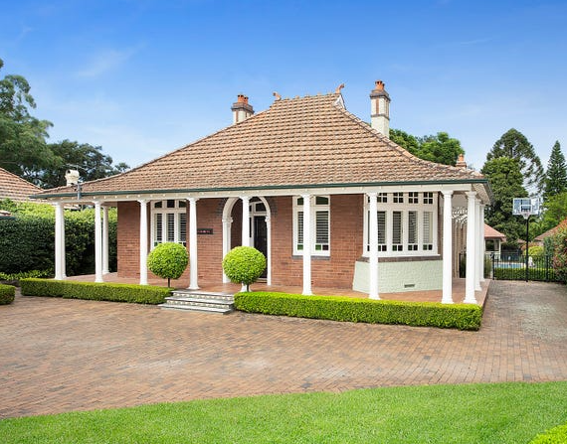

Lot 2 DP 931641

**Hornsby Shire Council details**

**Heritage Register: Item No. 264**

Part of Cheltenham Park Estate Subdivision 1901

The 1901 Cheltenham Park Estate Subdivision created lots for sale along the Beecroft Road, Mason Avenue, Kent Road (later Cheltenham Road) and Boronia Avenue.

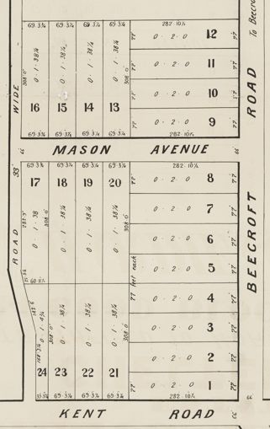

The 1908 Mount Pleasant Estate – Cheltenham (1st Subdivision) shows the house being occupied by Mr. Alex Robinson (ship’s captain) and his wife Annie.

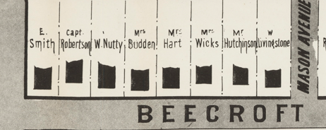

*[Captain Alexander Robinson, 2nd son of Alexander Robinson, Glenarm, County Antrim, Ireland, married in 1890, N.Z. Annie, 2nd daughter of John Rendell, Auckland (late of Brighton, England)].*

Sands Directory 1915-1921 Alex Robinson “Birkenhead”; 1922 Mrs. A. Robinson; 1923 Gerard F. Reber; 1924 James E. Allan; 1925-27 Joseph A. Allan;

Sands Directory 1925-1932/3 M. Lindsay “Lynlea”

Electoral Roll 1933: Matthew Lindsay No. 170

The house was referred to as “**Birkenhead**” in the Sands Directories of 1915 & 1917.

The Mount Pleasant Estate – Cheltenham (2nd Subdivision) 1918 shows the house being occupied by Captain Robinson.

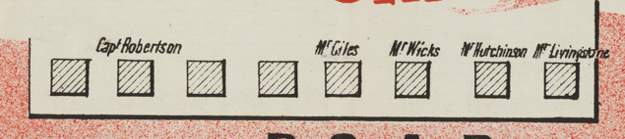

In 1921 Captain Alexander Robinson died at his Cheltenham residence, at the age of 60 years.

Captain Robinson was a well-known master mariner in Howard Smith's service. He first took command in 1887 of the barquentine Handa Isle”. In this vessel he had a part interest. He

joined Howard Smith & Company's service in 1899, and his first command was the “Julia Percy.“ Subsequently he was in charge of practically every vessel of the fleet, including the “Peregrine,” and at a recent date was in command of the Canberra.

During the whole of his 34 years' command he neither lost nor had one serious accident to a vessel. He was a man of sterling character and integrity, and during his long service maintained the highest traditions of the merchant service.

The late Captain Robinson leaves a widow and four children, all grown up. Two of his boys [Norman Alexander & Allan Howard] saw service with the A.I.F. in Egypt and France, both returning wounded.1

In October 1922 Captain Robinson’s house was put up for auction, described as follows:

*A Modern and Attractive COTTAGE RESIDENCE,*

*fronting the BEECROFT ROAD (south side), a short distance west of Cheltenham-road, and in view of and only 4 minutes’ walk of the Railway Station, well-known as the residence of the late Captain A. Robinson. The garden is attractive in lawn and flower beds, gravelled paths, and ample room for motor entrance.*

*The Land is 76ft x 275ft. Torrens Title.2*

The property was sold to Matthew Lindsay who renamed it “**Lynlee**.”

The 1930 Electoral Roll lists the occupants as Matthew Lindsay (retired), Hilda Jane Pearl Catherine Lindsay, Jean Mary Lindsay – “Lynlee,” Beecroft-road, Cheltenham

*[Matthew Lindsay married Hilda Jane Pearl Park]*

Subsequent Electoral Rolls give the address as 170 Beecroft-road, Cheltenham

The house was occupied by the Lindsay family up to 1933.

In 1937 Nellie Kaye Hutchinson occupied the house and in 1943 Alexander Bowie, police constable.

The house was last sold in 2021, renamed “**Bermuda**.”3

**NOT**E: Incorrectly put on BCHG website as commercial site (general store & petrol pump) however this is applicable to 172 Beecroft-road.

**Bibliography:**

1 Daily Commercial News and Shipping List, 21st May 1921; also Daily Telegraph, 21st May 1921

2 Sydney Morning Herald, 4th October 1922

3 [170 Beecroft Road, Cheltenham, NSW 2119 - Property Details (realestate.com.au)](https://www.realestate.com.au/sold/property-house-nsw-cheltenham-134406614)

**Resources available (varies):**

* Sands Directories 1858-1933 City of Sydney [Sands Postal Directory | City of Sydney Archives (nsw.gov.au)](https://archives.cityofsydney.nsw.gov.au/nodes/view/495003)
* Newspaper articles – TROVE - [Search - Trove (nla.gov.au)](https://trove.nla.gov.au/search/advanced/category/newspapers)
* Ancestry.com (subscription only) [Genealogy, Family Trees and Family History Records online - Ancestry.com](https://www.ancestry.com.au/) – Sands Directories, Electoral Rolls, Family photos (Public Member photos), Census lists, marriage details, + miscellaneous
* N.S.W. Births, Deaths & Marriages [Family history search | NSW Government](https://www.nsw.gov.au/family-and-relationships/family-history-search) (QLD & Victoria also obtainable online)
* House photos and information via Hornsby Shire Council website for Property Search and Heritage Register [Heritage | Hornsby Shire Council (nsw.gov.au)](https://www.hornsby.nsw.gov.au/property/build/heritage)
* House photos and associated information via Internet search on address via Real Estate websites (from 2005)
* “Beecroft and Cheltenham Heritage Walks” - Beecroft-Cheltenham History Group Inc. 2004 book (1st edition)
* Australian War Museum website [Home | Australian War Memorial (awm.gov.au)](https://www.awm.gov.au/)
* Beecroft and Cheltenham History Group website [Beecroft and Cheltenham History - Beecroft Cheltenham History Group (bchg.org.au)](https://bchg.org.au/)