**172 BEECROFT ROAD, CHELTENHAM**

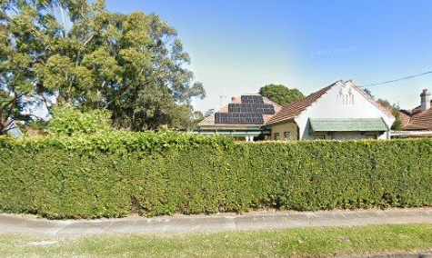

172 Beecroft Road Lot 1 DP 624110

50B Cheltenham Road Lot 1 DP 624110

**Hornsby Shire Council details**

**Heritage Register: (NONE)**

The corner house at 172 Beecroft Road (alternate 50 B Cheltenham Road) is the site of what is claimed to be the only commercial operations in Cheltenham. In fact, it isn’t the only site of commercial activity as, in the early 1930’s, there was also a car hire business and a real estate agent located near the railway station in The Crescent.

Part of Cheltenham Park Estate Subdivision 1901

The 1901 Cheltenham Park Estate Subdivision created lots for sale along the Beecroft Road, Mason Avenue, Kent Road (later Cheltenham Road) and Boronia Avenue.

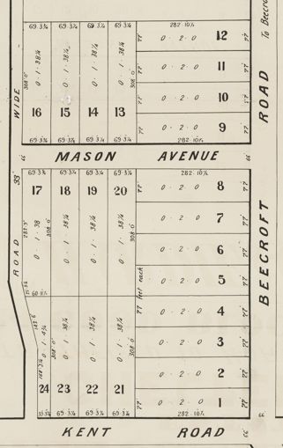

The first reference to the house was in 1902 was when Ruth, was born at “Dacotah” to George A. and Clara Park. In 1903 A fine American organ was presented to the Presbyterian Church at Beecroft by Mrs. G. Park, of Cheltenham.

In 1905 the property was auctioned, described as follows:

*A Neatly Designed COTTAGE RESIDENCE, known as DACOTAH, fronting BEECROFT ROAD, at the corner of KENT ROAD [now Cheltenham-road], only 4 minutes' walk from the Railway Station; healthy district, with good elevation; rapidly coming to the front. Land 77ft X 280ft. Torrens Title.*1

The 1906 Beecroft and Cheltenham Land for Sale Subdivision Plan shows Mr. Early at the corner of Cheltenham-road and Beecroft-road (No. 172).

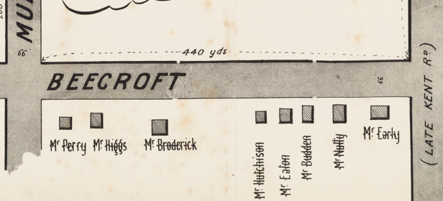

*(Mason Avenue is not shown although it did exist in 1901)*

In 1906 a benefit concert was held for Mrs. Hannah Early, recently of Cheltenham, who had been in bad health for some considerable time. In 1908 Hannah Early, late of Beecroft and Epping, died. In 1909 her husband, Thomas F. W. Early, died in the district of Liverpool.

In 1907 Edwin Smith purchased Mr. Park’s property and was to live there.

*[Edwin Smith married Harriet Elizabeth Roughley, 1873, Parramatta district]*

The Mount Pleasant Estate – Cheltenham (1st Subdivision) 1908 shows the house being occupied by Mr. E. Smith.

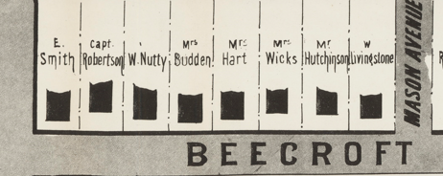

In 1910 Mr. Smith was living in “Dacotah” when his son, Archie William, was married to May, daughter of Mr. & Mrs. C. W. Wheeler, of Beecroft.

*[Archie W. Smith, born 1888, parents: Edwin & Harriet E., Central Cumberland]*

*[Edwin Smith, later moved to “Millingra,” corner of Beecroft-road & Kirkham-street.]*

In March 1914 at “Dacotah” the death occurred of Joan, aged 2 years, the daughter of Rev. W. A. & Mrs. Harris-Walker, of Ballina. In August 1914 an advertisement was placed for a girl, about 14, to assist in domestic duties.

Sands Directory 1915 Montague Kerr “Dacotah”; 1917 James H. Coyle; 1918 Ernest F. Liley; 1920 Frank E. Humphries; 1925 Henry Hinks; 1931 H. J. McCoy “Merrymax”; 1932/3 Henry Hinks No. 172 “Merrymax”; 1933 Casper Wye Rayner

In 1915 Montague S. Kerr was the occupant of the house.

By 1916 it was occupied by James H. Coyle, estate agent, who carried on business at the Imperial Arcade, Sydney.

*[James H. Coyle (1870-1952) married Annie Leon (1871-1953)]*

*[His father John Coyle, born 1830 in Belfast, Ireland, lived an adventurous life, both in America and Australia.2]*

In March 1917 Ernest Frederick Liley, the new owner of the house advertised it to let, described as follows:

*CHELTENHAM. - To Let, Furnished, Superior Gentleman's BRICK VILLA, elevated corner position, containing 7 rooms and offices, gas and fuel stoves, nice lawns and gardens, kitchen garden, very healthy, 4 minutes railway station.*

*Apply Liley, Dacotah, Beecroft.*3

In September 1917 Mr. Liley put up for sale the house and contents, the house described as follows:

*DACOTAH,*

*Built of Brick, Tuckpointed, on Stone Foundation, Tiled Front and Side Verandahs, Tile Roof, containing Hall, Drawing, Dining, and 4 Bed Rooms, Breakfast-room. Bathroom, Kitchen, Laundry, Outhouses, and large Fernery.*

*The LAND, in an elevated position, has a frontage to Beecroft-road of 75ft by depth of 250ft along Cheltenham-road.*

*The GROUNDS are well laid out in Lawns, Flower Beds, Fruit Trees, Grape Vines, and Kitchen Garden.*4

[NOTE: In 1905 the land size was 77 x 280ft.]

In 1919 the property was again put up for sale, described as follows:

*CHELTENHAM. — “DACOTAH,” Beecroft & Cheltenham Roads, Gentleman’s Cottage Residence, substantially built of brick, on stone foundation. Bangor slate roof. It contains hall, drawing, dining and breakfast rooms, 5 bedrooms, kit., laundry, pantry, bathroom, etc. Wide verandahs. Gardens, lawns, etc. The position is the best in Cheltenham, and as building is modern and the rooms spacious, the home is a most desirable one. Land 80 x 200. Tor. Title.*5

[NOTE: Again, the land size has changed.]

In November 1920 an Order of Sale was placed on the property.

By 1920 Frank E. Humphries occupied the house and from about 1925 was occupied by Henry Hinks, who named the house “Merrymax.”

In 1933 the house was occupied by Casper Wye Rayner (engineer), Ethel Florence Rayner & Aubrey George Rayner (clerk)

In January 1934, despite a petition of protest from residents, the Hornsby Shire Council granted an application for the erection of a garage and service station in the residential suburb of Cheltenham at this address. At the time the suburb contained no other business of any kind. The council, when considering the application, decided that as long as the regulations were complied with, it had no power to prevent the erection of the building.

The garage and service station were duly established.

In April 1938 the business was put up for sale, described as follows:

*Freehold and Business Combined*

*CHELTENHAM*

*In an exclusive area where no other business premises may be erected.*

*RAYNER’S SERVICE STATION, SHOP with SUB NEWS AGENCY and HOME, producing a comfortable income with excellent prospects of expansion.*

*SITUATE at the corner of BEECROFT and CHELTENHAM ROADS, built of brick, tiled main roof. The cottage has return wide verandah, hall, and lounge, dining and breakfast rooms, 4 bedrooms, bathroom tiled and built-in bath, additional bathroom, kitchen, laundry, wide enclosed rear verandah. Detached brick garage, accessories apartment.*

*ATTACHED TO THE RESIDENCE is a SHOP OF BRICK. Land has 77 feet frontage to BEECROFT ROAD, and 222 feet along CHELTENHAM ROAD. TORRENS TITLE. Gas and electric light, city water connected.6*

The sale of the property seems to have been quickly finalised. In May 1939 tenders were called for the erection of a garage, with billiard room, Tudor design.

By 1940 Casper Wye Rayner had moved to Earlwood. He died in 1973 in the district of Ryde.

The 1943 Electoral Roll lists Frederick Seddon (storekeeper), Clara Seddon, Elsie May Etherington – 172 Beecroft-road, Cheltenham

In 1951 the service station was referred to as “The Stores Service Station.” It was one where owners refused to allow their businesses to become “tied houses,” Backed by four independent oil companies they could stock all brands available to them, and thus ‘give a service superior to any “tied house.”’

In September 1954 it was again auctioned, and described as follows:

*172 BEECROFT ROAD (cnr. Cheltenham Road).*

*The PROPERTY comprises SPACIOUS BRICK RESIDENCE with part tile and Iron roof, on the FRONT of which HAS BEEN ERECTED a SHOP, STOREROOM, and SERVICE STATION, with 5 PETROL BOWSERS. ACCOM.: Hall. 3 bedrooms, lounge-room, dining-room, kitchen, enclosed verandah, bathroom. GARAGE. G.A.R. £267/16/.*

*LAND: 77ft X 222ft. TITLE TORRENS.7*

The service station continued to operate until the 1970’s.

**Bibliography:**

1 Sydney Morning Herald, 4th March 1905

2 Nepean Times, 12th Feb 1916

3 Sydney Morning Herald, 31st March 1917

4 Sydney Morning Herald, 29th September 1917

5 Cumberland Argus and Fruitgrowers Advocate, 1st February 1919

6 Sydney Morning Herald, 23rd April 1938

7 Sydney Morning Herald, 25 Sept 1954

**Resources available (varies):**

* Sands Directories 1858-1933 City of Sydney [Sands Postal Directory | City of Sydney Archives (nsw.gov.au)](https://archives.cityofsydney.nsw.gov.au/nodes/view/495003)
* Newspaper articles – TROVE - [Search - Trove (nla.gov.au)](https://trove.nla.gov.au/search/advanced/category/newspapers)
* Ancestry.com (subscription only) [Genealogy, Family Trees and Family History Records online - Ancestry.com](https://www.ancestry.com.au/) – Sands Directories, Electoral Rolls, Family photos (Public Member photos), Census lists, marriage details, + miscellaneous
* N.S.W. Births, Deaths & Marriages [Family history search | NSW Government](https://www.nsw.gov.au/family-and-relationships/family-history-search) (QLD & Victoria also obtainable online)
* House photos and information via Hornsby Shire Council website for Property Search and Heritage Register [Heritage | Hornsby Shire Council (nsw.gov.au)](https://www.hornsby.nsw.gov.au/property/build/heritage)
* House photos and associated information via Internet search on address via Real Estate websites (from 2005)
* “Beecroft and Cheltenham Heritage Walks” - Beecroft-Cheltenham History Group Inc. 2004 book (1st edition)
* Australian War Museum website [Home | Australian War Memorial (awm.gov.au)](https://www.awm.gov.au/)