**178 BEECROFT ROAD, CHELTENHAM (“Glengavin”)**

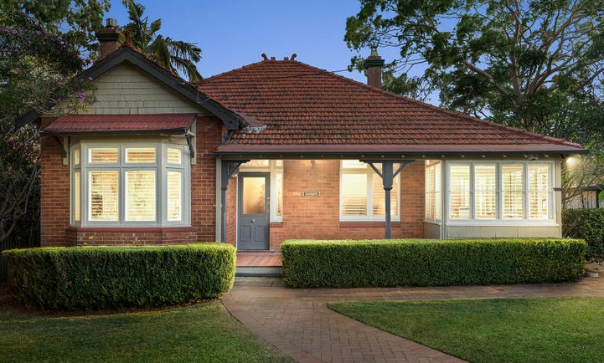

Lot 1 DP 854023

**Hornsby Shire Council details**

**Heritage Register: (NONE)**

Part of Beecroft & Cheltenham – Land for Sale Subdivision 1906

The 1906 Beecroft & Cheltenham – Land for Sale Subdivision shows vacant land on this site.

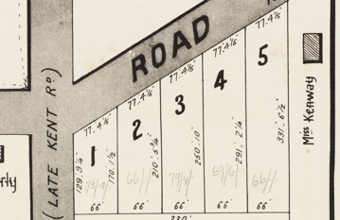

The Mount Pleasant Estate 1st Subdivision 1908 shows the house being occupied by Mr. Charles Judson. He became a telephone subscriber in April 1907.

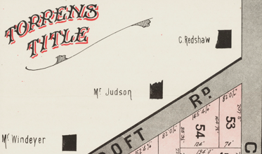

In June 1912 Mr. Judson’s house was burgled. A newspaper article stated: “Mr. Judson had invitingly left the front door open, and the burglar casually passed into the house, through Mr. Judson 's bedroom, where he “lifted” a waistcoat and a pair of trousers, and then passed out of the back, leaving the back door open. Mr. Judson, fortunately, is not a believer in gold watches, and neither his silver chain or brass time-piece tempted the robber, and the trousers panned out no better. He thereupon chucked the garments under the verandah”’1

The 1913 Electoral Roll records Charles Judson (carrier), Blanch Sarah Judson – Beecroft-road, Cheltenham

*[Charles Judson [1870-1939] married Blanche S. Helman in 1898 at Redfern]*

Charles Judson left Cheltenham in 1913 to establish a stud poultry farm at Thornleigh, finding the occupation of master carrier too strenuous. He became known as one of the best-known stud poultry breeders of the State, exporting his Black Orpingtons and his developed Australorp breed world-wide, and winning many awards. Upon his death in 1938, at his home in Dartford-road, Thornleigh, the business would be carried on by his son, Noel Judson.

Sands Directory 1915-1932/3: Sydney Johnson “Glengavin”

1933 Electoral Roll: Algernon Johnson No. 178

During 1913 the house was then occupied by Algernon Sydney Melville Johnson & his wife Emily Margaret Johnson. At the time he was an accountant at the Office of Inspector-General of Lunacy. The house then assumed the name “Glengavin.” He became, in August 1913, a trustee of Cheltenham Park, Beecroft.

*[Algernon S. M. Johnson [1878-1933] married Emily M. Manson in 1909 at Goulburn.*

*[Algernon’s father, George Charles Johnson, died in 1924, being one of the oldest journalists in NS.W., and a prolific writer, using the nom-de-plumes of “Paul Twyford” and “Cooyal,”]*

The Mount Pleasant Estate – Cheltenham (2nd Subdivision) 1918 shows the house being occupied by Mr. Johnson.

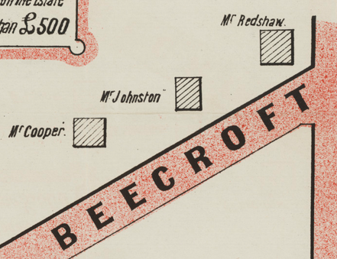

In 1933 Algernon Johnson, Chief Accountant to the Department of Lunacy, died at his residence, "Glengavin," Beecroft-road, Cheltenham, after a long illness, leaving a wife and three children.

His wife, Emily, continued to live in the house into the 1940’s with other family members.

The home was last sold in 2018.2

**Bibliography:**

1 Cumberland Argus, 8th June 1912

2 [178 Beecroft Road, Cheltenham, NSW 2119 - Property Details (realestate.com.au)](https://www.realestate.com.au/sold/property-house-nsw-cheltenham-128523770)

**Resources available (varies):**

* Sands Directories 1858-1933 City of Sydney [Sands Postal Directory | City of Sydney Archives (nsw.gov.au)](https://archives.cityofsydney.nsw.gov.au/nodes/view/495003)
* Newspaper articles – TROVE - [Search - Trove (nla.gov.au)](https://trove.nla.gov.au/search/advanced/category/newspapers)
* Ancestry.com (subscription only) [Genealogy, Family Trees and Family History Records online - Ancestry.com](https://www.ancestry.com.au/) – Sands Directories, Electoral Rolls, Family photos (Public Member photos), Census lists, marriage details, + miscellaneous
* N.S.W. Births, Deaths & Marriages [Family history search | NSW Government](https://www.nsw.gov.au/family-and-relationships/family-history-search) (QLD & Victoria also obtainable online)
* House photos and information via Hornsby Shire Council website for Property Search and Heritage Register [Heritage | Hornsby Shire Council (nsw.gov.au)](https://www.hornsby.nsw.gov.au/property/build/heritage)
* House photos and associated information via Internet search on address via Real Estate websites (from 2005)
* “Beecroft and Cheltenham Heritage Walks” - Beecroft-Cheltenham History Group Inc. 2004 book (1st edition)
* Australian War Museum website [Home | Australian War Memorial (awm.gov.au)](https://www.awm.gov.au/)
* Beecroft and Cheltenham History Group website [Beecroft and Cheltenham History - Beecroft Cheltenham History Group (bchg.org.au)](https://bchg.org.au/)