**179 BEECROFT ROAD, CHELTENHAM (Congregational Church)**

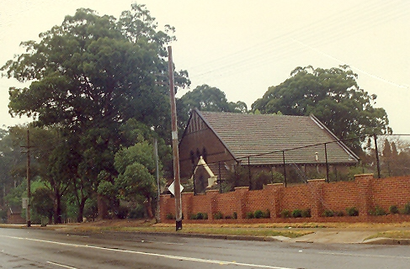

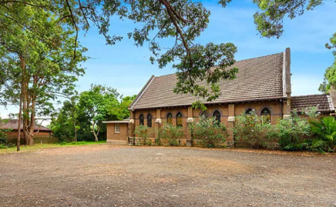

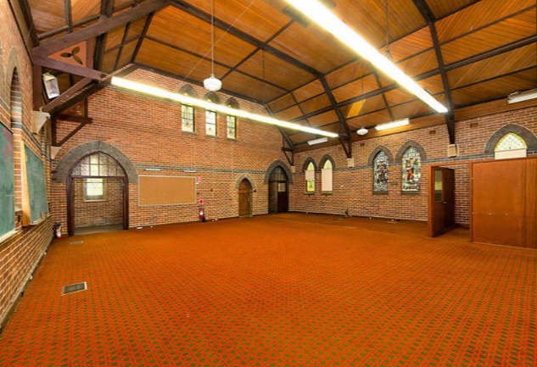

Lot 8483 DP 1256389

**Hornsby Shire Council details**

**Heritage Register – Item No.: 266**

[Also referred to as the Golden Kangaroos Hall.]

Part of Mount Pleasant Estate – Cheltenham 2nd Subdivision 1918

The Congregational Church was built on land donated by the Chorley family. The church closed in 1970.

Following closure of the church it became an educational facility and then the home of the Golden Kangaroos, a well-known band of local musicians who now practice in the Community Centre. It is now used as a child care centre.

The site still contains some significant mature trees: a tallowwood planted when the church was built, a radiate pine, a camphor laurel (c. 1940), and an ironbark. Tree planting took place from 1920/30’s.

In May 1926 Mrs. Chorley gave the site, together with £500, and her husband followed with a straight-out gift of £1500. In June 1926 it was reported that a site had been donated for a new Congregational Church at Cheltenham and that about £2000 was at hand for the structure.

Although the balance of £2750 required to meet the cost of the projected project, 59ft. by 38ft. in internal measurement, was not immediately forthcoming from others, it was decided in December to commence operations, in the confidence that support would not be wanting. That month plans and specifications had been prepared and tenders for an erection were called in early January 1927. The architect was Wm. M. Nixon, architect, 163 Pitt Street, Sydney.

In April 1927 there was a foundation-stone ceremony at which Mr. William Chorley laid the stone. Rev. Dr. Dey (chairman of the local committee) handed to Mr. Chorley a silver trowel, and said that the new church would be carried on in non-sectarian spirit, but that ministers of other denominations would be asked from time to time to officiate. The shortfall in funds was largely subscribed at the ceremony.

Rev. William Touchell (chairman of the Congregational Union) presided, and the short preliminary service included the singing of "The Church’s One Foundation,” invocation, and the reading of Scripture by Rev. A. H. Austin (secretary of the Congregational. Union). This was followed by an address by Rev. T. E. Ruth (minister of Pitt Street Church). The future church would have the distinction of being the only non-Episcopal place of worship there.

In September 1927 the Cheltenham Congregational Church was officially opened. Rev. Dr. Dey, D.D., chairman of the Building Committee, presided, the doors being opened by Mrs. Chorley at 3.05 p.m.

In the absence through Illness of Mrs. Chorley, the church, which Is a handsome structure of brick, with seating accommodation for 200, was opened by her daughter, Mrs. G. J. Graham. The Rev. Dr. Dey (chairman of the building committee) presided at the opening service. The Rev. Dr. Thatcher (of Camden College) delivered the sermon, and the Rev. William Touchell (chairman of the Congregational Union) read the dedication prayer. The Revs. T. Gordon Robertson, R. A. Thompson, R. E. Chapman (of Pennant Hills), who will act temporarily as minister of the new church), and W. H. Patison (superintendent of Home Missions), assisted in the service.

The church, of brick with cement facings and tiled roof, described as the best building of Its kind in the district, cost close upon £4000 to build and furnish. The building committee Rev. Robert Dey, D.D., chairman) would raise £500 for the church.

This church was not erected in sectarian spirit, as the proposed union of the neighbouring churches was turned down by the Presbyterian Church, otherwise this building would have been represented legally as well as actually by all three denominations — Presbyterian, Methodist, and Congregational. Even so it would be carried on in the spirit of that proposed union.

In October 1927 the first wedding was celebrated there when Miss Elsie Preston, third daughter of Mr. and Mrs. Arthur Preston, Beecroft, was married to Mr. James Logan, of Gordon.

The ceremony was performed by Rev. Dr. Thatcher, assisted by Rev R. Chapman.

The reception was held at the Beecroft Presbyterian School Hall. It being the first marriage in the new church, a beautiful Bible was presented to the happy couple by Rev. Dr. Dey.

In August 1930 Miss Elizabeth Helen Taylor, 2nd daughter of Mr. and Mrs. W. J. Taylor, of Beecroft, was married there to Mr. Arthur Preston, the only son of Mr. and Mrs. Arthur Preston, of Beecroft. Rev. Dr. W. H. Day officiated.

*(A daughter of Mr. & Mrs. Arthur Preston had previously married there in 1927.)*

In June 1931 there was the marriage of Miss Pat Brett, a London girl, who a few days after her arrival married Mr. Henry Charles Graham, 2nd son of Mr, & Mrs. G. J. Graham of Cheltenham, whom she met two years ago when he was on a visit to England. Rev. Dr. Dey officiated.

*(Mrs. G. J. Graham was the daughter of Mr. & Mrs. William Chorley.)*

In February 1933 at the Cheltenham Congregational Church the marriage took place of Miss

Audrey Mary Sherar, second daughter of Mrs. Sherar and the late Andrew Sherar, of Surrey Hills, Melbourne, to Mr William Pearman Thomas, son of the late Mr and Mrs C Thomas, of Surrey Hills, Melbourne. The Rev W. H. Lewis officiated, assisted by the Rev. Dr. Dey. the reception which was held at the home of the bride’s sister, Mrs. Leo Cockett, “Glenesk,” Beecroft.

In June 1934 a service of remembrance and thanksgiving for the life and work of the late Mrs. Robert Dey was held in the Cheltenham Congregational Church. Mrs Dey, wife of the Rev. Dr. Robert Dey, veteran editor of the "Christian World.” In September a stained-class window Installed In memory of the late Mrs. Robert Dey, was unveiled and dedicated there.

In January 1935 a service was held there for the funeral of Jeanie Jackson Hunter, of 32 Boronia-avenue, Cheltenham.

In April 1935 a memorial service was held for William Chorley at the Cheltenham Congregational Church.

The chief mourners were Messrs. H. Chorley and W. Chorley (sons), Mrs. Millar, Mrs. Graham, Mrs. Allison, Mrs. Tulloch, Mrs. Rayner, and Miss Chorley (daughters), Mrs. T. Hooper (sister), Messrs. G. Graham, J. Allison, A. Tulloch, and C. W. Rayner (sons-in-law), Mr. T. Hooper, and Mrs. H. Chorley.

In August 1936 a memorial service was conducted for Rev. Dr. Robert Dey, honorary pastor of the Cheltenham Congregational Church for nine years. In 1937 a memorial window was unveiled by Dr. Lindsay Dey, one of his sons. The window, depicting “The Good Shepherd,” was a companion of one erected previously in memory of Mrs. Dey.

By April 1938 Rev. F. F. Wheaton resigned from Brown Street Congregational Church, Newcastle, to enter on his new ministry at Cheltenham Congregational Church. Mr. Wheaton retired in 1941 and after a long illness died in 1942 at Sydney.

In 1945 an appeal for £3,000 to build a modern kindergarten on a block of land in The Promenade, Cheltenham, (close to the Cheltenham Congregational Church) which was given for the purpose by Mrs. Robert (Violet) Vicars, was launched at a public meeting at the Congregational Church, Cheltenham.

It was proposed that the building shall include a community hall, and shall serve as a memorial to those who have served in the war. The. Hornsby Shire Council has decided to lay out part of the land adjoining the site of the kindergarten as a children's play-ground.

In March 1953 the first wedding for nine years at the Congregational Church, Cheltenham, took place when Elizabeth Brown, only daughter of Mr. and Mrs. J. Rhodes Brown, of Cheltenham, married Elton Marsden.

The church closed in 1970.

The property was last sold in 2015.1

A corner site over two large approximately 986sqm lots with two street frontages (Beecroft-road and The Promenade) – Lot 83 containing the former church, and corner Lot 84 vacant land, to be sold in one line with vacant possession.

**Bibliography:**

1 [179 Beecroft Road, Cheltenham, NSW 2119 - Property Details (realestate.com.au)](https://www.realestate.com.au/sold/property-house-nsw-cheltenham-119434879)

**Resources available (varies):**

* Sands Directories 1858-1933 City of Sydney [Sands Postal Directory | City of Sydney Archives (nsw.gov.au)](https://archives.cityofsydney.nsw.gov.au/nodes/view/495003)
* Newspaper articles – TROVE - [Search - Trove (nla.gov.au)](https://trove.nla.gov.au/search/advanced/category/newspapers)
* Ancestry.com (subscription only) [Genealogy, Family Trees and Family History Records online - Ancestry.com](https://www.ancestry.com.au/) – Sands Directories, Electoral Rolls, Family photos (Public Member photos), Census lists, marriage details, + miscellaneous
* N.S.W. Births, Deaths & Marriages [Family history search | NSW Government](https://www.nsw.gov.au/family-and-relationships/family-history-search) (QLD & Victoria also obtainable online)
* House photos and information via Hornsby Shire Council website for Property Search and Heritage Register [Heritage | Hornsby Shire Council (nsw.gov.au)](https://www.hornsby.nsw.gov.au/property/build/heritage)
* House photos and associated information via Internet search on address via Real Estate websites (from 2005)
* “Beecroft and Cheltenham Heritage Walks” - Beecroft-Cheltenham History Group Inc. 2004 book (1st edition)
* Australian War Museum website [Home | Australian War Memorial (awm.gov.au)](https://www.awm.gov.au/)