**18 THE BOULEVARD, CHELTENHAM (“Framar”)**

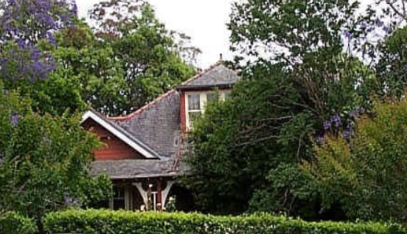

Lot 1 DP 526173

**Hornsby Shire Council details**

**Heritage Register: Item No. 286 (House and Garden)**

Part of Mount Pleasant Estate – Cheltenham 1st Subdivision 1908

A Federation Bungalow style house, built 1912-15, with fine quality original detail, possibly for W. B. Bull.

Sands Directories 1915-1918: W. B. Bull; 1919-1920 Walter Kerridge; 1921-1932/3 David Bertram “Maidavale”

Electoral Roll 1933: Alexander Bertram

Sands Directories 1924-1932/3: Francis Young “Framar”

Electoral Roll 1933: Maxwell Young “Framar”

The earliest known occupant was Francis William Young in 1923.

*[Francis W. Young married Mary J. MacCubbin in 1904, district of Manly]*

The house name, “Framar,” would appear to be the first 3 letters of “Francis” and “Mary.”

In 1930 Francis made alterations and additions to the property.

In 1933 occupants were Francis William Young (produce merchant), Mary Jane Young, Hazel Thelma Young, Doris Helen Young and Maxwell Francis Arthur Young (salesman).

Francis W. Young would continue to live at “Framar” until his death in 1956, his occupation designated as Company Director. His wife, Mary Jane, survived him. The executors of his Will were Maxwell Francis Arthur Young, Keith William Young and Eric David Young.

**Bibliography: none**

**Resources available (varies):**

* Sands Directories 1858-1933 City of Sydney [Sands Postal Directory | City of Sydney Archives (nsw.gov.au)](https://archives.cityofsydney.nsw.gov.au/nodes/view/495003)
* Newspaper articles – TROVE - [Search - Trove (nla.gov.au)](https://trove.nla.gov.au/search/advanced/category/newspapers)
* Ancestry.com (subscription only) [Genealogy, Family Trees and Family History Records online - Ancestry.com](https://www.ancestry.com.au/) – Sands Directories, Electoral Rolls, Family photos (Public Member photos), Census lists, marriage details, + miscellaneous
* N.S.W. Births, Deaths & Marriages [Family history search | NSW Government](https://www.nsw.gov.au/family-and-relationships/family-history-search) (QLD & Victoria also obtainable online)
* House photos and information via Hornsby Shire Council website for Property Search and Heritage Register [Heritage | Hornsby Shire Council (nsw.gov.au)](https://www.hornsby.nsw.gov.au/property/build/heritage)
* House photos and associated information via Internet search on address via Real Estate websites (from 2005)
* “Beecroft and Cheltenham Heritage Walks” - Beecroft-Cheltenham History Group Inc. 2004 book (1st edition)
* Australian War Museum website [Home | Australian War Memorial (awm.gov.au)](https://www.awm.gov.au/)
* Beecroft and Cheltenham History Group website [Beecroft and Cheltenham History - Beecroft Cheltenham History Group (bchg.org.au)](https://bchg.org.au/)