**18 THE PROMENADE, CHELTENHAM (“Kairaki”)**

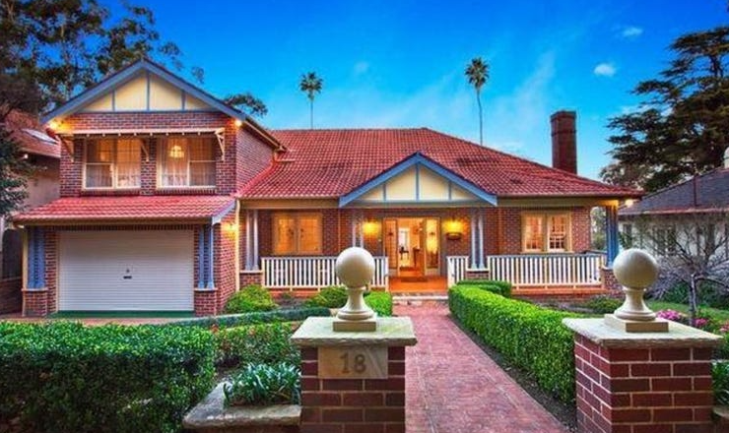

Lot 93 DP 9085

**Hornsby Shire Council details**

**Heritage Register: (NONE)**

Part of Mount Pleasant Estate – Cheltenham 2nd Subdivision 1918

In 1925 occupied by Harold Gladstone Turnidge (leather merchant) and Katherine Turnidge.

*[Harold Gladstone Turnidge married Katherine Fallover 1916 Ashfield]*

Harold Gladstone Turnidge enlisted in the A.I.F. 19th July 1916, aged 31, by then married, residing in Mosman.

The 1933 Electoral Roll lists at this address Harold Gladstone Turnidge (leather merchant) and Katherine Turnidge.

The Turnidge family were still living at “Kairaki” in 1963.

The house was last sold in 2011.1

**Bibliography:**

1 [18 The Promenade, Cheltenham, NSW 2119 - Property Details (realestate.com.au)](https://www.realestate.com.au/sold/property-house-nsw-cheltenham-107791481)

**Resources available (varies):**

* Sands Directories 1858-1933 City of Sydney [Sands Postal Directory | City of Sydney Archives (nsw.gov.au)](https://archives.cityofsydney.nsw.gov.au/nodes/view/495003)
* Newspaper articles – TROVE - [Search - Trove (nla.gov.au)](https://trove.nla.gov.au/search/advanced/category/newspapers)
* Ancestry.com (subscription only) [Genealogy, Family Trees and Family History Records online - Ancestry.com](https://www.ancestry.com.au/) – Sands Directories, Electoral Rolls, Family photos (Public Member photos), Census lists, marriage details, + miscellaneous
* N.S.W. Births, Deaths & Marriages [Family history search | NSW Government](https://www.nsw.gov.au/family-and-relationships/family-history-search) (QLD & Victoria also obtainable online)
* House photos and information via Hornsby Shire Council website for Property Search and Heritage Register [Heritage | Hornsby Shire Council (nsw.gov.au)](https://www.hornsby.nsw.gov.au/property/build/heritage)
* House photos and associated information via Internet search on address via Real Estate websites (from 2005)
* “Beecroft and Cheltenham Heritage Walks” - Beecroft-Cheltenham History Group Inc. 2004 book (1st edition)
* Australian War Museum website [Home | Australian War Memorial (awm.gov.au)](https://www.awm.gov.au/)