**181-183 BEECROFT ROAD, CHELTENHAM**

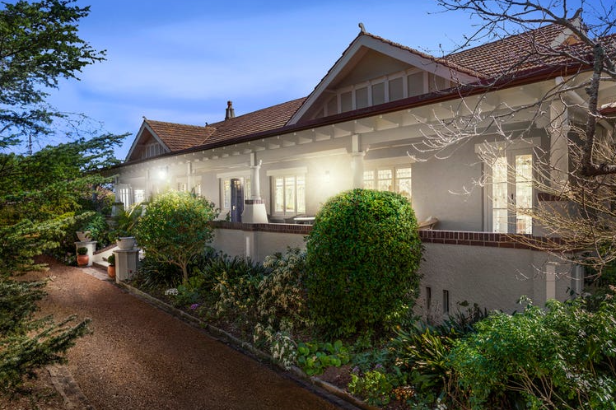

181 Beecroft Road Lot 82 DP 9085

183 Beecroft Road Lot 79 DP 9085

Lot 80 DP 9085

Lot 81 DP 9085

Pt Lot 80 DP 9085

50A Cheltenham Road Lot 79 DP 9085

Lot 80 DP 9085

Lot 81 DP 9085

Pt Lot 80 DP 9085

**Hornsby Shire Council details**

**Heritage Register: Item No. 267 (Garden only)**

Part of Mount Pleasant Estate – Cheltenham 2nd Subdivision 1918

‘This property formed part of the Mount Pleasant Estate of William and Lilly Chorley [2]. This site was part of a parcel of land that subdivided into 4 lots and auctioned in 1918. The first of the lots that sold was the first one off Beecroft Road facing Cheltenham Road. It was sold to Frank Grainger Spurway a manufacturer. The two blocks on the corner of Beecroft and Cheltenham Roads were then sold to Walter George Norton a tanner. All three lots were then sold in 1920 to John Brown Surgeon, a grazier. Lot 82, between these lots and the Congregational Church, remained owned as part of the Mount Pleasant Estate.’

[The property lies on lots 79, 80 and 81 along Beecroft-road, Cheltenham.]

In January 1921 it was reported that “Mr. J. B. Surgeon was having a residence built at Cheltenham at a cost of £4700”. The architect was William Nixon.

John Brown Surgeon was born on 23rd October 1889 in Queensland, son of John & Harriet Surgeon. He came from a well-established grazier and abattoir owning family in Charters Towers. His parents lived in Anne-street, Charters Towers, Queensland. His father John, grazier and butcher, died in 1910.

Sands Directories 1922-1932/3 J. B. Surgeon

Electoral Roll 1933: John Surgeon No. 183

**Nathan, Christina & John Surgeon c1900**

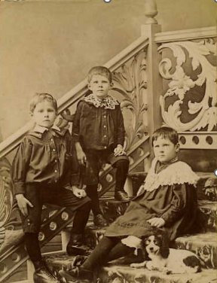

John B. Surgeon met his wife-to-be, Minnie Topping, at Charters Towers.

In June 1912 Minnie Topping had visited Charters Towers with the D. B. O'Connor's Merry Widow Company, in June 1912 in which she played the leading part of Mary Gibbs in the comic opera “Our Miss Gibbs.” Her “dainty singing, her dear enunciation of the libretto, and her graceful acting made her a favourite at once. In such Items as “Country Cousins,” sung and danced with Mr. Geo. Edwards, as Timothy Gibbs, she manifested all the freedom from restraint expected of country folk. Her dancing with Hughie (Mr. D. B. O'Connor) was quaint and spirited, and she quite captivated and held the attention of the audience throughout her fine performance.”1

Previously she had visited Charters Towers as a member of Pollard’s Lilliputian Co., another theatrical company.

On 18th December 1912, at St. Alban’s Church, Epping, John B. Surgeon, of Burdekin Downs Station, Charters Towers, married Minnie Topping, daughter of Harry Topping, of Melbourne, Victoria.

[At that time Minnie Topping’s sister, Florence Margaret (Madge) was living with her husband, Albert Henry Cowley, at “Coo-ee,” 39 Boronia-avenue, Cheltenham]

In 1913 they were living with his mother and sister Christina at Anne-street, Charters Towers

A son, John was born 10-10-1913 at Charters Towers.

For 1914 & 1916 John Brown Surgeon was working with his brother Nathan, both as graziers, on Wyora Station, Winton, Central West QLD.

**Vehicles on Wyora Station 1927**

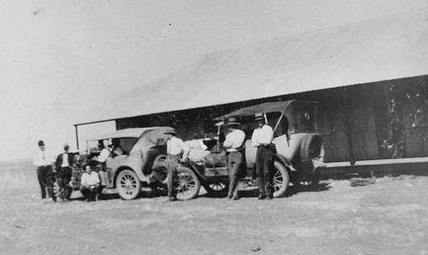

In 1915 John’s wife, Minnie, was living alone in Ann-street, Charters Towers, probably because of her mother-in-law marrying Jack Fraser.

She would later move to Cheltenham, N.S.W., said to be due to her dislike of the oppressive heat in Queensland. A son, Edward James Surgeon, was born on 17th September 1916 in the Ryde district. Presumably she was living with her sister, Florence, at “Coo-ee,” 39 Boronia-avenue, Cheltenham.

For 1917 & 1919 John Brown Surgeon was still at Wyora Station, Winton, with his brother Nathan, another brother, James Robert Surgeon (grazier), and Irene Madeline Surgeon.

In 1942 the Probate of the Will of James Robert Surgeon, grazier of Woodbine Station, Prairie, QLD, in 1942, was granted to John Brown Surgeon, retired grazier, of Cheltenham.

In 1920 John Brown Surgeon is recorded as living at “Far Hills,” Inkerman-road, Ryde.

A daughter, Mignon May, was born on 8th May 1920 in the Ryde district)

The last child to the couple, Rhoda, was born on 27th May 1921 in the Hornsby district.

The 1936 & 1937 Electoral Rolls for 183 Beecroft-road records John Brown Surgeon (grazier), Minnie Elizabeth Surgeon, John Surgeon (wool-classer) as occupants.

In 1941 the son John married Mollie Stanger of Cheltenham.

John Brown Surgeon died at his residence, Cheltenham-road, Cheltenham, on 29th November, 1943, leaving a widow, Minnie, and four children.

**Photos of house 1944**

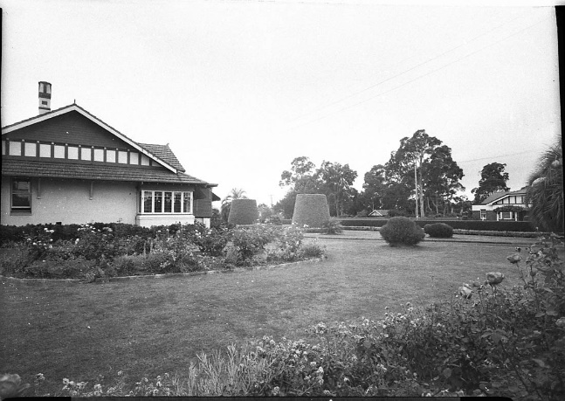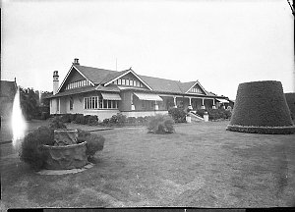

By 1946 Minnie had moved to 51 Wolseley-road, Point Piper. The daughter Mignon was engaged in 1946 and the son Edward James was married in 1947, both using this address.

The 1949 Electoral Roll recorded the Cheltenham house as being occupied by Loris Harley Hassall (exporter) and his wife Elizabeth Mabel Hassall.

*[Loris Hassall married Elizabeth Berry in 1942 and they lived together for a time in Point Piper, before purchasing the Cheltenham property]2*

By 1950 Minnie Surgeon had moved to Denistone. That year the daughter Rhoda was engaged to Robert Lawrence Cunneen, of Roseville.

In 1954 John Surgeon (junior) was listed as a teacher of wool-classing, living in West Pennant Hills.

In 1968 he was living at 18 Hull-road, Beecroft.

In 1970 his mother, Minnie, died at Beecroft. presumably at the home of her son John, who died in 2000.

**Bibliography:**

1 Northern Miner (Charters Towers, QLD), 22nd June 1912

2 Heritage Impact Statement March 2020

**Resources available (varies):**

* Sands Directories 1858-1933 City of Sydney [Sands Postal Directory | City of Sydney Archives (nsw.gov.au)](https://archives.cityofsydney.nsw.gov.au/nodes/view/495003)
* Newspaper articles – TROVE - [Search - Trove (nla.gov.au)](https://trove.nla.gov.au/search/advanced/category/newspapers)
* Ancestry.com (subscription only) [Genealogy, Family Trees and Family History Records online - Ancestry.com](https://www.ancestry.com.au/) – Sands Directories, Electoral Rolls, Family photos (Public Member photos), Census lists, marriage details, + miscellaneous
* N.S.W. Births, Deaths & Marriages [Family history search | NSW Government](https://www.nsw.gov.au/family-and-relationships/family-history-search) (QLD & Victoria also obtainable online)
* House photos and information via Hornsby Shire Council website for Property Search and Heritage Register [Heritage | Hornsby Shire Council (nsw.gov.au)](https://www.hornsby.nsw.gov.au/property/build/heritage)
* House photos and associated information via Internet search on address via Real Estate websites (from 2005)
* “Beecroft and Cheltenham Heritage Walks” - Beecroft-Cheltenham History Group Inc. 2004 book (1st edition)
* Australian War Museum website [Home | Australian War Memorial (awm.gov.au)](https://www.awm.gov.au/)
* Beecroft and Cheltenham History Group website [Beecroft and Cheltenham History - Beecroft Cheltenham History Group (bchg.org.au)](https://bchg.org.au/)