**182 BEECROFT ROAD, CHELTENHAM (“Norella”)**

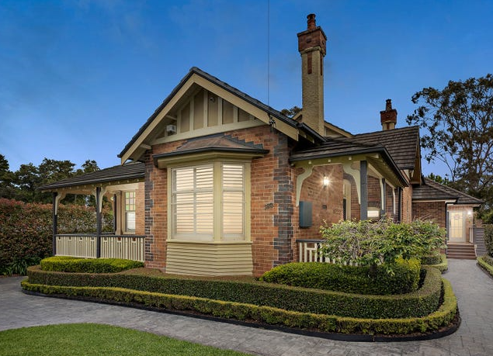

Lot 5 DP 4713

**Hornsby Shire Council details**

**Heritage Register: (NONE)**

Part of Beecroft & Cheltenham – Land for Sale Subdivision 1906

The 1906 Beecroft & Cheltenham – Land for Sale Subdivision shows vacant land on this site.

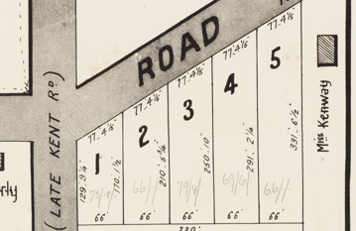

The Mount Pleasant Estate – Cheltenham (1st Subdivision) 1908 shows the house being occupied by Mr. Windeyer, who would move to Murray Farm-road, Beecroft by 1913.

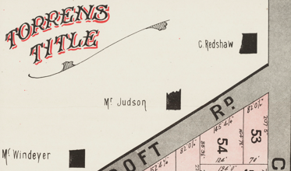

By 1915 Harold R. Cooper was the occupant of this house, named “Norella.”

*[Henry K. Cooper (born 1869-1950) married Harriett Priscilla Stering 1898 Sydney]*

Sands Directory 1915-1917: Harold R. Cooper “Norella”; 1918-1932/3 Henry K. Cooper

1933 Electoral Roll: Henry Cooper No. 182

**Henry Kingsbury Cooper (1869-1950)**

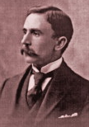

The 1918 Mount Pleasant Estate – Cheltenham (2nd Subdivision) shows the house being occupied by Mr. Cooper.

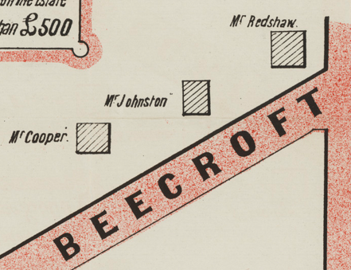

In 1923 his only son, Arthur George Cooper, was registered as a medical practitioner for 1924, titled M.B., Ch. M., 1923, Univ., Sydney. Arthur would marry Marguerite Henry, of Epping, in 1924.

In 1936 Henry’s wife, Harriett (“Hettie”) died.

The 1937 Electoral Roll records Henry Kingsbury Cooper (company official), Arthur George Stening Cooper (med. pre.), Marguerite Cooper – 182 Beecroft-road, Cheltenham

In 1950 Henry died at his residence, “Norella,” 182 Beecroft-road, Cheltenham

The house was last sold in 2018.1

**Bibliography:**

1 [182 Beecroft Road, Cheltenham, NSW 2119 - Property Details (realestate.com.au)](https://www.realestate.com.au/sold/property-house-nsw-cheltenham-127365746)

**Resources available (varies):**

* Sands Directories 1858-1933 City of Sydney [Sands Postal Directory | City of Sydney Archives (nsw.gov.au)](https://archives.cityofsydney.nsw.gov.au/nodes/view/495003)
* Newspaper articles – TROVE - [Search - Trove (nla.gov.au)](https://trove.nla.gov.au/search/advanced/category/newspapers)
* Ancestry.com (subscription only) [Genealogy, Family Trees and Family History Records online - Ancestry.com](https://www.ancestry.com.au/) – Sands Directories, Electoral Rolls, Family photos (Public Member photos), Census lists, marriage details, + miscellaneous
* N.S.W. Births, Deaths & Marriages [Family history search | NSW Government](https://www.nsw.gov.au/family-and-relationships/family-history-search) (QLD & Victoria also obtainable online)
* House photos and information via Hornsby Shire Council website for Property Search and Heritage Register [Heritage | Hornsby Shire Council (nsw.gov.au)](https://www.hornsby.nsw.gov.au/property/build/heritage)
* House photos and associated information via Internet search on address via Real Estate websites (from 2005)
* “Beecroft and Cheltenham Heritage Walks” - Beecroft-Cheltenham History Group Inc. 2004 book (1st edition)
* Australian War Museum website [Home | Australian War Memorial (awm.gov.au)](https://www.awm.gov.au/)