**189 BEECROFT ROAD, CHELTENHAM (“Carlholme”)**

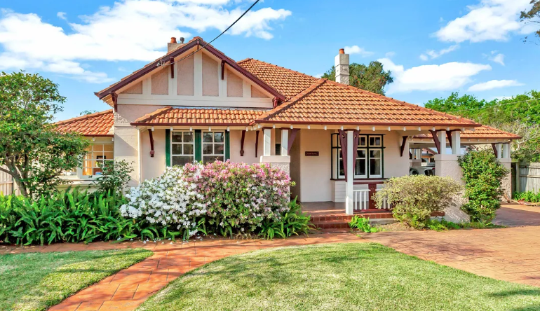

Lot Y DP 401013

**Hornsby Shire Council details**

**Heritage Register: (NONE)**

Part of Mount Pleasant Estate – Cheltenham 1st Subdivision 1908

The land was purchased by William James Wilson, Gentleman, in 1893 and he sold to William Chorley, Tailor in 1899. The house was built in 1906. The property was then sold to George Redshaw, teacher, in 1911.

Sands Directories 1916 Leopold Rogaly Illobo; 1917 Frank Hess Wyanga, 1918-1920 Claude H. Stanwix; 1921-1932/3 Thomas Whitehouse Carholme No.189

Electoral Roll 1933: Ethel Whitehouse Carholme

By 1915 it was purchased by Thomas Whitehouse.

Thomas Whitehouse was born c.1858 Staffordshire, England. He married Sarah Armson in 1886 Staffordshire. Children: Harry (1887), Frank (1891), Bessie (1893) – all born in Lancashire. They arrived in Australia in 1912.

The 1933 Electoral Roll lists Thomas Whitehouse (mech. engineer), Sarah Whitehouse, Bessie Whitehouse (teacher) of Beecroft-road, Cheltenham

In 1943 Sarah Whitehouse of Cheltenham died, aged 89 years, survived by her husband Thomas and children Harry, Frank and Bessie.

Thomas Whitehouse, retired engineer, of Cheltenham, died 11th May 1953.

It was sold in 1957 to Sydney Ronald Quick who subdivided and sold this house block, also in 1957 to Edward Bernard Morgan and Marjorie Olive Martin. They sold to Anthony Scott Denham and Vanessa Szypica-Denham in 1998 and they sold to Colin Ian Robinson in 2003.

The house was last sold in 2012.1

**Bibliography:**

1 [189 Beecroft Road, Cheltenham, NSW 2119 - realestate.com.au](https://www.realestate.com.au/property/189-beecroft-rd-cheltenham-nsw-2119/)

**Resources available (varies):**

* Sands Directories 1858-1933 City of Sydney [Sands Postal Directory | City of Sydney Archives (nsw.gov.au)](https://archives.cityofsydney.nsw.gov.au/nodes/view/495003)
* Newspaper articles – TROVE - [Search - Trove (nla.gov.au)](https://trove.nla.gov.au/search/advanced/category/newspapers)
* Ancestry.com (subscription only) [Genealogy, Family Trees and Family History Records online - Ancestry.com](https://www.ancestry.com.au/) – Sands Directories, Electoral Rolls, Family photos (Public Member photos), Census lists, marriage details, + miscellaneous
* N.S.W. Births, Deaths & Marriages [Family history search | NSW Government](https://www.nsw.gov.au/family-and-relationships/family-history-search) (QLD & Victoria also obtainable online)
* House photos and information via Hornsby Shire Council website for Property Search and Heritage Register [Heritage | Hornsby Shire Council (nsw.gov.au)](https://www.hornsby.nsw.gov.au/property/build/heritage)
* House photos and associated information via Internet search on address via Real Estate websites (from 2005)
* “Beecroft and Cheltenham Heritage Walks” - Beecroft-Cheltenham History Group Inc. 2004 book (1st edition)
* Australian War Museum website [Home | Australian War Memorial (awm.gov.au)](https://www.awm.gov.au/)
* Beecroft and Cheltenham History Group website [Beecroft and Cheltenham History - Beecroft Cheltenham History Group (bchg.org.au)](https://bchg.org.au/)