**19 CHELTENHAM ROAD, CHELTENHAM (“Lochindaal”, prev. “Kings Langley”)**

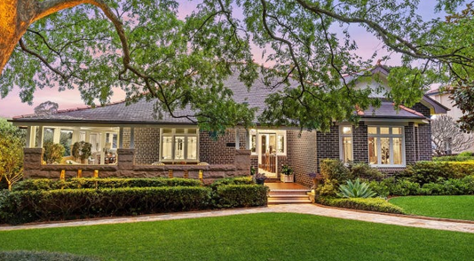

Lot 11 DP 536525

**Hornsby Shire Council details**

**Heritage Register: (NONE)**

Sands Directories 1925-32/33 Albert E. Tullock “King’s Stanley”

Electoral Roll 1933: Albert Tulloch No. 19

*Lochindaal,* formerly *Kings Stanley*, was built in the street in 1925, for. It was built by William Chorley for his daughter Alice, who had married Albert Tulloch whose family-owned Phoenix Engineering (later Tullochs) was at Rhodes.

Kings Stanley was the town in which Alice Tulloch’s mother, Lily Chorley, was born.

It uses sandstone in the foundations, half the wall of the verandah and in the path. The stone was quarried from the block as the house was being built. The house has leadlight front windows and sidelights.

*[Albert Edward Tulloch, of Thornleigh, married Alice Annie Chorley in 1924, at Sydney.*

The 1933 Electoral Roll lists as occupants Albert Edward Tulloch (elec. engineer), Alice Annie Tulloch, of 19 Cheltenham-road, Cheltenham

In 1949 they were still living at the house.

By 1958 Albert (electrical engineer) and his wife Alice Tulloch had moved to 22 Cheltenham-road, Cheltenham, the home of Alice’s sister, Lily May Chorley.

Alice Annie Tulloch died in 1967 and Albert Edward Tulloch in 1970, both in the district of St. Leonards.

The house was last sold in 2022.1

**Bibliography:**

1 [19 Cheltenham Road, Cheltenham NSW 2119 - property.com.au](https://www.property.com.au/nsw/cheltenham-2119/cheltenham-rd/19-pid-351794/)

**Resources available (varies):**

* Sands Directories 1858-1933 City of Sydney [Sands Postal Directory | City of Sydney Archives (nsw.gov.au)](https://archives.cityofsydney.nsw.gov.au/nodes/view/495003)
* Newspaper articles – TROVE - [Search - Trove (nla.gov.au)](https://trove.nla.gov.au/search/advanced/category/newspapers)
* Ancestry.com (subscription only) [Genealogy, Family Trees and Family History Records online - Ancestry.com](https://www.ancestry.com.au/) – Sands Directories, Electoral Rolls, Family photos (Public Member photos), Census lists, marriage details, + miscellaneous
* N.S.W. Births, Deaths & Marriages [Family history search | NSW Government](https://www.nsw.gov.au/family-and-relationships/family-history-search) (QLD & Victoria also obtainable online)
* House photos and information via Hornsby Shire Council website for Property Search and Heritage Register [Heritage | Hornsby Shire Council (nsw.gov.au)](https://www.hornsby.nsw.gov.au/property/build/heritage)
* House photos and associated information via Internet search on address via Real Estate websites (from 2005)
* “Beecroft and Cheltenham Heritage Walks” - Beecroft-Cheltenham History Group Inc. 2004 book (1st edition)
* Australian War Museum website [Home | Australian War Memorial (awm.gov.au)](https://www.awm.gov.au/)