**191 BEECROFT ROAD, CHELTENHAM (“Emoh Ruo” later “Furtwangen”)**

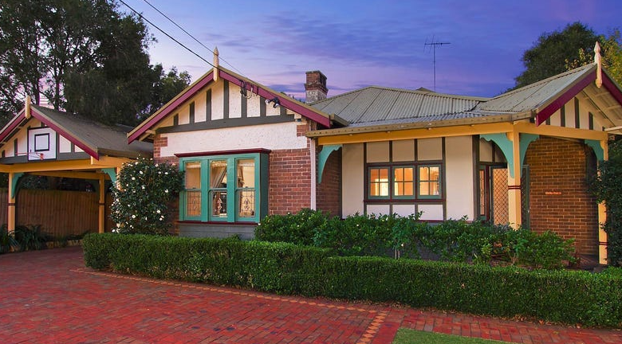

Lot 55 DP 5440

**Hornsby Shire Council details**

**Heritage Register: (NONE)**

Part of Mount Pleasant Estate – Cheltenham 1st Subdivision 1908

Sands Directories 1917-26 Mrs. Violet Nichols Emoh Ruo; 1927 H. J. Hutchinson; Constantin Wearn Furtwanger No. 191

Electoral Roll 1933: ?

In January 1915 it was announced that Mrs. Nicholls [sic] was about to build.

In August 1915 Rose Josephine, eldest daughter of Mrs. Violet Nichols and the late John Nichols, late of Arncliffe, died at her mother’s residence, “Emohruo,” Beecroft-road, Cheltenham, aged 46 years. The house is also referred to as “Emoh Ruo.”

The house (also named “Emoh Ruo”) was rented out by 1918 when the Burrell family occupied the house.

By 1921 George Thomas Austen (seed merchant, Hatymarket) was renting the house. He died there in July 1921, aged 74 years.

The house was put up for sale in 1922, described as a 5-room brick cottage.1

Mrs. Violet Nichols continued to live at the house until her death there in 1924, aged 77 years, the widow of John Joseph Nichols, and mother of Violet Ida Nichols.

By 1926 Violet Ida Nichols had inherited the Cheltenham home, which had been put up for sale. The sale of the property was withdrawn.

By 1930 the home had been sold and the new occupants were Constantin Wehrle and the home was renamed “Furtwanger.” Constantin, watchmaker and jeweller, died there in 1932, aged 68 years.

His widow, Bertha Australia Lecky Wehrle, continued to live at the home up to the late 1930’s.

By 1943 Leo Albert Gotting and Noel Stanhope Gotting, garage proprietors, were occupying 191 Beecroft-road, Cheltenham.2

The house was last sold in 2015.2

**Bibliography:**

1 Daily Telegraph, 15th July 1922

2 [191 Beecroft Road, Cheltenham, NSW 2119 - Property Details (realestate.com.au)](https://www.realestate.com.au/sold/property-house-nsw-cheltenham-119171735)

**Resources available (varies):**

* Sands Directories 1858-1933 City of Sydney [Sands Postal Directory | City of Sydney Archives (nsw.gov.au)](https://archives.cityofsydney.nsw.gov.au/nodes/view/495003)
* Newspaper articles – TROVE - [Search - Trove (nla.gov.au)](https://trove.nla.gov.au/search/advanced/category/newspapers)
* Ancestry.com (subscription only) [Genealogy, Family Trees and Family History Records online - Ancestry.com](https://www.ancestry.com.au/) – Sands Directories, Electoral Rolls, Family photos (Public Member photos), Census lists, marriage details, + miscellaneous
* N.S.W. Births, Deaths & Marriages [Family history search | NSW Government](https://www.nsw.gov.au/family-and-relationships/family-history-search) (QLD & Victoria also obtainable online)
* House photos and information via Hornsby Shire Council website for Property Search and Heritage Register [Heritage | Hornsby Shire Council (nsw.gov.au)](https://www.hornsby.nsw.gov.au/property/build/heritage)
* House photos and associated information via Internet search on address via Real Estate websites (from 2005)
* “Beecroft and Cheltenham Heritage Walks” - Beecroft-Cheltenham History Group Inc. 2004 book (1st edition)
* Australian War Museum website [Home | Australian War Memorial (awm.gov.au)](https://www.awm.gov.au/)