**196 BEECROFT ROAD, CHELTENHAM**

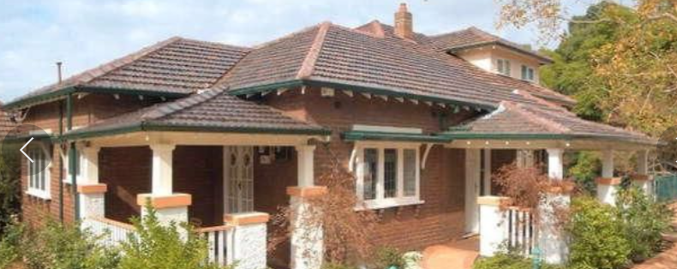

Lot 1 DP 1079312

**Hornsby Shire Council details**

**Heritage Register: (NONE)**

Part of Darling Hill Estate – Cheltenham Subdivision 1918

Sands Directories 1921-26 Victor J. Wilson “Vidor”; 1927 L. H. Beattie “Vidor”; 1930-32/3 R. C. Stanger “Vidor”

1933 Electoral Roll: Ralph Stanger {200????]

Occupied in 1925 by Ralph Carey Stanger and his wife Ethel Eliza, who remained there for many years.

*[Ralph C. Stanger married Ethel E. Watts in 1912 at Granville]*

Previously Ralph was a well-known resident of Lismore. He was at one time a Methodist Circuit missionary in the Lismore district but was not temperamentally fitted to the arduous work of a circuit minister, and felt it best to resign. However, he remained a loyal member of the Methodist church, and once settled in Cheltenham became part of the Epping Circuit and gave unstinted service.

During the 1930’s & 1940’s his occupation is given as builder.

In 1940 their daughter, Kathleen Ethel, married Richard Thomas Golby of Cheltenham.

In 1941 their daughter, Mollie, married John Surgeon of Cheltenham.

In 1943 Ralph Carey Stanger died at his Cheltenham home, survived by a widow and three daughters.

It was reported that “In his married life he was supremely happy, and his home was a place of harmony and happiness all through the years.”

In 1945 their daughter, Enid, married Eric David Young of Cheltenham.

In 1949 Ethel Eliza Stanger was still living at 196 Beecroft-road, Cheltenham.

Ethel died in 1963, within the district of Ashfield.

**Bibliography: none**

**Resources available (varies):**

* Sands Directories 1858-1933 City of Sydney [Sands Postal Directory | City of Sydney Archives (nsw.gov.au)](https://archives.cityofsydney.nsw.gov.au/nodes/view/495003)
* Newspaper articles – TROVE - [Search - Trove (nla.gov.au)](https://trove.nla.gov.au/search/advanced/category/newspapers)
* Ancestry.com (subscription only) [Genealogy, Family Trees and Family History Records online - Ancestry.com](https://www.ancestry.com.au/) – Sands Directories, Electoral Rolls, Family photos (Public Member photos), Census lists, marriage details, + miscellaneous
* N.S.W. Births, Deaths & Marriages [Family history search | NSW Government](https://www.nsw.gov.au/family-and-relationships/family-history-search) (QLD & Victoria also obtainable online)
* House photos and information via Hornsby Shire Council website for Property Search and Heritage Register [Heritage | Hornsby Shire Council (nsw.gov.au)](https://www.hornsby.nsw.gov.au/property/build/heritage)
* House photos and associated information via Internet search on address via Real Estate websites (from 2005)
* “Beecroft and Cheltenham Heritage Walks” - Beecroft-Cheltenham History Group Inc. 2004 book (1st edition)
* Australian War Museum website [Home | Australian War Memorial (awm.gov.au)](https://www.awm.gov.au/)