**20 THE PROMENADE, CHELTENHAM (“Strathkyle”)**

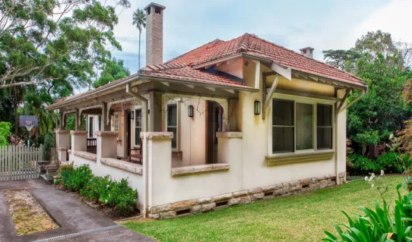

Lot 94 DP 9085

**Hornsby Shire Council details:**

**Heritage Register: (NONE)**

Part of Mount Pleasant Estate – Cheltenham 2nd Subdivision 1918

In December 1919 Hornsby Council approved the plans and specifications for a 6-roomed brick villa in The Promenade for J. A. Grange.

It was occupied by George Elmen Grange & Janet Almyra Grange.

*[George Grange married Janet A. Crighton in 1903, district of Newtown]*

In 1933 occupants were George Elmen Grange (ironmonger), Janet Almyra Grange, Dorothy Eileen Grange, and Gordon Harold Grange (window dresser).

In 1947 George Elmen Grange died at “Strathkyle,” The Promenade, aged 69 years.

**Bibliography: none**

**Resources available (varies):**

* Sands Directories 1858-1933 City of Sydney [Sands Postal Directory | City of Sydney Archives (nsw.gov.au)](https://archives.cityofsydney.nsw.gov.au/nodes/view/495003)
* Newspaper articles – TROVE - [Search - Trove (nla.gov.au)](https://trove.nla.gov.au/search/advanced/category/newspapers)
* Ancestry.com (subscription only) [Genealogy, Family Trees and Family History Records online - Ancestry.com](https://www.ancestry.com.au/) – Sands Directories, Electoral Rolls, Family photos (Public Member photos), Census lists, marriage details, + miscellaneous
* N.S.W. Births, Deaths & Marriages [Family history search | NSW Government](https://www.nsw.gov.au/family-and-relationships/family-history-search) (QLD & Victoria also obtainable online)
* House photos and information via Hornsby Shire Council website for Property Search and Heritage Register [Heritage | Hornsby Shire Council (nsw.gov.au)](https://www.hornsby.nsw.gov.au/property/build/heritage)
* House photos and associated information via Internet search on address via Real Estate websites (from 2005)
* “Beecroft and Cheltenham Heritage Walks” - Beecroft-Cheltenham History Group Inc. 2004 book (1st edition)
* Australian War Museum website [Home | Australian War Memorial (awm.gov.au)](https://www.awm.gov.au/)