**200 BEECROFT ROAD, CHELTENHAM (“Vidor”)???**

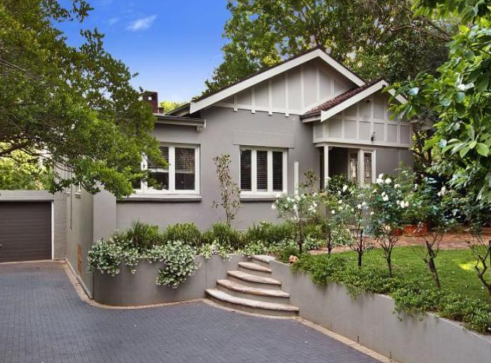

Lot Y DP 354642

**Hornsby Shire Council details**

**Heritage Register: (NONE)**

Part of Darling Hill Estate – Cheltenham Subdivision 1918

Sands Directories 1921-26 Victor J. Wilson “Vidor”; 1927 L. H. Beattie “Vidor”; 1930-32/3 R. C. Stanger “Vidor”

1933 Electoral Roll: Ralph Stanger

Sands Directories 1931 H. Lording; 1932/3 R. E. Lording 1933 (No. 200)

1933 Electoral Roll: Rowland Lording “Vidor”

“Vidor” is first mentioned when put up for auction in 1928, described as follows:

"VIDOR," BEECROFT-ROAD, between Cheltenham-road and Lyne-road, about 10 minutes from station.

The cottage Is built of brick, has tiled roof, verandahs, and contains living-room, 2 bedrooms, kitchen, bathroom, all domestic offices. At present let at 30/ per week.

The land has a frontage of about 66ft to Beecroft-road by a depth of about 300ft.

Torrens Title.

The grounds are well arranged in garden and fowl runs, and there is also a TENNIS COURT.1

Rowland Edward Lording would be living in “Vidor” by 1932.

In January 1915, Rowland Edward Lording, son of Edward Ernest Lording, aged 18, enlisted for WW1. He returned wounded and would be a military pensioner for many years but by 1935 would work as an accountant.

In 1920 he was living in Cheltenham.

In 1922, Rowland married Rosalind Mary Crowther, in the district of Ryde.

During the 1920’s he may have been living with his parents at Cheltenham.

*[His father Edward Ernest Lording, manufacturer, lived at “Hillston,” Old Beecroft-road, Cheltenham from 1923 (located at the Epping Boundary; house no. unknown)]*

**Rowland Edward Lording (1899-1944)**

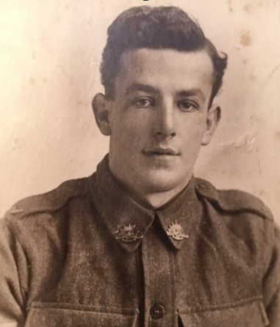

In 1930 Rowland (military pensioner), his wife Rosalind, along with his brother, Edward Sydney Lording (signwriter) were living in Beecroft-road, Cheltenham

From 1932 to 1936 Rowland was living at “Vidor,” 200 Beecroft-road, Cheltenham, presumably being rental accommodation.

By 1937 he had moved to Bondi Beach. He died in 1944, aged 44 years.

“Vidor” was then occupied by Edwin Henry Scaysbrook and by 1943 by Robert Bissett Paton.

The house was last sold in 2011.2

**Bibliography:**

1 Sydney Morning Herald, 6th June 1928

2 [200 Beecroft Road, Cheltenham, NSW 2119 - Property Details (realestate.com.au)](https://www.realestate.com.au/sold/property-house-nsw-cheltenham-108523506)

**Resources available (varies):**

* Sands Directories 1858-1933 City of Sydney [Sands Postal Directory | City of Sydney Archives (nsw.gov.au)](https://archives.cityofsydney.nsw.gov.au/nodes/view/495003)
* Newspaper articles – TROVE - [Search - Trove (nla.gov.au)](https://trove.nla.gov.au/search/advanced/category/newspapers)
* Ancestry.com (subscription only) [Genealogy, Family Trees and Family History Records online - Ancestry.com](https://www.ancestry.com.au/) – Sands Directories, Electoral Rolls, Family photos (Public Member photos), Census lists, marriage details, + miscellaneous
* N.S.W. Births, Deaths & Marriages [Family history search | NSW Government](https://www.nsw.gov.au/family-and-relationships/family-history-search) (QLD & Victoria also obtainable online)
* House photos and information via Hornsby Shire Council website for Property Search and Heritage Register [Heritage | Hornsby Shire Council (nsw.gov.au)](https://www.hornsby.nsw.gov.au/property/build/heritage)
* House photos and associated information via Internet search on address via Real Estate websites (from 2005)
* “Beecroft and Cheltenham Heritage Walks” - Beecroft-Cheltenham History Group Inc. 2004 book (1st edition)
* Australian War Museum website [Home | Australian War Memorial (awm.gov.au)](https://www.awm.gov.au/)