**204 BEECROFT ROAD, CHELTENHAM (“Illaroo” prev. “Tyraman”)**

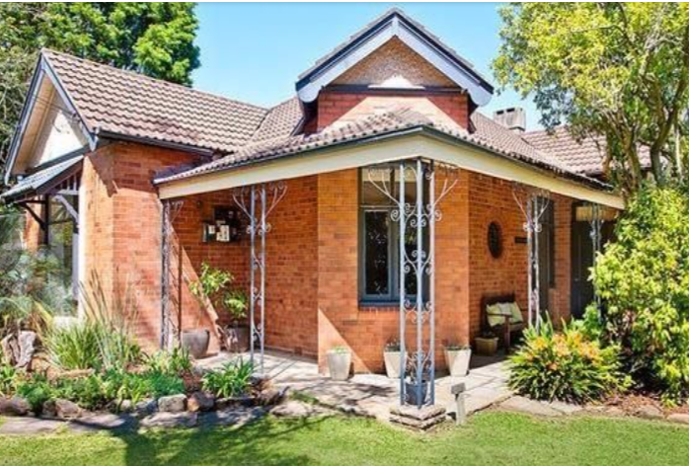

204 Beecroft Road Lot 111 DP 871365

9C Lyne Road Lot 111 DP 871365

**Hornsby Shire Council details**

**Heritage Register: (NONE)**

Occupied by John Patrick [Jack] Drinan (glazier) and Vera Mary Drinan in 1913.

*[John P. Drinan married Hannah M. V. J. L. Hill in 1906, district of Chatswood]*

A daughter, Margaret M., was born in 1907, district of Singleton.

A son, Bernard F., was born in 1913, at East Glendon (near Singleton). At this time Jack Drinan’s address was referred to as both East Glendon [near Singleton] and Cheltenham.

Sands Directories 1915-21 John P. Drinan “Tyraman”; 1924-1932/3 John H. Rothwell “Illaroo”

1933 Electoral Roll: John Rothwell

In 1915 the property is referred to as “Tyraman,” situated between “Hillside Villa” (no.194?) and “Kyola” (no. 208).

The 1918 Darling Hill Estate – Cheltenham subdivision shows three houses in succession on the West side of Beecroft-road after Lyne-road.

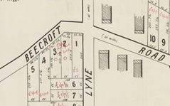

In 1919 the property was put up for sale, described as follows:

*TYRAMAN CORNER OF BEECROFT and LYNE RDS.*

*DETACHED BRICK BUNGALOW, slate roof, hall, 2 verandahs (45ft x 10ft and 24ft x 9ft), lounge (18ft x 9ft), drawing and dining rooms, breakfast room, 4 bedrooms, kitchenette (gas stove and gas copper), bathroom, pantry and storeroom, Fruit trees, flower garden, bush-house and fowl runs.*

*LAND 198ft [60m] to BEECROFT ROAD by 250ft [76m] along LYNE ROAD.*1

[Currently land covers 9c, 9d & 11 Lyne-road & 204a Beecroft-road; originally 204 Beecroft-road]

In 1920 the property is again put up for sale, described as follows:

TYRAMAN, CONVENIENT TO STATION.

*Superior Residence, built of brick, slate roof, containing drawing and dining rooms, 4 bedrooms, breakfast-room, and all usual offices. Land. 210ft. x 250ft.*2

From 1925 John Harry Rothwell was occupying the property, now named at “Illaroo.”

*[John H. Rothwell married Julia Edith Mackenzie 1907 Sydney]*

**John Harry Rothwell (1876-1956)**

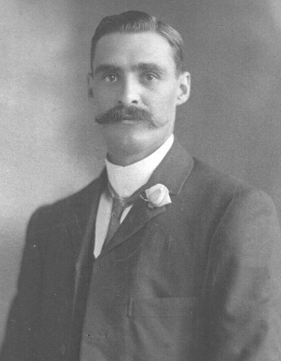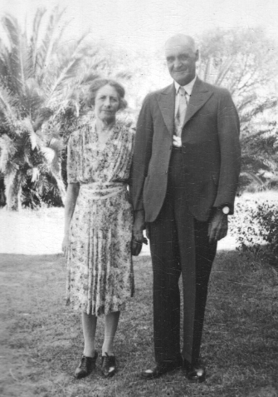

The 1933 & 1935 Electoral Rolls lists John Harry Rothwell (produce merchant), Julia Edith Rothwell – 204 Beecroft-road, Cheltenham

*[By 1936 they had moved to “Curragh,” Roma, QLD]*

The house was then occupied by John Martin Hawkey (Defence Dept.) and his wife Annie Louise Hawkey.

*[John M. Hawkey married Annie Louisa Krinks 1905 Surry Hills]*

**John Martin Hawkey (1877-1958)**

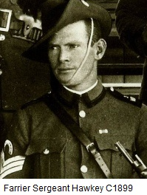

In 1947 Annie Louise Hawkey died and her husband John continued to live in the house for several more years. He died in 1958 at Monto, N.S.W.

**Bibliography:**

1 Sydney Morning Herald, 17th December 1919

2 Sydney Morning Herald 10th July 1920

**Resources available (varies):**

* Sands Directories 1858-1933 City of Sydney [Sands Postal Directory | City of Sydney Archives (nsw.gov.au)](https://archives.cityofsydney.nsw.gov.au/nodes/view/495003)
* Newspaper articles – TROVE - [Search - Trove (nla.gov.au)](https://trove.nla.gov.au/search/advanced/category/newspapers)
* Ancestry.com (subscription only) [Genealogy, Family Trees and Family History Records online - Ancestry.com](https://www.ancestry.com.au/) – Sands Directories, Electoral Rolls, Family photos (Public Member photos), Census lists, marriage details, + miscellaneous
* N.S.W. Births, Deaths & Marriages [Family history search | NSW Government](https://www.nsw.gov.au/family-and-relationships/family-history-search) (QLD & Victoria also obtainable online)
* House photos and information via Hornsby Shire Council website for Property Search and Heritage Register [Heritage | Hornsby Shire Council (nsw.gov.au)](https://www.hornsby.nsw.gov.au/property/build/heritage)
* House photos and associated information via Internet search on address via Real Estate websites (from 2005)
* “Beecroft and Cheltenham Heritage Walks” - Beecroft-Cheltenham History Group Inc. 2004 book (1st edition)
* Australian War Museum website [Home | Australian War Memorial (awm.gov.au)](https://www.awm.gov.au/)