**207 & 211 BEECROFT ROAD, CHELTENHAM (“Wytona”)**

**Photo not found**

207 Beecroft Road Lot 3 DP 205241

209 Beecroft Road Lot 4 DP 205241

211 Beecroft Road Lot A DP 417307

**Hornsby Shire Council details**

**Heritage Register: (NONE)**

**No. 207 was built circa 1950. No.211 was built in 1950.**

The Hornsby Council Rate Books for 1907-1909 lists land owned by Frederick J. Brierley, of Beecroft-road, Carlingford [now Epping, previously East Carlingford], comprising 4 acres 1 rood and 27 perches, and occupied by Katherine Rattray.

*[Frederick James Brierley married Emilie Florence Dyer in 1901, at Croydon. He was the only surviving son if James Brierley, of “Ascot,” Burwood, and Emilie was the only child of Henry C. Dyer, of ”Lysanda,” Burwood.*

*Their child born at Burwood in 1902 died in that year. Their 2nd child was born in 1908 in the Ryde district.]*

In 1909 Frederick Brierley advertised for sale three cows with calves at foot for £4, £6 and £7. In 1910 he reported a theft of his dark-brown mare.

In 1910 moved from Carlingford to his “Wytona” ‘modern’ poultry yards (presumably the 4 acres previously occupied by Katherine Rattray], which he had substantially built up and where he ran about 850 hens.**1**

The 1913 Electoral Roll lists Frederick James Brierley (poultry farmer), Emily Florence Brierley & John Yeomans Cowlishaw (labourer) at “Wytona,” Cheltenham

**Brierley’s Poultry Farm (1913)**

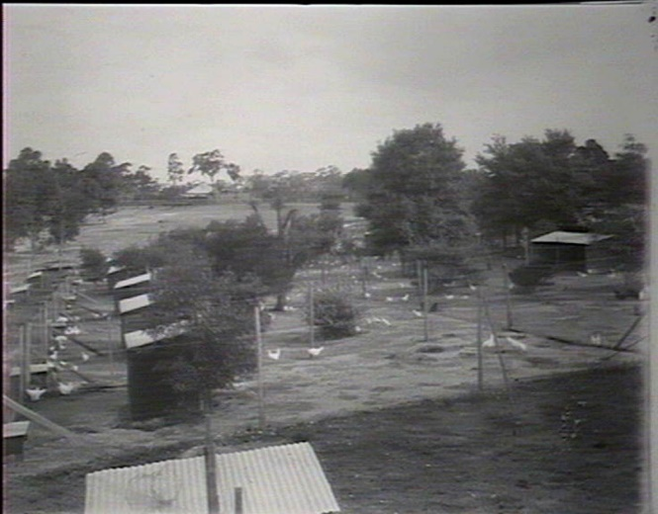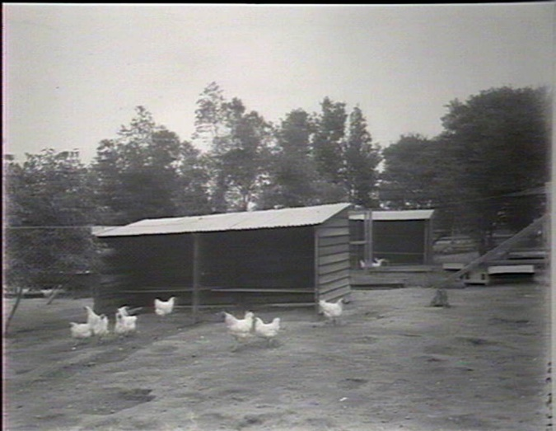

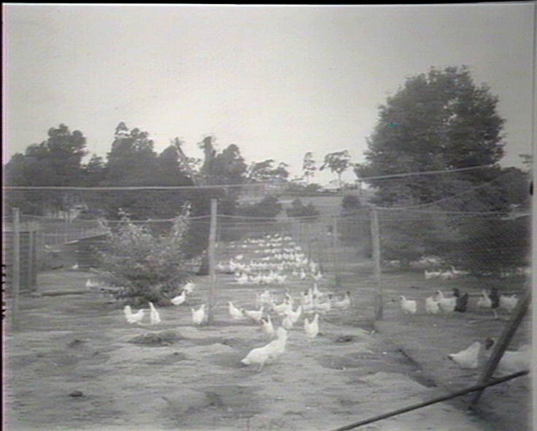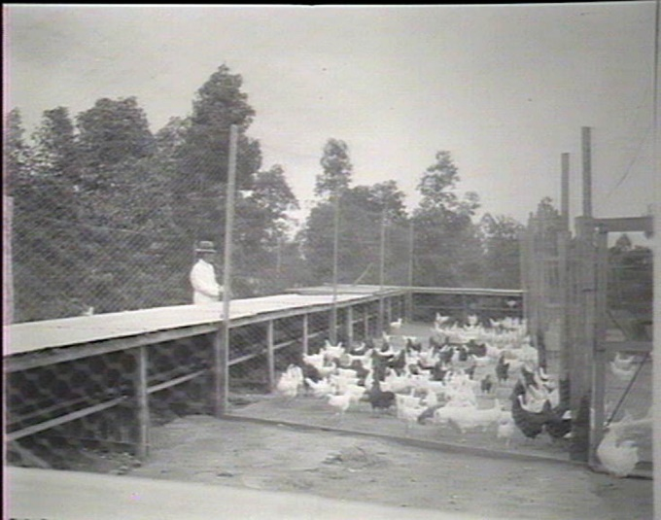

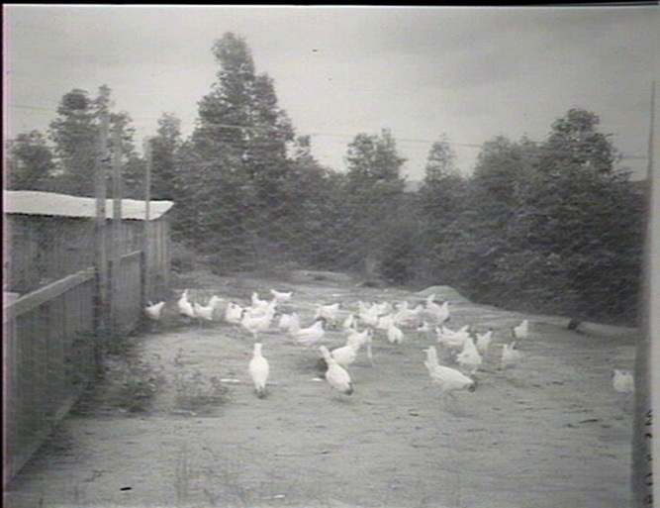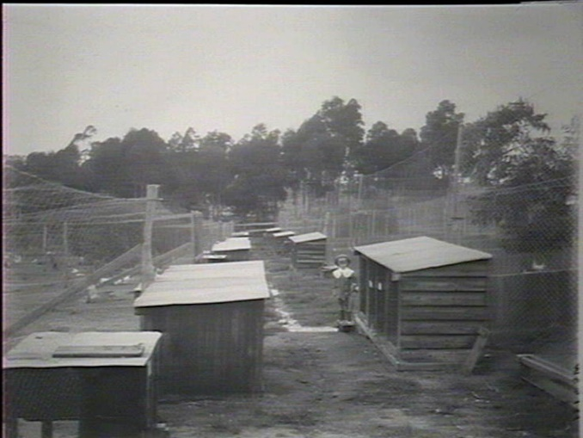

Sands Directories 1915-22 Frederick Brierley Wytona; 1923-32/33 Mrs Emilie Brierley Maxwelltown No. 207

Electoral Roll 1933: Florence Brierley No. 211

In 1914 he was also dealing in horses, such as ‘PLANET,’ a pure-bred Welsh pony, imported from New Zealand (*Mares visited by arrangement FEE, £1/1/.*)**2**

Also, in 1914 he had constructed a brick cottage on his property which was advertised for sale and described as follows:

A MODERN BRICK RESIDENCE, on Wytona Estate.

4 minutes from station and 3 minutes from the bowls, tennis and croquet greens with an uninterrupted view of the surrounding hills, containing reception hall and 5 rooms (dining room 20 x 14, bedroom 16 x 15), front and side verandahs 40 x 5 (bricked in), back verandahs 20 x 10 (enclosed), really making 6 rooms in all, fibrous plaster ceilings, elaborate finish throughout, land 68 x 175 or more, rich gardening soil.**3**

In January 1915 a villa was being completed for Mr. Brierley (location unknown).

Unfortunately, on 26th December 1916, Frederick Brierley died, aged 44 years, leaving a widow and three young sons (Frederick, Adrian & Gerald). He had been prominent some years ago as an exhibitor of white Leghorns (known as the “Leghorn King”,) but was better known as the proprietor of one of the best poultry farms in the State. For seven years had been a member of the executive committee controlling the Hawkesbury Agricultural College poultry competitions. He had been seriously ill for about ten days, and on the Saturday, before he was laid up, he won the bowling championship of the Cheltenham Club, of which he was a foundation member.

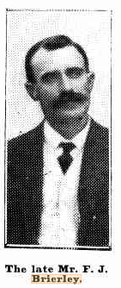

In March 1917 the Brierley Stock and Plant, spread over 4 acres, was put up for sale.**4**

In April 1919 Mrs. Brierley was selling off some of the remaining stock; black Orpingtons and white Leghorns.

In September 1919 Mrs. Brierley put up any remaining stock and plant, as well as a cottage, described as follows:

Weatherboard Cottage, iron roof, containing 5 rooms, kitchen, offices, broad verandah, gas, water, bath heater, floor coverings, blinds, etc. Land, 80ft frontage, good depth.**5**

The cottage does not appear to have been sold.

A Mrs. McDougall occupied the “Wytona” cottage, Beecroft-road, during the 1920’s.

Mrs. Emilie F. Brierley also lived on the Beecroft-road in a home named “Maxwellton.”

In 1927 Mrs. Brierley advised agents that her land in Cheltenham-crescent (The Crescent) was sold.

In 1931 her address is referred to as 207 Beecroft-road, Cheltenham. In that year her weatherboard cottage, on the corner of Lyne and Beecroft roads, was demolished and removed,

In 1933 Mrs. Brierley was living with her son, Frederick Henry William Brierley, nurseryman, at 211 Beecroft-road, Cheltenham

In 1936 she put up for sale two building sites – Lot 12a Brierley Estate, with frontage to Cheltenham-crescent {The Crescent) and Lot 1 Darling Hill Estate, with frontage to Cheltenham-crescent.

For 1937 Mrs. Brierley continued to live at 211 Beecroft-road with her son Frederick, and

207 Beecroft-road being occupied by her son Gerald James Brierley (no occupation), and Geoffrey Brierley (printer).

In 1949 up to 1958 Mrs. Brierley was living at 207 Beecroft-road, Cheltenham.

Emilie Florence Brierley died in 1961, in the district of Chatswood.

**Bibliography:**

1 Daily Telegraph, 11th June 1910

2 Cumberland Argus, 3rd January 1914

3 Sydney Morning Herald, 3rd October 1914

4 Daily Telegraph, 31st March 1917

5 Sydney Morning Herald, 13th September 1919

**Resources available (varies):**

* Sands Directories 1858-1933 City of Sydney [Sands Postal Directory | City of Sydney Archives (nsw.gov.au)](https://archives.cityofsydney.nsw.gov.au/nodes/view/495003)
* Newspaper articles – TROVE - [Search - Trove (nla.gov.au)](https://trove.nla.gov.au/search/advanced/category/newspapers)
* Ancestry.com (subscription only) [Genealogy, Family Trees and Family History Records online - Ancestry.com](https://www.ancestry.com.au/) – Sands Directories, Electoral Rolls, Family photos (Public Member photos), Census lists, marriage details, + miscellaneous
* N.S.W. Births, Deaths & Marriages [Family history search | NSW Government](https://www.nsw.gov.au/family-and-relationships/family-history-search) (QLD & Victoria also obtainable online)
* House photos and information via Hornsby Shire Council website for Property Search and Heritage Register [Heritage | Hornsby Shire Council (nsw.gov.au)](https://www.hornsby.nsw.gov.au/property/build/heritage)
* House photos and associated information via Internet search on address via Real Estate websites (from 2005)
* “Beecroft and Cheltenham Heritage Walks” - Beecroft-Cheltenham History Group Inc. 2004 book (1st edition)
* Australian War Museum website [Home | Australian War Memorial (awm.gov.au)](https://www.awm.gov.au/)