**208 BEECROFT ROAD, CHELTENHAM (“Kyola”)**

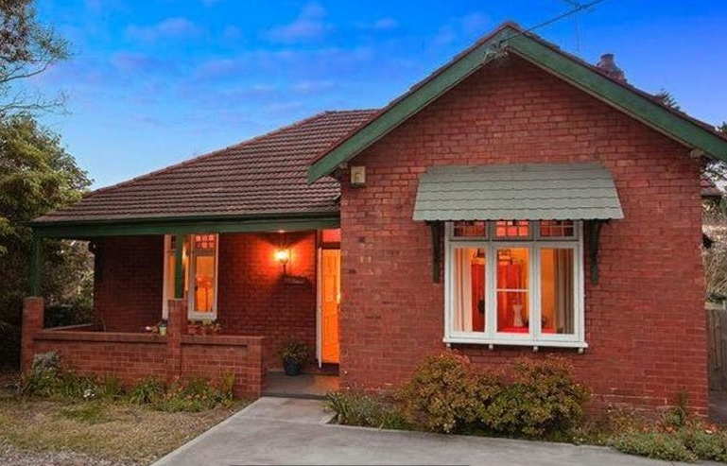

Lot 1 DP 1077869

**Hornsby Shire Council details**

**Heritage Register: (NONE)**

In 1913, at “Kyola,” Beecroft-road, Cheltenham, the wife of Ernest Fleming Willans, Cillie, gave birth to a daughter, and in 1916 a son was born.

*[Ernest Fleming Willans married Cillie Rousell Young 1912 in Tasmania]*

Sands Directories 1915-19 Ernest Willans “Kyola”; 1920 James Somerville; 1921-32/33 T. M. Somerville “Kyola”

Electoral Roll 1933: Townshend Somerville No. 208

By 1920 the house was occupied by James Somerville.

By 1923 Townsend Neville Somerville was in residence.

*[Townsend Neville Somerville, born 1887 N.Z., married Mabel Eileen Watts 1916 Victoria]*

T. N. Somerville (clerk) moved to Warringah in 1933. He died in 1959.

In 1934 & 1935 Rudolf Kehrli was the occupant of 208 Beecroft-road, Cheltenham.

In 1943 Josef Ackermann (engineer) was the occupant.

The house was last sold in 2010.1

**Bibliography:**

1 [208 Beecroft Road, Cheltenham, NSW 2119 - Property Details (realestate.com.au)](https://www.realestate.com.au/sold/property-house-nsw-cheltenham-106847499)

**Resources available (varies):**

* Sands Directories 1858-1933 City of Sydney [Sands Postal Directory | City of Sydney Archives (nsw.gov.au)](https://archives.cityofsydney.nsw.gov.au/nodes/view/495003)
* Newspaper articles – TROVE - [Search - Trove (nla.gov.au)](https://trove.nla.gov.au/search/advanced/category/newspapers)
* Ancestry.com (subscription only) [Genealogy, Family Trees and Family History Records online - Ancestry.com](https://www.ancestry.com.au/) – Sands Directories, Electoral Rolls, Family photos (Public Member photos), Census lists, marriage details, + miscellaneous
* N.S.W. Births, Deaths & Marriages [Family history search | NSW Government](https://www.nsw.gov.au/family-and-relationships/family-history-search) (QLD & Victoria also obtainable online)
* House photos and information via Hornsby Shire Council website for Property Search and Heritage Register [Heritage | Hornsby Shire Council (nsw.gov.au)](https://www.hornsby.nsw.gov.au/property/build/heritage)
* House photos and associated information via Internet search on address via Real Estate websites (from 2005)
* “Beecroft and Cheltenham Heritage Walks” - Beecroft-Cheltenham History Group Inc. 2004 book (1st edition)
* Australian War Museum website [Home | Australian War Memorial (awm.gov.au)](https://www.awm.gov.au/)