**210 BEECROFT ROAD, CHELTENHAM (“Cheltan”, prev. “Askham”)**

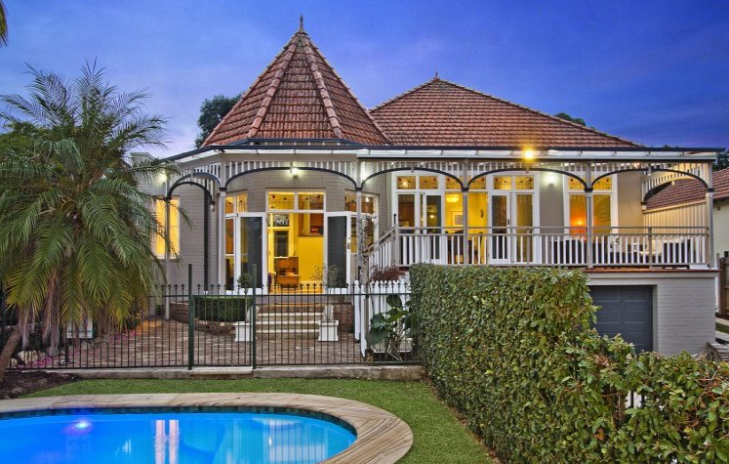

Lot 6 DP 1082126

**Hornsby Shire Council details**

**Heritage Register: (NONE)**

The 1913 Electoral Roll lists William John Barraclough (operator – Royal Mint), Annie Prest Barraclough – Beecroft-road, Cheltenham

*[William J. Barraclough married Annie P. Smith in 1903, Paddington]*

Sands Directories 1915-1932/3 William Barraclough “Askham”

Electoral Roll 1933: William Barraclough No. 210

In 1915 William Barraclough is living at “Askham,” Beecroft-road, Cheltenham. In 1919 he wrote to the Hornsby Council, calling attention to the disgraceful condition of the footpaths and road fronting his residence in Beecroft-road, and he was informed that the road is to be metalled.

In 1936 William John Barraclough (mint operator), Annie Prest Barraclough and Harry Barraclough (salesman) were still living at 210 Beecroft-road, Cheltenham, however by 1937 they had moved to Lilyfield.

By 1943 Florence Crabb was living in the house.

The house (now named “Cheltan,” c1905) was last sold in 2015.1

**Bibliography:**

1 [210 Beecroft Road, Cheltenham, NSW 2119 - Property Details (realestate.com.au)](https://www.realestate.com.au/sold/property-house-nsw-cheltenham-119861849)

**Resources available (varies):**

* Sands Directories 1858-1933 City of Sydney [Sands Postal Directory | City of Sydney Archives (nsw.gov.au)](https://archives.cityofsydney.nsw.gov.au/nodes/view/495003)
* Newspaper articles – TROVE - [Search - Trove (nla.gov.au)](https://trove.nla.gov.au/search/advanced/category/newspapers)
* Ancestry.com (subscription only) [Genealogy, Family Trees and Family History Records online - Ancestry.com](https://www.ancestry.com.au/) – Sands Directories, Electoral Rolls, Family photos (Public Member photos), Census lists, marriage details, + miscellaneous
* N.S.W. Births, Deaths & Marriages [Family history search | NSW Government](https://www.nsw.gov.au/family-and-relationships/family-history-search) (QLD & Victoria also obtainable online)
* House photos and information via Hornsby Shire Council website for Property Search and Heritage Register [Heritage | Hornsby Shire Council (nsw.gov.au)](https://www.hornsby.nsw.gov.au/property/build/heritage)
* House photos and associated information via Internet search on address via Real Estate websites (from 2005)
* “Beecroft and Cheltenham Heritage Walks” - Beecroft-Cheltenham History Group Inc. 2004 book (1st edition)
* Australian War Museum website [Home | Australian War Memorial (awm.gov.au)](https://www.awm.gov.au/)