**212 BEECROFT ROAD, CHELTENHAM (“Argyle”?)**

**Thought to be the home of Arthur R. Munro 1918-1923 as immediately follows No. 210 in Sands Directories, although Nos. 214 & 216 could also be considered**

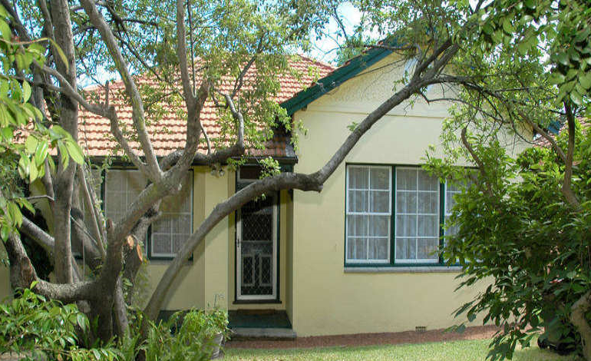

Lot 1 DP 551431

Real Estate details state that the house was built in 1920.

**Hornsby Shire Council details**

**Heritage Register: (NONE)**

Sands Directories 1918-1923 Arthur R. Munro; 1924-25 John L. Fitzpatrick “Argyle”; 1926-27 William Freeman

“Argyle” was the home of Arthur R. Munro, son of Arthur William Munro, from 1918.

Arthur R. Munro married Harriet M. Pryor in 1917, Sydney]

In 1918 Mary Ann, wife of Arthur William Munro, of “Argyle,” Beecroft-road, Cheltenham, late of Forest Lodge, died at her daughter’s residence in Hornsby, aged 71 years. Her children were William, Edward (on active service [later to become a lieutenant-colonel]), Arthur R. and Mildred.

In 1924-25 John L. Fitzpatrick was living at “Argyle,” Beecroft-road. The Munro family moved to 78 The Crescent, Cheltenham, also later named “Argyle.”

For 1926-27 William Freeman was at this address.

The next occupants were recorded in 1932: Alexander John Coster, sen. (poultry farmer), Elizabeth Coster, Alexander John Coster, jun. (bread carter), Hannah Elizabeth Coster, Sarah Cecelia Florence Coster, Esther May Jewell – 212 Beecroft-road, Cheltenham

In 1943 the home was occupied by Leonard Joseph Turner (storeman) and Beryl Jean Turner – 212 Beecroft-road, Cheltenham.

*[Leonard J. Turner married Beryl Jean Schlaadt 1938 Ryde]*

They would continue to live at this address up to 1958 and by 1963 had moved to Hornsby.

The house was last sold in 2022.**1**

**Bibliography:**

1 [212 Beecroft Road, Cheltenham, NSW 2119 - Property Details (realestate.com.au)](https://www.realestate.com.au/sold/property-house-nsw-cheltenham-106297868)

**Resources available (varies):**

* Sands Directories 1858-1933 City of Sydney [Sands Postal Directory | City of Sydney Archives (nsw.gov.au)](https://archives.cityofsydney.nsw.gov.au/nodes/view/495003)
* Newspaper articles – TROVE - [Search - Trove (nla.gov.au)](https://trove.nla.gov.au/search/advanced/category/newspapers)
* Ancestry.com (subscription only) [Genealogy, Family Trees and Family History Records online - Ancestry.com](https://www.ancestry.com.au/) – Sands Directories, Electoral Rolls, Family photos (Public Member photos), Census lists, marriage details, + miscellaneous
* N.S.W. Births, Deaths & Marriages [Family history search | NSW Government](https://www.nsw.gov.au/family-and-relationships/family-history-search) (QLD & Victoria also obtainable online)
* House photos and information via Hornsby Shire Council website for Property Search and Heritage Register [Heritage | Hornsby Shire Council (nsw.gov.au)](https://www.hornsby.nsw.gov.au/property/build/heritage)
* House photos and associated information via Internet search on address via Real Estate websites (from 2005)
* “Beecroft and Cheltenham Heritage Walks” - Beecroft-Cheltenham History Group Inc. 2004 book (1st edition)
* Australian War Museum website [Home | Australian War Memorial (awm.gov.au)](https://www.awm.gov.au/)