**213 BEECROFT ROAD, CHELTENHAM (“Headley”)**

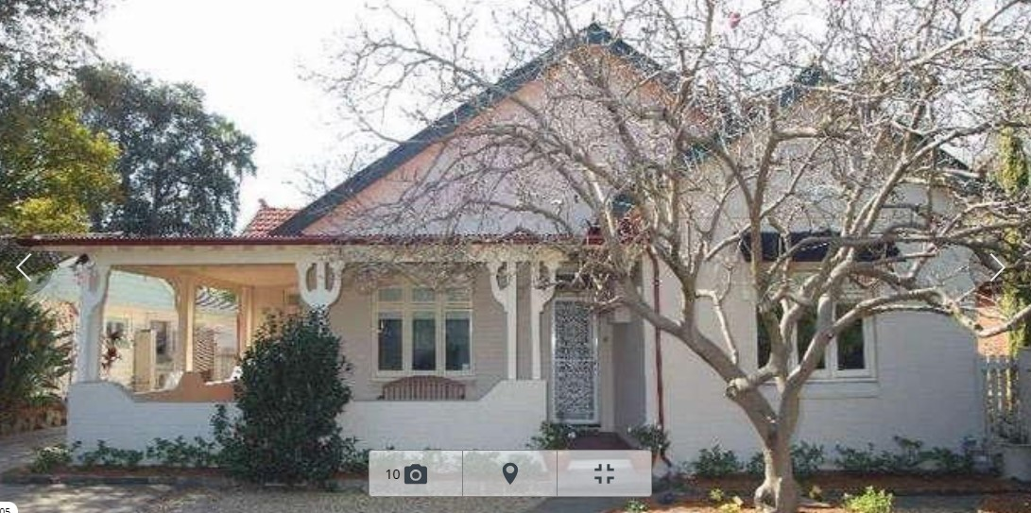

Lot 21 DP 526411

**Hornsby Shire Council details**

**Heritage Register: (NONE)**

“Headley” is a Federation bungalow which was under construction in August 1915, described as a W.B. Cottage for Mrs. A. M. Smith, Beecroft-road, Cheltenham

*[Leslie Smith, an English immigrant, married Ada Maud Jones (born 1879 Berrima), of “Heather Brae,” Moss Vale, at St. Philips, Church Hill, Sydney.]*

Sands Directories 1917-32/33 Leslie Smith Headley No. 213

Electoral Roll 1933: Leslie Smith No. 213

On 29th June 1916, a son, Leslie Alderson Smith was born at Cheltenham. His WW2 Army service number was NX18456.

There were two older siblings: Elizabeth A., 1913 & Moverley A., 1915; both in the district of St. Leonards

In March 1917 there was an advertisement for an exchange of houses for 3 months. The Smiths were wanting a suitable cottage at the seaside. “Headley” is described as a ‘brick Cottage, nice grounds, Hornsby Line, containing 3 bedrooms, sleep-out verandah, modern conveniences, including gas stove, gas copper, telephone, pianola, garage, etc.’

In 1920 “Headley” is advertised for sale, described as follows:

‘an Attractive COTTAGE, built of brick, tile roof, containing TWO RECEPTION ROOMS, THREE BEDROOMS, Bathroom, Kitchen, Laundry, etc., Sleeping-out Verandah.

Detached is a W.B. Shed, suitable for Garage.

THE LAND, which is ample and laid out in lawns, garden, etc., has a frontage of about 200 feet to Beecroft-road, by depths of about 240 feet and 170 feet.’1

The house was not sold.

In 1921 Ada’s father, William Jones, of Moss Vale, died, aged 65 years. He was a builder and contractor, and built many public edifices and fine residences in Moss Vale. He was heavily involved in community affairs, and was survived by a widow, one son, and four daughters.

In 1926, at “Headley,” Ada’s mother, Elizabeth Jones, died.

During the 1930’s the house was occupied by Leslie Smith (clerk), Ada Maud Smith, and Elizabeth Marie Jones.

In 1939 the house was again put up for sale, described as follows:

‘IDEAL FAMILY HOME, 13 miles Sydney, consisting of D.F. Brick Cottage, 4 bedrooms, large sleeping out verandahs, lounge room, dining room, breakfast room, kitchen, etc., outside laundry. All doors and windows wire screened. Brick garage with concrete drive; to road. 202 feet frontage, about one acre in all laid out in tennis court, flower and vegetable gardens, bush house, fish ponds, etc. Price £2260.**’2**

Later that year their daughter, Elizabeth Alderson Smith, returned to Sydney after two years travelling in England and on the Continent.

By 1943 the Smiths had left “Headley” for North Sydney, and the house was occupied by Frederick John Norrie (retail manager) and family.

**Bibliography:**

1 Sydney Morning Herald, 6th November 1920

2 Land, 10th March 1939

**Resources available (varies):**

* Sands Directories 1858-1933 City of Sydney [Sands Postal Directory | City of Sydney Archives (nsw.gov.au)](https://archives.cityofsydney.nsw.gov.au/nodes/view/495003)
* Newspaper articles – TROVE - [Search - Trove (nla.gov.au)](https://trove.nla.gov.au/search/advanced/category/newspapers)
* Ancestry.com (subscription only) [Genealogy, Family Trees and Family History Records online - Ancestry.com](https://www.ancestry.com.au/) – Sands Directories, Electoral Rolls, Family photos (Public Member photos), Census lists, marriage details, + miscellaneous
* N.S.W. Births, Deaths & Marriages [Family history search | NSW Government](https://www.nsw.gov.au/family-and-relationships/family-history-search) (QLD & Victoria also obtainable online)
* House photos and information via Hornsby Shire Council website for Property Search and Heritage Register [Heritage | Hornsby Shire Council (nsw.gov.au)](https://www.hornsby.nsw.gov.au/property/build/heritage)
* House photos and associated information via Internet search on address via Real Estate websites (from 2005)
* “Beecroft and Cheltenham Heritage Walks” - Beecroft-Cheltenham History Group Inc. 2004 book (1st edition)
* Australian War Museum website [Home | Australian War Memorial (awm.gov.au)](https://www.awm.gov.au/)
* Beecroft and Cheltenham History Group website [Beecroft and Cheltenham History - Beecroft Cheltenham History Group (bchg.org.au)](https://bchg.org.au/)