**219 BEECROFT ROAD, CHELTENHAM (“Elowera”)**

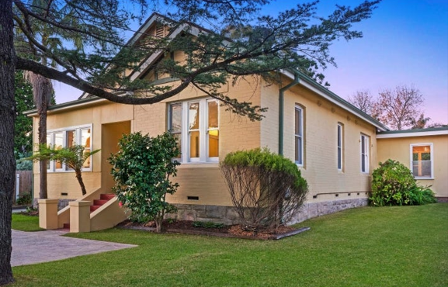

Lot 33 DP 1053621

**Hornsby Shire Council details**

**Heritage Register: (NONE)**

Part of Darling Hill Estate – Cheltenham Subdivision 1918

Sands Directories 1921-32/33 Charles W. Hampton Elowera No. 219

Electoral Roll 1933: Charles Hampton No. 219

The first resident of this property was Charles Walter Hampton, in 1923.

The house name “Elowera” is first recorded in 1925. The origin of the name is unknown.

The 1930 Electoral Roll lists the occupants as Charles W. Hampton (assistant foreman) and Annie Amelia Hampton, of Beecroft-road, Cheltenham

*[In 1912 Charles W. Hampton (1882-1954) married Annie A. Williams (1888-1961), district of Liverpool]*

The Hampton family continued to live at 219 Beecroft-road, Cheltenham up to 1954 when Charles (assistant foreman) died.

By 1958 his widow Annie had moved.

The house was last sold in 2017.1

**Bibliography:**

1 [219 Beecroft Road, Cheltenham, NSW 2119 - Property Details (realestate.com.au)](https://www.realestate.com.au/sold/property-house-nsw-cheltenham-125555866)

**Resources available (varies):**

* Sands Directories 1858-1933 City of Sydney [Sands Postal Directory | City of Sydney Archives (nsw.gov.au)](https://archives.cityofsydney.nsw.gov.au/nodes/view/495003)
* Newspaper articles – TROVE - [Search - Trove (nla.gov.au)](https://trove.nla.gov.au/search/advanced/category/newspapers)
* Ancestry.com (subscription only) [Genealogy, Family Trees and Family History Records online - Ancestry.com](https://www.ancestry.com.au/) – Sands Directories, Electoral Rolls, Family photos (Public Member photos), Census lists, marriage details, + miscellaneous
* N.S.W. Births, Deaths & Marriages [Family history search | NSW Government](https://www.nsw.gov.au/family-and-relationships/family-history-search) (QLD & Victoria also obtainable online)
* House photos and information via Hornsby Shire Council website for Property Search and Heritage Register [Heritage | Hornsby Shire Council (nsw.gov.au)](https://www.hornsby.nsw.gov.au/property/build/heritage)
* House photos and associated information via Internet search on address via Real Estate websites (from 2005)
* “Beecroft and Cheltenham Heritage Walks” - Beecroft-Cheltenham History Group Inc. 2004 book (1st edition)
* Australian War Museum website [Home | Australian War Memorial (awm.gov.au)](https://www.awm.gov.au/)