**22 CHORLEY AVENUE, CHELTENHAM**

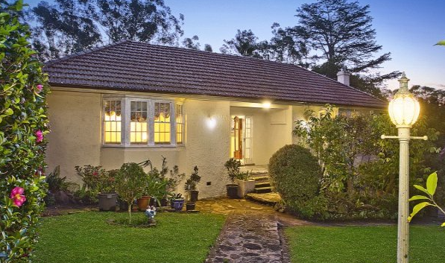

Lot 125 DP 12364

Sands Directories 1932/3 P. H. N. Matthews

Electoral Roll 1933: Percy Matthews No. 22

Percy Harry Matthews was living there in 1930.

In 1933 occupants were Percy Harry Nicholls Matthews (engineer) and Olive Matthews.

*[Percy H. N. Matthews married Olive Sneath in 1928, district of Lismore]*

In 1943 they were still living at this address.

The house was last sold in 2015.1

**Bibliography:**

1 [22 Chorley Avenue, Cheltenham, NSW 2119 - realestate.com.au](https://www.realestate.com.au/property/22-chorley-ave-cheltenham-nsw-2119/)

**Resources available (varies):**

* Sands Directories 1858-1933 City of Sydney [Sands Postal Directory | City of Sydney Archives (nsw.gov.au)](https://archives.cityofsydney.nsw.gov.au/nodes/view/495003)
* Newspaper articles – TROVE - [Search - Trove (nla.gov.au)](https://trove.nla.gov.au/search/advanced/category/newspapers)
* Ancestry.com (subscription only) [Genealogy, Family Trees and Family History Records online - Ancestry.com](https://www.ancestry.com.au/) – Sands Directories, Electoral Rolls, Family photos (Public Member photos), Census lists, marriage details, + miscellaneous
* N.S.W. Births, Deaths & Marriages [Family history search | NSW Government](https://www.nsw.gov.au/family-and-relationships/family-history-search) (QLD & Victoria also obtainable online)
* House photos and information via Hornsby Shire Council website for Property Search and Heritage Register [Heritage | Hornsby Shire Council (nsw.gov.au)](https://www.hornsby.nsw.gov.au/property/build/heritage)
* House photos and associated information via Internet search on address via Real Estate websites (from 2005)
* “Beecroft and Cheltenham Heritage Walks” - Beecroft-Cheltenham History Group Inc. 2004 book (1st edition)
* Australian War Museum website [Home | Australian War Memorial (awm.gov.au)](https://www.awm.gov.au/)