**22 THE BOULEVARD, CHELTENHAM (“Maida Vale”)**

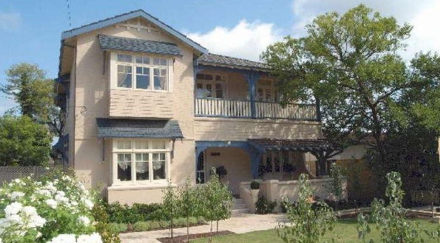

Lot A DP 337333

**Hornsby Shire Council details**

**Heritage Register: (NONE)**

Part of Mount Pleasant Estate – Cheltenham 1st Subdivision 1908

This house dates from circa 1906 and has painted rendered walls. While originally single storey, it had a second storey added in about 2010.

David Benjamin Bertram, of Marrickville, married Una May Johnston, of Marrickville, in 1907, Sydney.

They were living in The Boulevard, Cheltenham by 1919.

Sands Directories 1915-1918: W. B. Bull; 1919-1920 Walter Kerridge (then movedf to no.28); 1921-1932/3 David Bertram “Maidavale”

Electoral Roll 1933: Alexander Bertram

In 1933 the occupants were: David Benjamin Bertram (manager), Una May Bertram,Myrtle Merline Bertram (home duties), Alexander Roy Douglas Bertram (student) – “Maida Vale,” The Boulevard, Cheltenham

*[“Maida Vale” is a residential district in London]*

In 1941 he wrote to the Editor of the “Herald,” thus:

“Sir, - The average resident of Cheltenham does not seek for publicity. All he wishes to do is to live a quiet life within his garden and his trees, do the right to his neighbour, keep the enemy out, and have his soldier son safely back with him. However, if Mr. Councillor Gollan will attend with me at any time suitable to himself and his fellow councillors at Cheltenham I will point out to them the acts of utter vandalism by the Shire Council's employees in the destruction of beautiful shady palm trees, that were, I believe, brought and planted many years ago by our respected resident, the late Mr. William Chorley.

Yours faithfully.

DAVID B. BERTRAM. Cheltenham, July 1.”

In 1952 David Benjamin Bertram died at his residence “Maida Vale,” aged 75 years.

His obituary states that he was associated with the well-known Sydney legal firm of A. S. Boulton, Lane, Rex & Co.

Una May Bertram was still living at 22 The Boulevard in 1954 but had moved to Epping by 1958. She died in 1959, in the district of Balmain.

**Bibliography: none**

**Resources available (varies):**

* Sands Directories 1858-1933 City of Sydney [Sands Postal Directory | City of Sydney Archives (nsw.gov.au)](https://archives.cityofsydney.nsw.gov.au/nodes/view/495003)
* Newspaper articles – TROVE - [Search - Trove (nla.gov.au)](https://trove.nla.gov.au/search/advanced/category/newspapers)
* Ancestry.com (subscription only) [Genealogy, Family Trees and Family History Records online - Ancestry.com](https://www.ancestry.com.au/) – Sands Directories, Electoral Rolls, Family photos (Public Member photos), Census lists, marriage details, + miscellaneous
* N.S.W. Births, Deaths & Marriages [Family history search | NSW Government](https://www.nsw.gov.au/family-and-relationships/family-history-search) (QLD & Victoria also obtainable online)
* House photos and information via Hornsby Shire Council website for Property Search and Heritage Register [Heritage | Hornsby Shire Council (nsw.gov.au)](https://www.hornsby.nsw.gov.au/property/build/heritage)
* House photos and associated information via Internet search on address via Real Estate websites (from 2005)
* “Beecroft and Cheltenham Heritage Walks” - Beecroft-Cheltenham History Group Inc. 2004 book (1st edition)
* Australian War Museum website [Home | Australian War Memorial (awm.gov.au)](https://www.awm.gov.au/)
* Beecroft and Cheltenham History Group website [Beecroft and Cheltenham History - Beecroft Cheltenham History Group (bchg.org.au)](https://bchg.org.au/)