**24 THE BOULEVARD, CHELTENHAM**

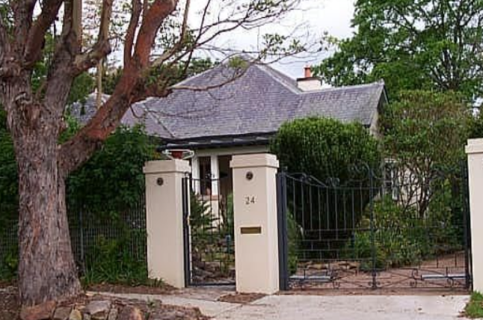

Lot 18 DP 5440

**Hornsby Shire Council details**

**Heritage Register: Item No. 287**

Part of Mount Pleasant Estate – Cheltenham 1st Subdivision 1908

The Californian bungalow was built in 1914 in the bungalow style with a slate roof featuring an uplift at each end and is white painted brick. It has an unusual window treatment and solid timber verandah posts on brick. It has two gables offset to each other. It has an unusual patterned slate roof and sunray motif on the front gable. It has a period formal front garden.

Sands Directories 1918-1919: Angus E. Cameron

Sands Directories 1920-1923: A. Cox; 1924-1927 Henry Cox “Carmylia”; 1930-1932/3 K. Arnott

Electoral Roll 1933: Lorna Arnott No.24

The earliest occupant found is Henry Ivamy F. Cox in 1923 and the name “Carmylia” is recorded in 1925.

*[Henry (‘Harry’) Cox Married Frances (‘Tottie’) Robson in 1899, Paddington]*

The home was bought in 1930 by Lorna Beryl Arnott, formerly living in The Boulevard, after the death of her husband, Keith Arnott, aged 29 years, son of H. L. Arnott of Beecroft-road, Beecroft, following an attack of influenza. Keith was involved in the family biscuit business. He was educated at King’s School and was an all-round athlete, winning many cups. He left a widow and three young boys.

*[Keith Arnott married Lorna Beryl Godfrey in 1920, at Newcastle]*

Lorna occupied 24 The Boulevard until 1939, when the house was sold to the family who would remain in there till as recent as 2004.

**Bibliography: none**

**Resources available (varies):**

* Sands Directories 1858-1933 City of Sydney [Sands Postal Directory | City of Sydney Archives (nsw.gov.au)](https://archives.cityofsydney.nsw.gov.au/nodes/view/495003)
* Newspaper articles – TROVE - [Search - Trove (nla.gov.au)](https://trove.nla.gov.au/search/advanced/category/newspapers)
* Ancestry.com (subscription only) [Genealogy, Family Trees and Family History Records online - Ancestry.com](https://www.ancestry.com.au/) – Sands Directories, Electoral Rolls, Family photos (Public Member photos), Census lists, marriage details, + miscellaneous
* N.S.W. Births, Deaths & Marriages [Family history search | NSW Government](https://www.nsw.gov.au/family-and-relationships/family-history-search) (QLD & Victoria also obtainable online)
* House photos and information via Hornsby Shire Council website for Property Search and Heritage Register [Heritage | Hornsby Shire Council (nsw.gov.au)](https://www.hornsby.nsw.gov.au/property/build/heritage)
* House photos and associated information via Internet search on address via Real Estate websites (from 2005)
* “Beecroft and Cheltenham Heritage Walks” - Beecroft-Cheltenham History Group Inc. 2004 book (1st edition)
* Australian War Museum website [Home | Australian War Memorial (awm.gov.au)](https://www.awm.gov.au/)
* Beecroft and Cheltenham History Group website [Beecroft and Cheltenham History - Beecroft Cheltenham History Group (bchg.org.au)](https://bchg.org.au/)