**26 THE BOULEVARD, CHELTENHAM (“Glenview”)**

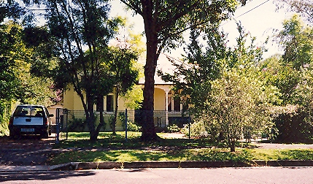

Lot 17 DP 5440

**Hornsby Shire Council details**

**Heritage Register: Item No. 288**

Part of Mount Pleasant Estate – Cheltenham 1st Subdivision 1908

A Federation period house of typical double-fronted design.

*[NOTE: There is no evidence that the house was built in 1913 for Keith and Lorna Arnott who lived at no. 24 The Boulevard, Cheltenham. They were married in 1920.]*

In 1913 Harold Arthur Sindell (collar maker) and Emma Louisa Sindell were living at “Glenview”.

*[Harold A. Sindel married Emma L. Gerrard in 1906, Sydney]*

*Frank William Sindel, brother of Harold Arthur Sindel, was living at “Verona,” 28 The Boulevard in 1913.*

Sands Directories 1915-1932/3: Harold Sindel “Glenview”

Electoral Roll 1933: Harold Sindel No. 26

In 1933 the couple were still living in the house but by 1936 had moved to Couria Creek, Tilba Tilba, N.S.W. where Harold was a farmer.

In 1936 “Glenview” was occupied by J. A. McCubben, who was having a brick house built in Cheltenham-avenue (The Crescent), Cheltenham.

In 1937 John Norman Lawson was at 26 The Boulevard, and by 1943 Arthur Thomas Hannam (traveller) and Anna Arghyri Hannam (previously at 158 Beecroft-road, Cheltenham).

By 1947 the house was occupied A. E. White.

**Bibliography:**

1

**Resources available (varies):**

* Sands Directories 1858-1933 City of Sydney [Sands Postal Directory | City of Sydney Archives (nsw.gov.au)](https://archives.cityofsydney.nsw.gov.au/nodes/view/495003)
* Newspaper articles – TROVE - [Search - Trove (nla.gov.au)](https://trove.nla.gov.au/search/advanced/category/newspapers)
* Ancestry.com (subscription only) [Genealogy, Family Trees and Family History Records online - Ancestry.com](https://www.ancestry.com.au/) – Sands Directories, Electoral Rolls, Family photos (Public Member photos), Census lists, marriage details, + miscellaneous
* N.S.W. Births, Deaths & Marriages [Family history search | NSW Government](https://www.nsw.gov.au/family-and-relationships/family-history-search) (QLD & Victoria also obtainable online)
* House photos and information via Hornsby Shire Council website for Property Search and Heritage Register [Heritage | Hornsby Shire Council (nsw.gov.au)](https://www.hornsby.nsw.gov.au/property/build/heritage)
* House photos and associated information via Internet search on address via Real Estate websites (from 2005)
* “Beecroft and Cheltenham Heritage Walks” - Beecroft-Cheltenham History Group Inc. 2004 book (1st edition)
* Australian War Museum website [Home | Australian War Memorial (awm.gov.au)](https://www.awm.gov.au/)
* Beecroft and Cheltenham History Group website [Beecroft and Cheltenham History - Beecroft Cheltenham History Group (bchg.org.au)](https://bchg.org.au/)