**28 BORONIA AVENUE, CHELTENHAM (“Beverly”)**

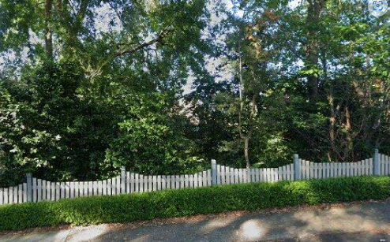

Lot 122 DP 833697

**Hornsby Shire Council details**

**Heritage Register: (NONE)**

“Beverly” [sometimes spelt as “Beverley”] is first mentioned in 1904 when a son to George and Florence Southward was born there.

*[George Collier Southward married Florence Caroline Halls in 1903, at Sydney]*

The Hornsby Council Rate Books for 1907-09 record George Collier Southward as owner and occupier, on 2 acres.

In 1913 George’s occupation is given as ‘clerk.’

Sands Directories 1915-16: George Southward “Beverly”; 1917-1921 Albert E. Owen “Beverly”; 1922-1931 Rev. E. Keith “Bevely”; 1932/3 Charles W. Bannister “Beverly”

Electoral Roll 1933: Charles Bannister No. 28

In 1916 Florence died, aged 38 years, leaving her husband George (commercial traveller), and two children - — a son 11 years of age and a girl nine.

The house was then occupied by Albert E. Owen.

By 1923 Reverend George Keith occupied the house.

In 1930 Rev. George Keith, M.A., one-time Moderator of the Presbyterian Church in 1909, Minister Emeritus of the Orange Presbytery, died at his Cheltenham home, aged 73 years, leaving a widow.

He came to Australia from Scotland in 1889, and after a short stay in Sydney went to Condobolin where he remained until his retirement in 1916. He was the brother of Sir Arthur Keith, the famous anthropologist.

“Beverly” was then occupied by Charles William Bannister (chemist) and wife Edith.

**Bibliography: none**

**Resources available (varies):**

* Sands Directories 1858-1933 City of Sydney [Sands Postal Directory | City of Sydney Archives (nsw.gov.au)](https://archives.cityofsydney.nsw.gov.au/nodes/view/495003)
* Newspaper articles – TROVE - [Search - Trove (nla.gov.au)](https://trove.nla.gov.au/search/advanced/category/newspapers)
* Ancestry.com (subscription only) [Genealogy, Family Trees and Family History Records online - Ancestry.com](https://www.ancestry.com.au/) – Sands Directories, Electoral Rolls, Family photos (Public Member photos), Census lists, marriage details, + miscellaneous
* N.S.W. Births, Deaths & Marriages [Family history search | NSW Government](https://www.nsw.gov.au/family-and-relationships/family-history-search) (QLD & Victoria also obtainable online)
* House photos and information via Hornsby Shire Council website for Property Search and Heritage Register [Heritage | Hornsby Shire Council (nsw.gov.au)](https://www.hornsby.nsw.gov.au/property/build/heritage)
* House photos and associated information via Internet search on address via Real Estate websites (from 2005)
* “Beecroft and Cheltenham Heritage Walks” - Beecroft-Cheltenham History Group Inc. 2004 book (1st edition)
* Australian War Museum website [Home | Australian War Memorial (awm.gov.au)](https://www.awm.gov.au/)